**TABLE OF CONTENTS**

INTRODUCTION 1

I. GETTING STARTED WITH EMR 2

1.1 LOGGING INTO EMR 2

1.2 HOME PAGE 3

II. USING EMR 5

2.1 FINDING AND CREATING A PATIENT 5

2.1.1 Finding patient 5

2.1.2 Creating new patient 13

2.2 PATIENT’S DASHBOARD 30

2.2.1 Overview 31

2.2.2 Regimens 36

2.2.3 Visits 37

2.2.4 Demographics 37

2.2.5 Graphs 39

2.2.6 Form entry 39

2.3 USING COHORT BUILDER 95

2.3.1 Concept / Observation 95

2.3.2 Patient Attributes 96

2.3.3 Encounter 97

2.3.4 Program Enrollment 97

2.3.5 Drug Order 97

2.3.6 SQL 98

2.3.7 Composition 98

2.4 APPOINTMENT 99

2.4.1 Creating appointment 99

2.4.2. Finding appointment 100

2.4.3. Manage service provider 102

2.4.4 Advanced search 104

2.5 LABORATORY ORDERS 105

2.5.1 Making laboratory order 105

2.5.2 Laboratory results entry 107

2.5.3 Viewing laboratory results monthly reports 112

2.5.4 Viewing laboratory results from patient dashboard 112

2.6 PHARMACY 114

2.6.1 Pharmacy store management 115

2.6.2 PHARMACY REQUISITION 121

2.6.3 Drug store alerts & Expiration date alert 128

2.6.4 Pharmacy location management 129

2.6.5 Pharmacy report 130

2.7 BILLING 132

2.7.1 Manage Insurance Policy 132

2.7.2 Admission 133

2.7.3 Billing a patient 135

2.7.4 Paying a bill 137

2.7.5 Discharging the patient 140

2.7.6 Deposit 142

2.7.7 Withdrawal of unused amount 143

2.7.8 Refunding / reimbursement 145

2.7.9 Billing report 150

2.8 REPORTING 153

2.8.1 Manage data exports 154

# INTRODUCTION

The government of Rwanda took a decision to adopt the Electronic Medical Record (EMR) system as a national system to support health care services within hospitals and health centers across the country.

The current version of EMR supports health care services in primary care (both OPD and IPD), communicable deseases (e.g: HIV care), non communicable diseases (e.g: heart failure, hypertension, diabete), antenatal care (ANC) and nutrition. It olso provides features that help users to use different services such as laboratory, pharmacy, accounting, reception and different specific programs.

# GETTING STARTED WITH EMR

This part is for any user who will login in EMR.

## 1.1 LOGGING INTO EMR

EMR is accessible from the server by entering the address of the following format: <http://Server-IP:Port/Application-name>. e.g: <http://192.168.43.58:8089/eopenmrs>

The browser should be any recent version of Internet browser such as Mozilla Firefox, Google chrome or any other browser.  


After entering the address in the browser, press **[Enter]** button and the system will take you to the bellow login page.

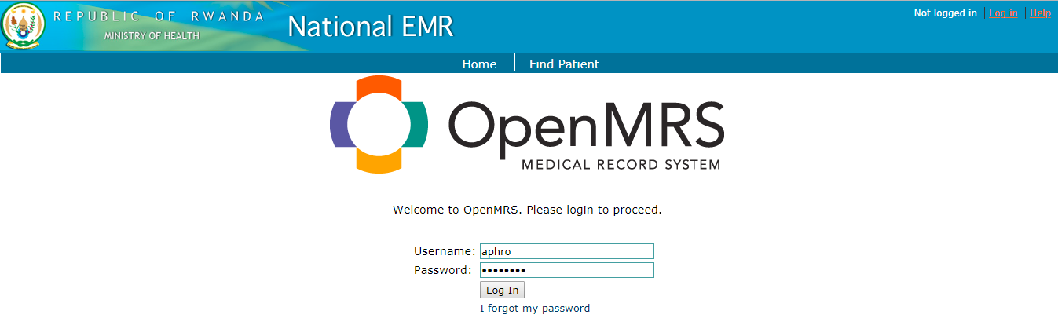

Enter your username and password to login

Click on the link for password recovery

Enter your username and password and press the **[Log in]** button. In case you have forgotten your password, click on **[I forgot my password]** link and you will be directed to the password recovery form.

|  |  |
| --- | --- |
| Image result for information icon | Note:   * Password recovery function is currently not activated. Please contact administrator in case this function needs to be utilized. * **Server_IP**, **Port** and **Application_name** should be provided to you by the system administrator. |

## 1.2 HOME PAGE

After login user is directed to the home page with different options based on his level of access.

The following is the home page in admin view:

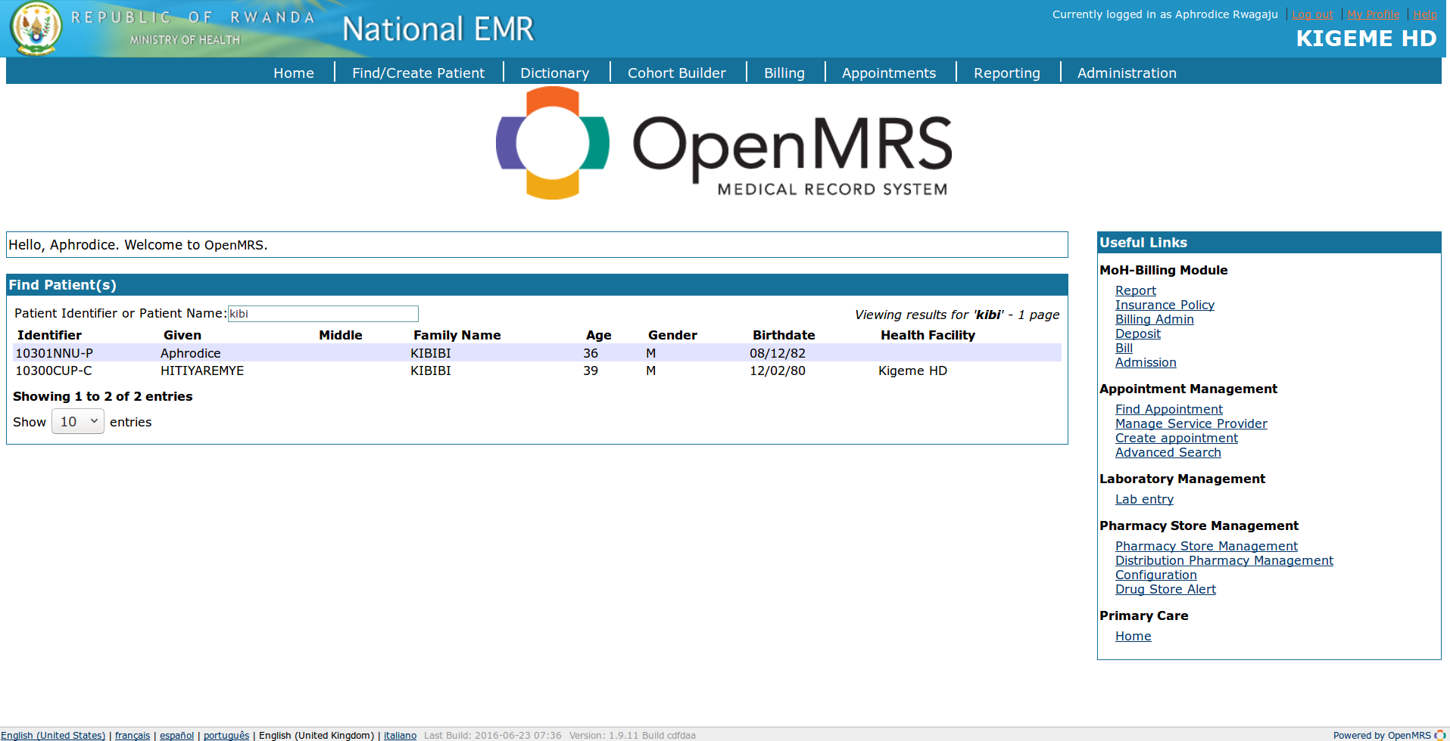

|  |  |
| --- | --- |
|  | **Item descriptions**   1. **Home:** Click this menu for going to the home page of EMR 2. **Find/Create patient:** This menu helps to find or create new patient 3. **Dictionary:** it is collection of coded and unique concepts used to generate forms and encode data within the system. 4. **Billing:** Click this menu in case you want to deal with billing and payment for clinical services and consumables. 5. **Cohort builder:** It is a tool that lets you perform ad-hoc queries for patients with defined characteristics and combined multiple queries into more complex ones 6. **Appointments:** It adds ability to schedule patients’ appointments, then manage their flow through a clinic once they arrive for appointments 7. **Reporting:** Provides option to access reports 8. **Administration:** This menu is used for administration settings 9. **Login user details area:** It displays details for current logged in user such as name, location, **[logout]** option and **help** link. 10. **Record listing area:** With a search field on the top, this option helps user to search a recorded patient based on his/her ID, name, and many other parameters 11. **Language selection area:** From this area you are able to select a navigation language for your preference 12. **Useful links area:** The links have been availed to help quick access across different types of users at health facility |

# II. USING EMR

## 2.1 FINDING AND CREATING A PATIENT

### 2.1.1 Finding patient

#### 2.1.1.1 First method for finding a patient

To find a patient, the user has to click on **[Find/Create Patient]** menu. The form containing **[Find Patient(s)]** and **[Create Patient]** sections is open.

Search by name or ID in the provided search area of the **[Find Patient(s)]** section and verify if the returned data contain the patient you are searching for.

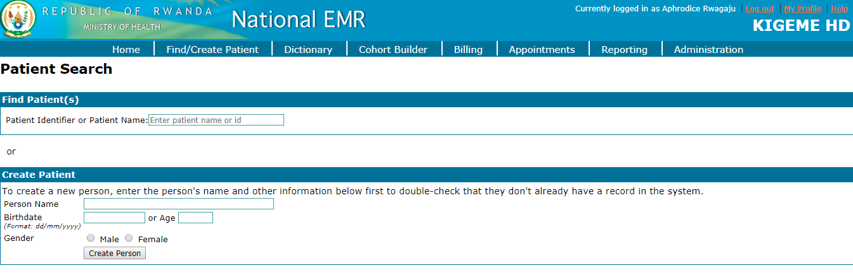

After entering the searching criteria the following is the results page. In our case the search criteria is “**kibi**” which is returning two patient records. The searching function is case insensitive i.e you can use capital letters or small case letters.

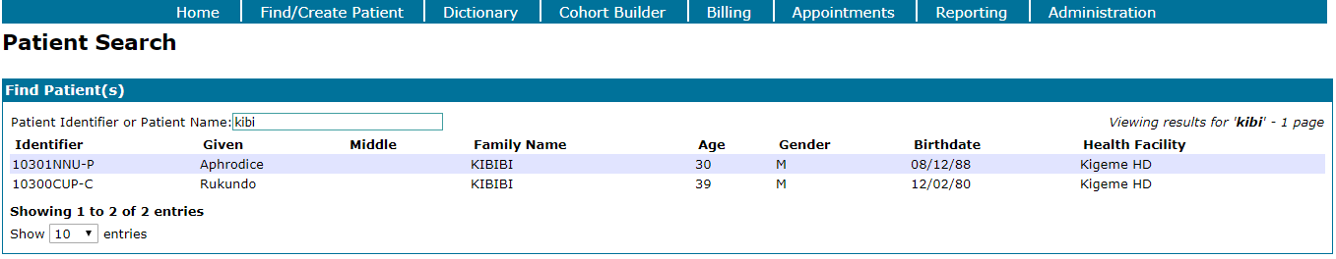

After the **double click** on the selected patient, the following form is open

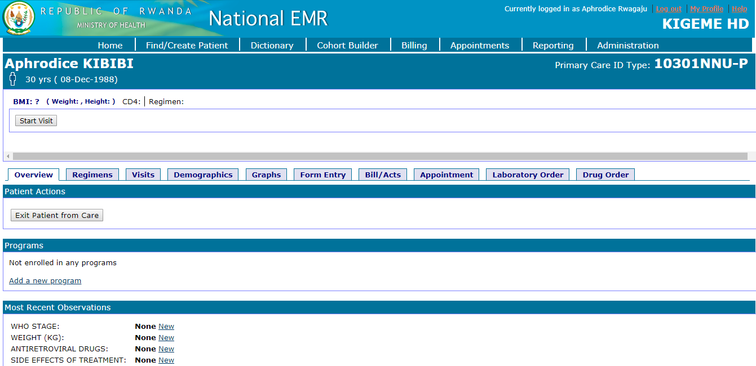

|  |  |
| --- | --- |
|  | **Item descriptions**   1. Patient name and age 2. **Start Visit**: Option to create new visit 3. Anthropometric data (BMI, Weight, Height) 4. Dashboard tabs 5. Patient ID |

#### Image result for information icon2.1.1.2 Second method for finding a patient

This method is used by receptionist especially when he/she is using touch screen devices.

**Steps**:

1. Log into EMR using your username and password
2. From **useful links** section, click on “**Home**” link under **primary care** option

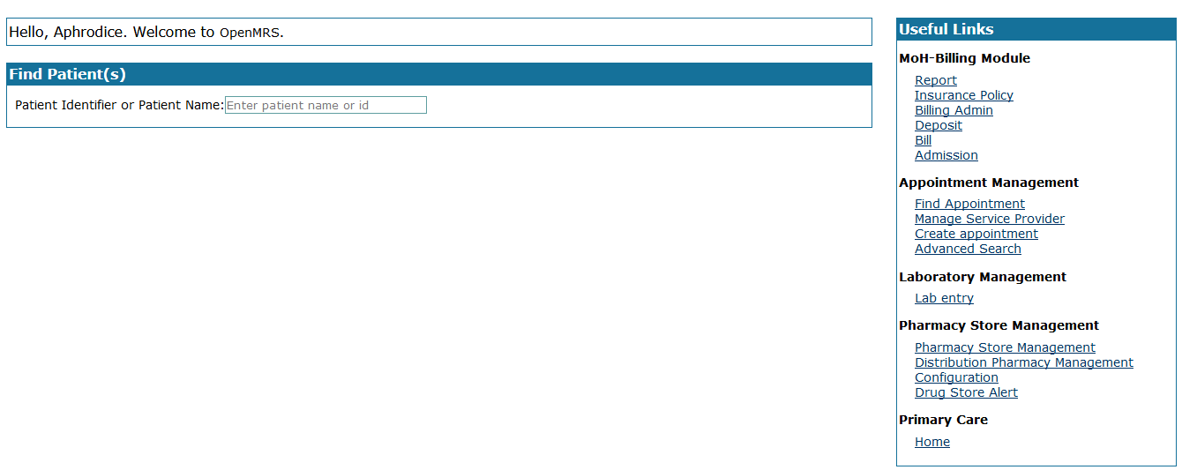

1. To continue, the user is again prompted to enter username. Enter username and click on **[Next]** button

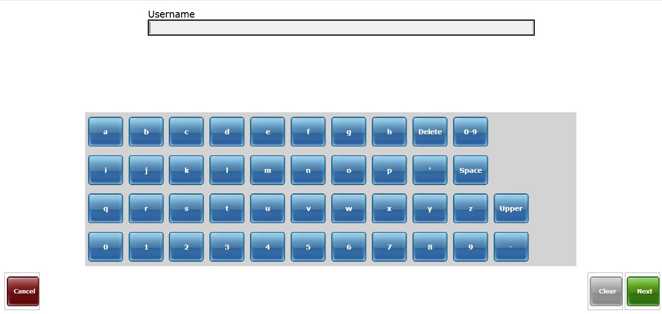

1. Enter password and click on **[Finish]** button

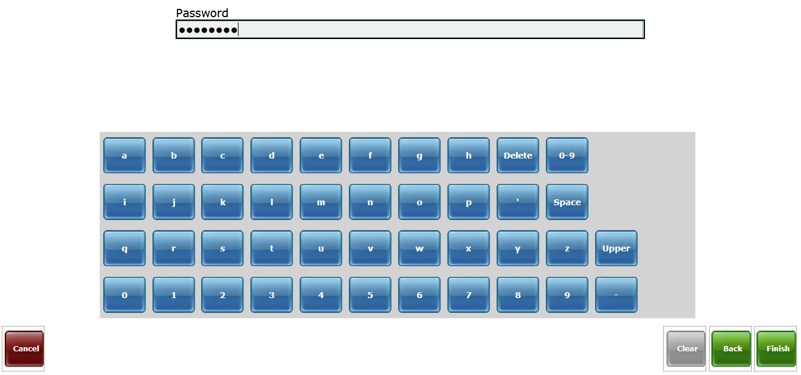

1. Verify if your health facility is selected and click on **[Finish]** button

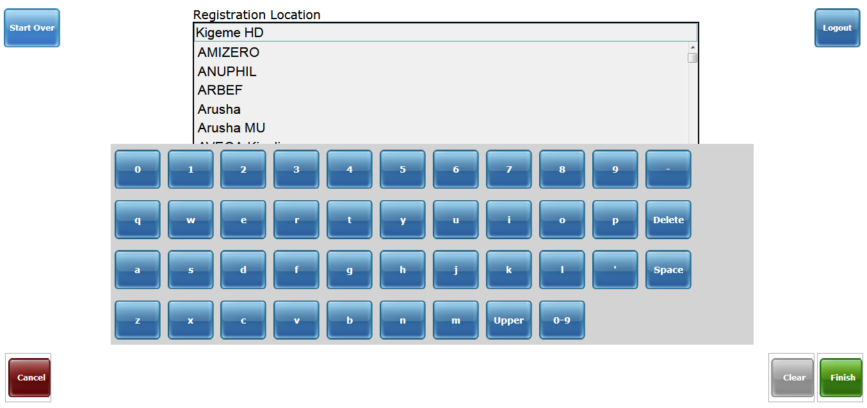

1. After health facility selection, different buttons are available to help you to navigate the system: **Search by ID, Search by name, print ID barcodes for offline use, generate IDs for other locations, my properties** and **logout**. Click on **[Search by name]** button

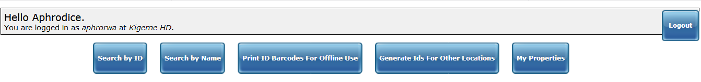

1. Enter Rwandan name. if many records are returned, select the name you would like to use and click on **[Next]** button

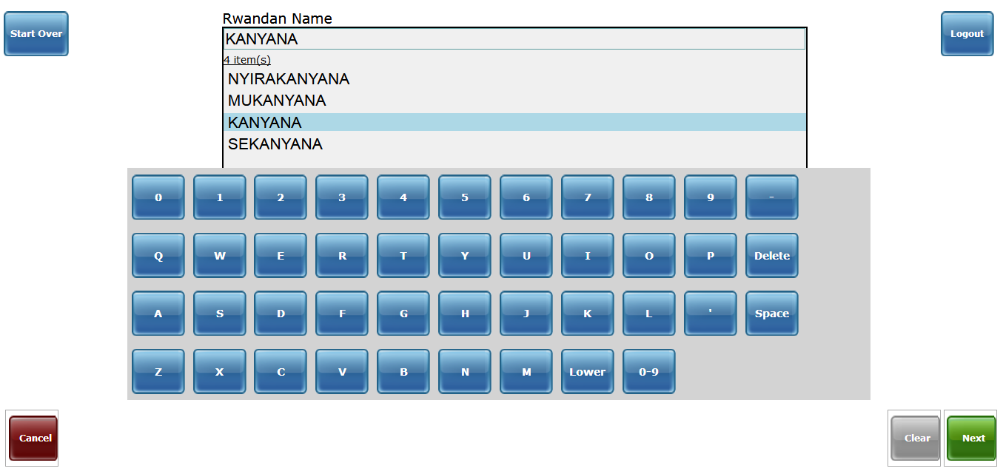

1. Enter the second name (French/Anglo name). Select the name present patient from many returned names and click on **[Next]** button

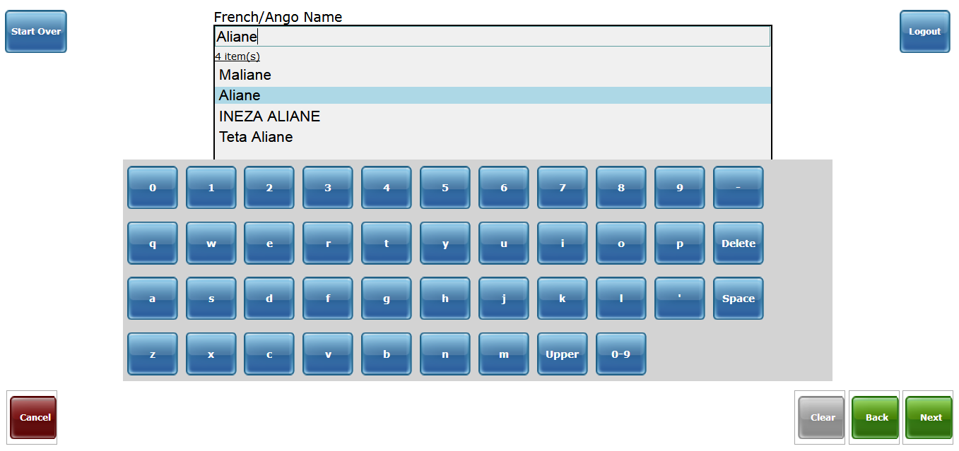

1. Select **Gender** and click on **[Next]** button

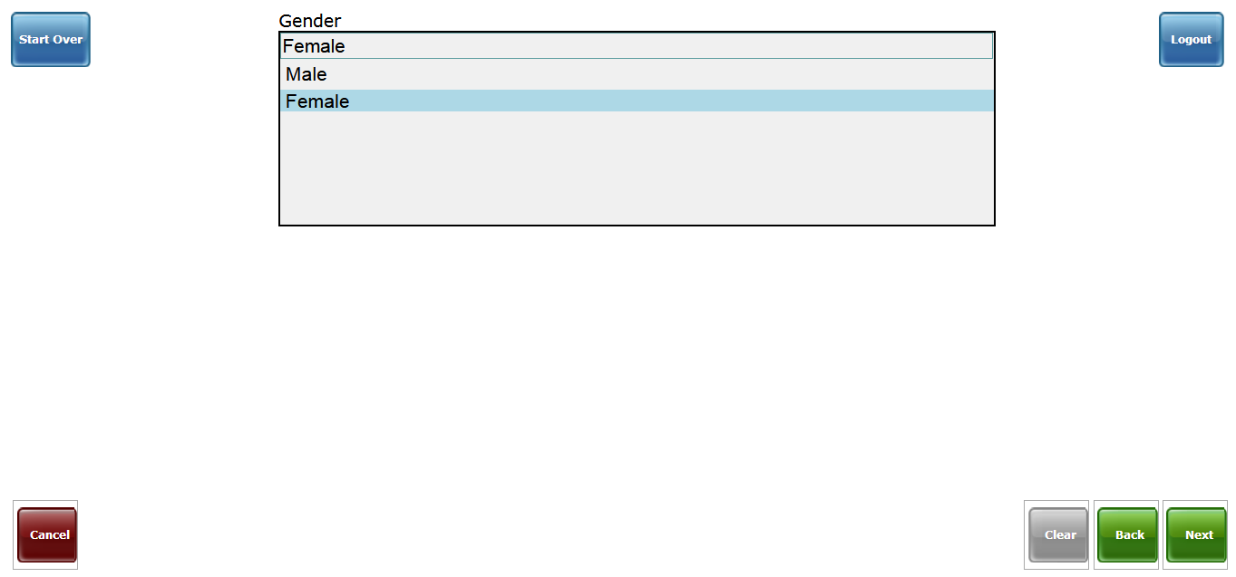

1. Enter age and click on **[Finish]** button

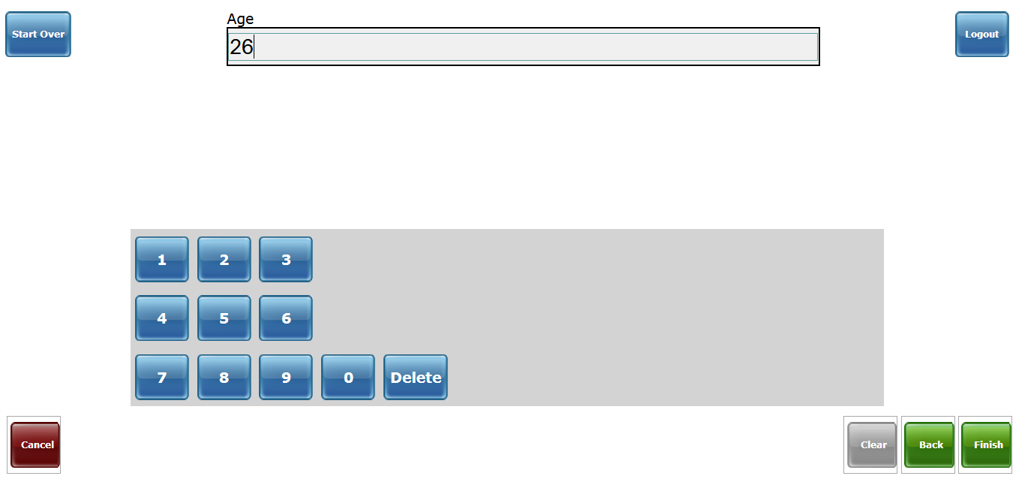

1. If the patient exists in the EMR, the ID number will be displayed and the user will click on gray color to continue with the patient of the same details. In case the patient is not found, the user will click on blue color button **[Not found, create new patient: X Y]**.

|  |  |
| --- | --- |
| Image result for information icon | Note:   * **X Y**: Stand for the names of the patient. |

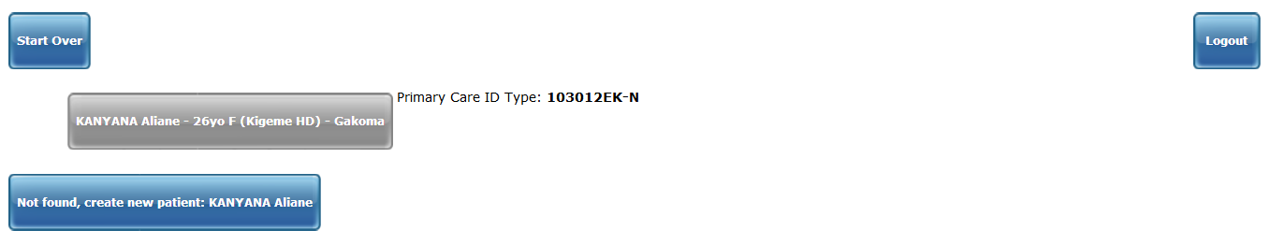

1. After selecting the patient, the return form will look like the following:

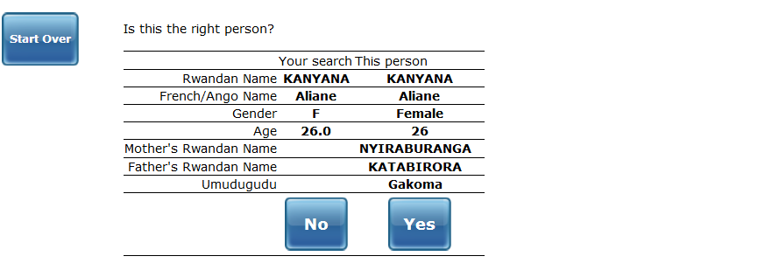

1. If the details are for the real person you are searching, click on **[Yes]** button to continue. The next form will look like this:

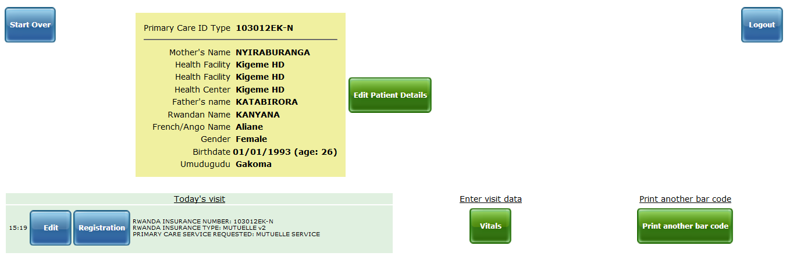

|  |  |
| --- | --- |
|  | **Item descriptions**   1. **Edit:** Click this button if you want to edit/add new enrollment service 2. **Registration:** Click this this button for encounter registration 3. **Services visited today:** Displays the services visited by the patient today 4. **Edit patient:** Click this button in case you want to edit the selected patient 5. **Vitals:** Click this button in case you want to enter/edit vital sings 6. **Print another bar code:** Click the button if you need to print the barcode for the patient 7. **Logout:** Click the button if you want to logout from the EMR |

1. Orient a patient in service by clicking on one of the services listed on the form to complete the process

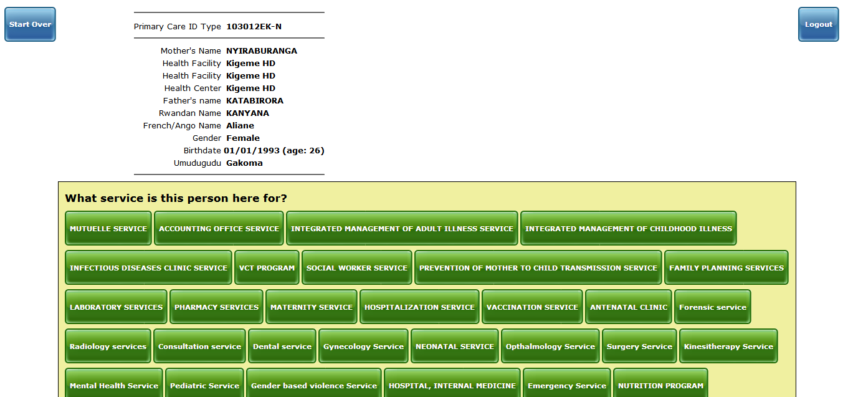

This second method for finding or creating patient is used by receptionist especially when he/she is using touch screen devices.

|  |  |
| --- | --- |
| Image result for information icon | Note:   * If the search returns empty, it means no records has found with the same search criteria * It is better to search a patient by using “Patient identifier” to be more precise * If the search returns the list containing the present patient, **hover a mouse** on his record and **double click** to open details * Before recording a new patient, the user has to first make sure that the present patient doesn’t exist in the system. Once he doesn’t exist, the present patient can be recorded as new patient in EMR * If the patient exist in the system, he/she is not eligible to be recorded for the second time |

### 2.1.2 Creating new patient

#### 2.1.2.1 First method

To create a new patient in EMR, a user has to make sure that the patient doesn’t exist in the current database.

After the verifying if the present patient in new, the user uses the same form or clicks again on “**Find/Create Patient**” menu then continue by filling the fields of “**Create Patient**” section.

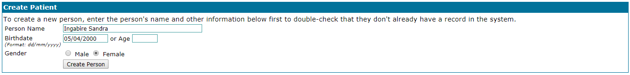

Fill the form in the red circle and click on **[Create Person]** button.

After creating a person, the following form is open to continue recording the patient details.

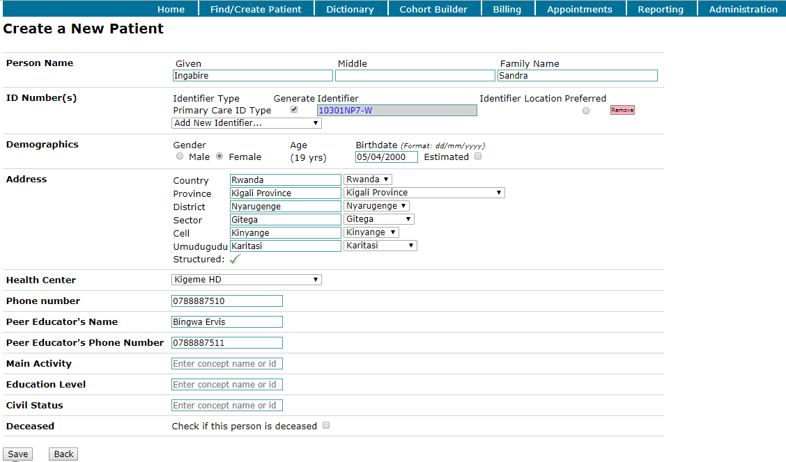

Fill the above form with all details and click on **[Save]** button.

#### 2.1.2.2 Second method for creating a patient

This method is used by receptionist especially when he/she is using touch screen devices.

**Steps**:

1. Log into EMR using your username and password
2. From **useful links** section, click on “**Home**” link under **primary care** option



1. To continue, the user is again prompted to enter username. Enter username and click on **[Next]** button



1. Enter password and click on **[Finish]** button



1. Verify if your health facility is selected and click on **[Finish]** button



1. After health facility selection, different buttons are available to help you to navigate the system: **Search by ID, Search by name, print ID barcodes for offline use, generate IDs for other locations, my properties** and **logout**. Click on **[Search by name]** button



1. Enter Rwandan name. if many records are returned, select the name you would like to use and click on **[Next]** button



1. Enter the second name (French/Anglo name). Select the name present patient from many returned names and click on **[Next]** button



1. Select **Gender** and click on **[Next]** button



1. Enter age and click on **[Finish]** button



1. If the patient exists in the EMR, the ID number will be displayed and the user will click on gray color to continue with the patient of the same details. In case the patient is not found, the user will click on blue color button **[Not found, create new patient: X Y]** to create the new patient.

|  |  |
| --- | --- |
| Image result for information icon | Note:   * **X Y**: Stand for the names of the patient. |



1. Once the button is clicked, the name is selected by default. Click on **[Next]** button to continue.

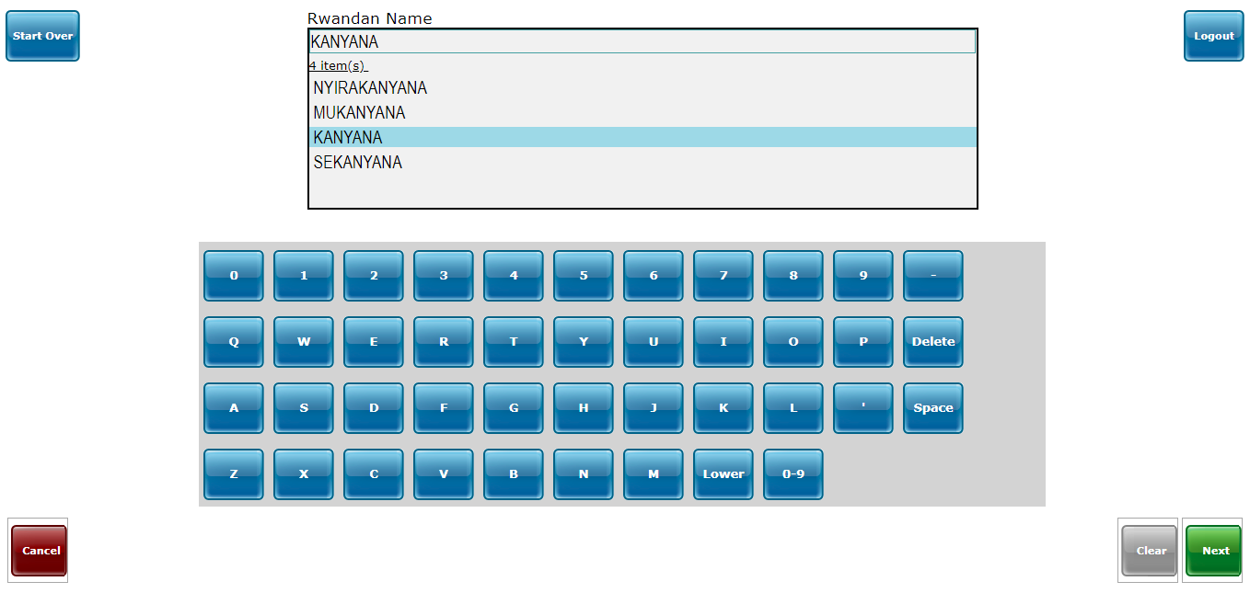

1. Enter second name (French/Anglo name). If the patient has more than two names, the user can enter other names at this step.

E.g: Instead of **Aliane** only, the patient has other two names: **Ineza Aliane.** Ether them and click on **[Next]** button to continue

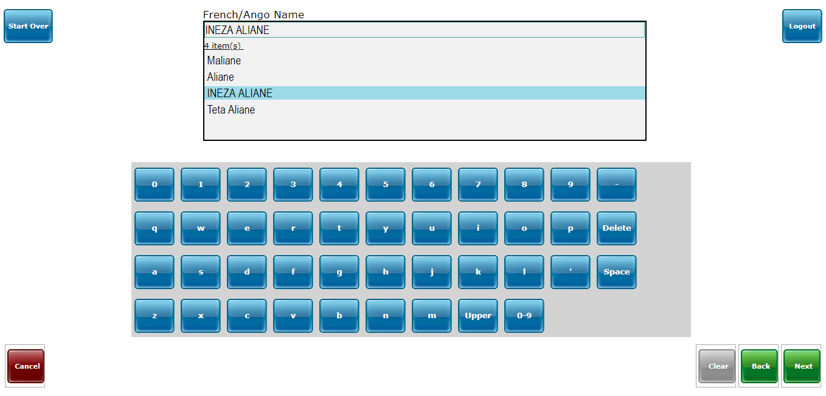

1. If the patient has a barcode, scan it to find his/her identification at this step otherwise click on **[Next]** button to continue.

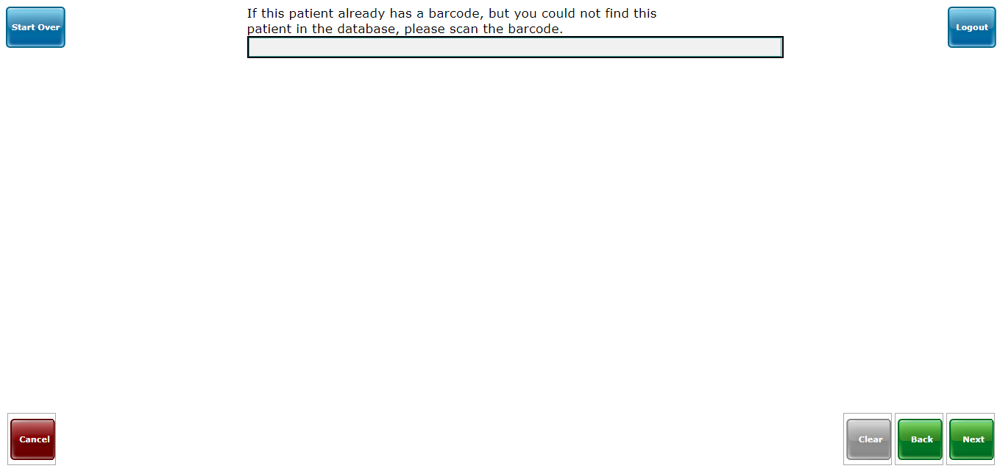

1. Enter **Birthdate day** and click on **[Next]** button to continue.

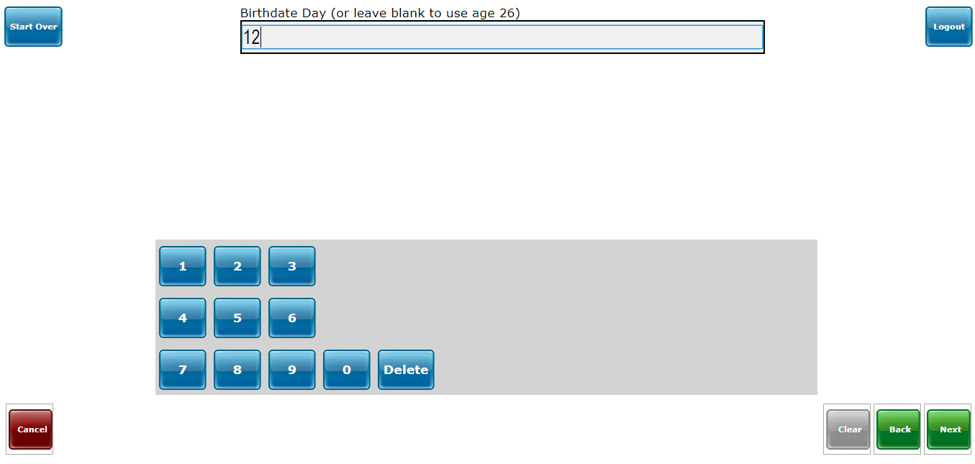

1. Enter **Birthdate month** and click on **[Next]** button to continue.

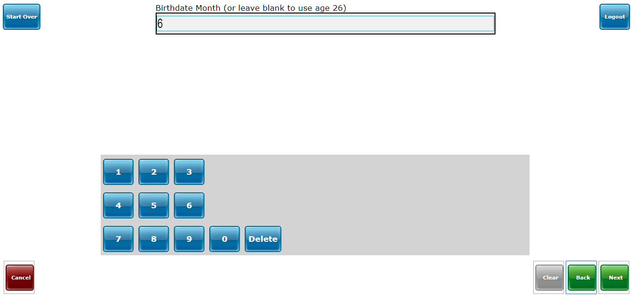

1. Enter **Birthdate year** and click on **[Next]** button to continue.

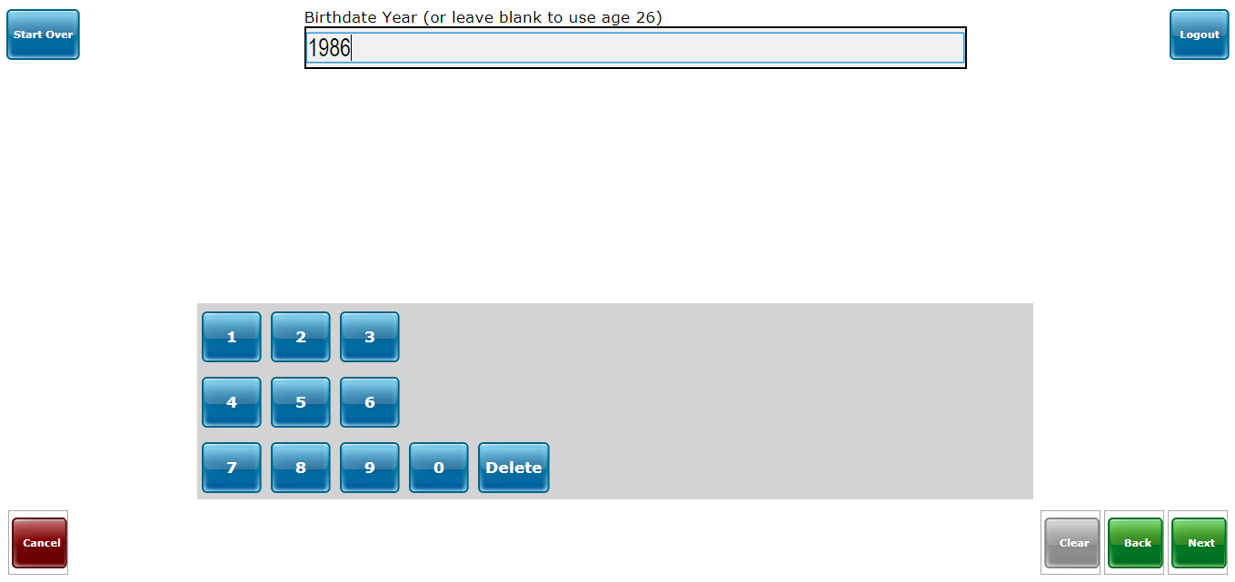

1. Select the **country** and click on **[Next]** button to continue

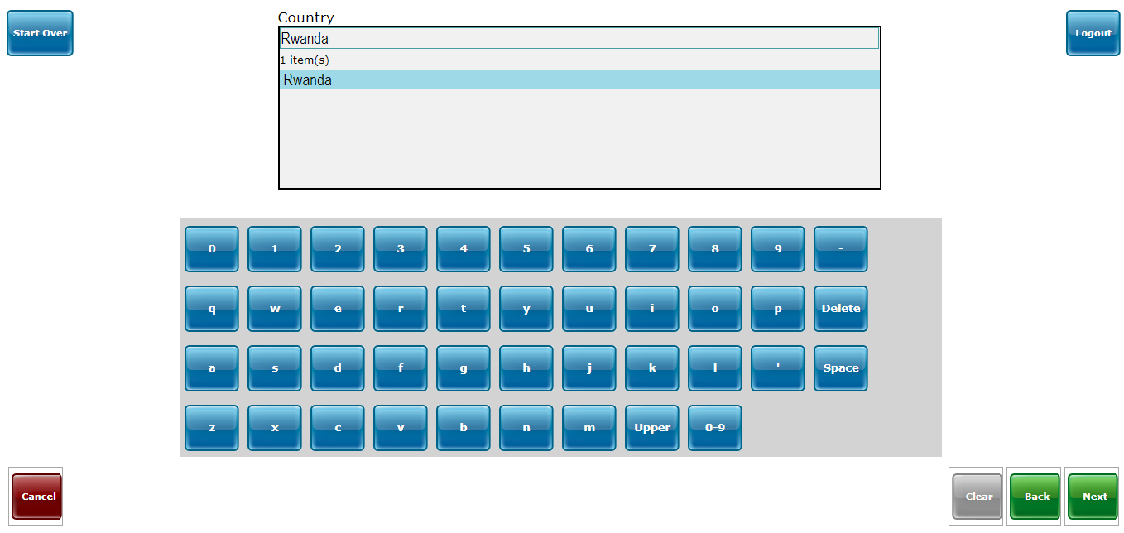

1. Select the **province** and click on **[Next]** button to continue

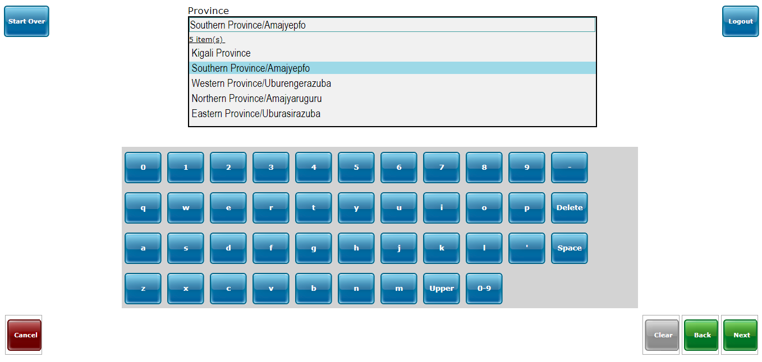

1. Select the **district** and click on **[Next]** button to continue

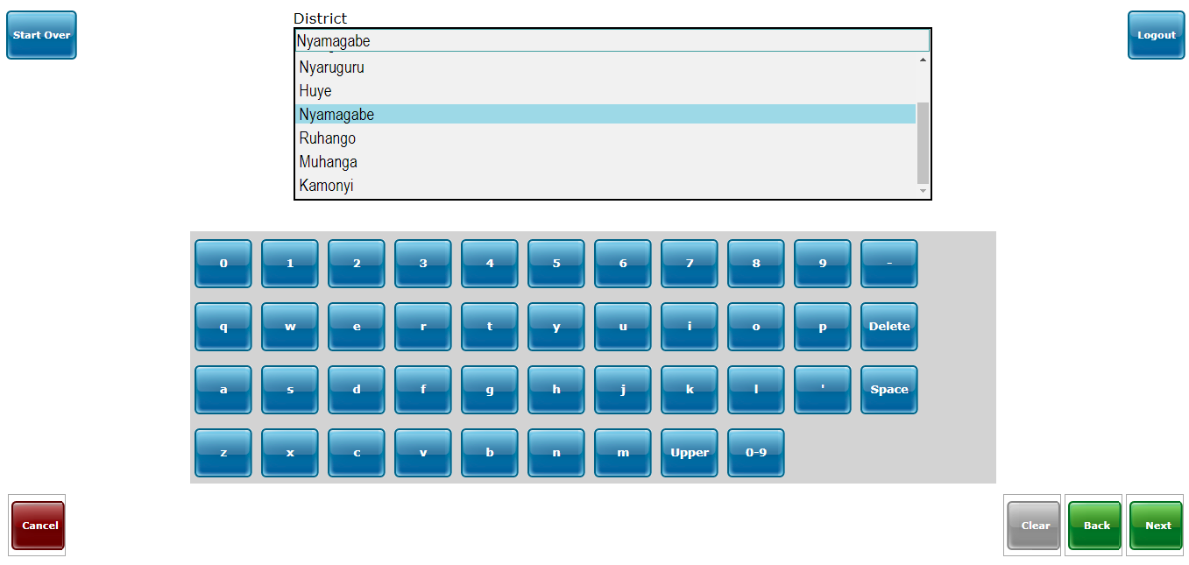

1. Select the **sector** and click on **[Next]** button to continue

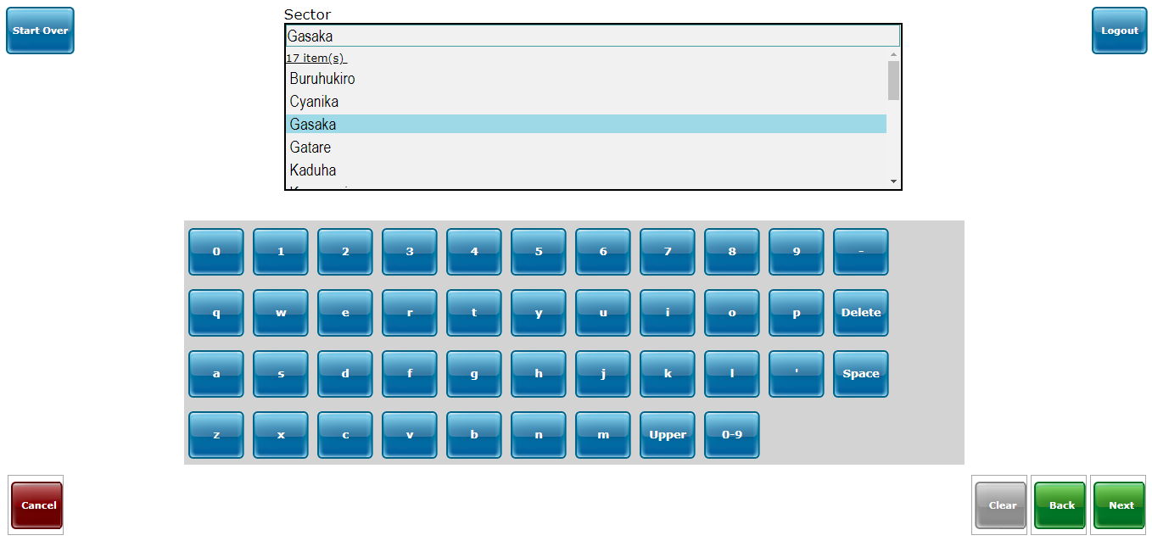

1. Select the **cell** and click on **[Next]** button to continue

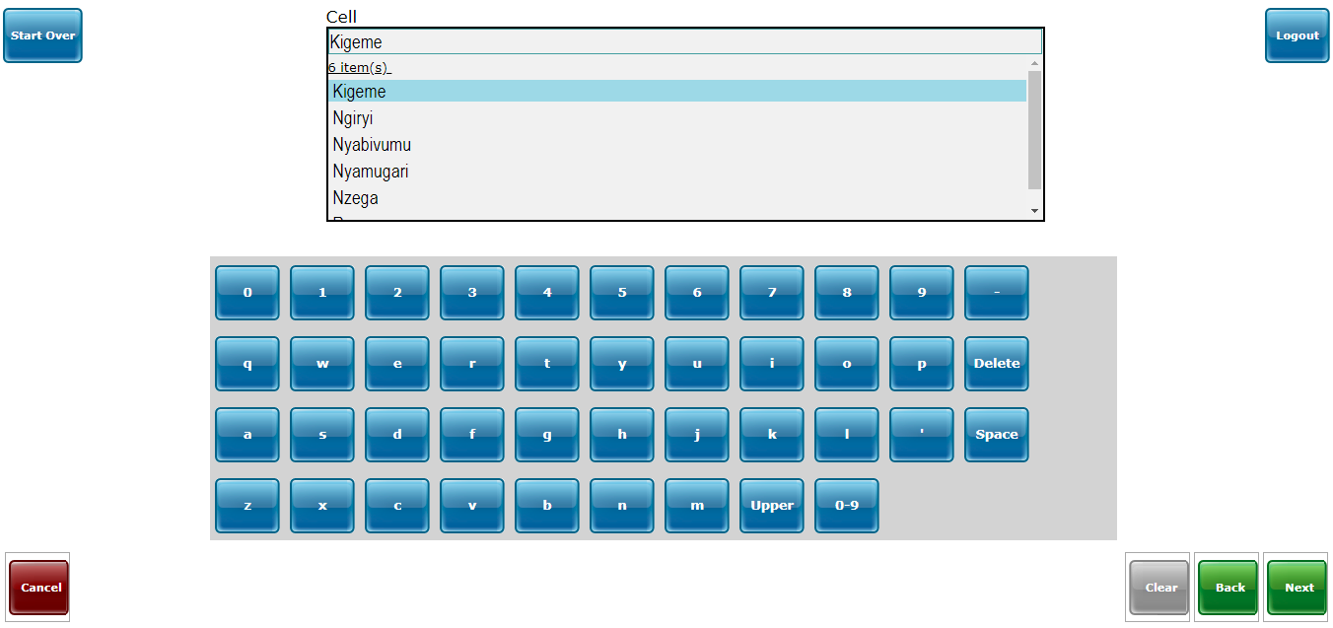

1. Select **Umudugudu (Village)** and click on **[Next]** button to continue

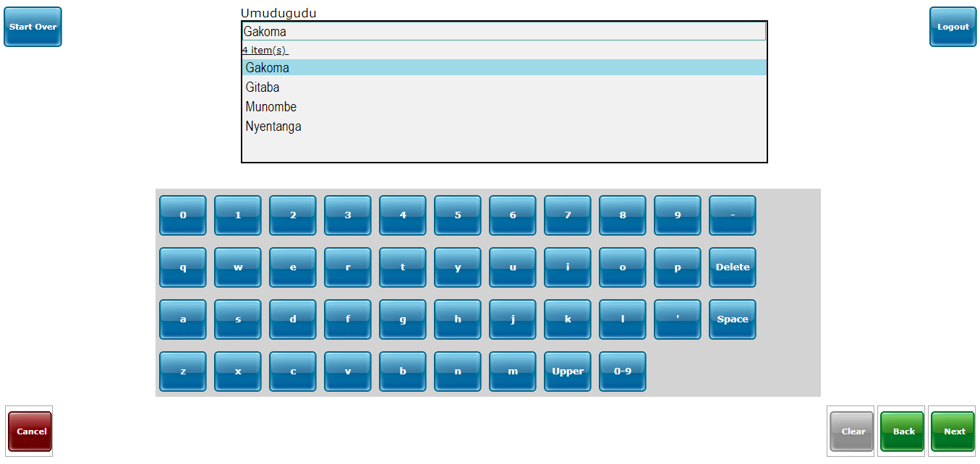

1. Enter **mother’s name**

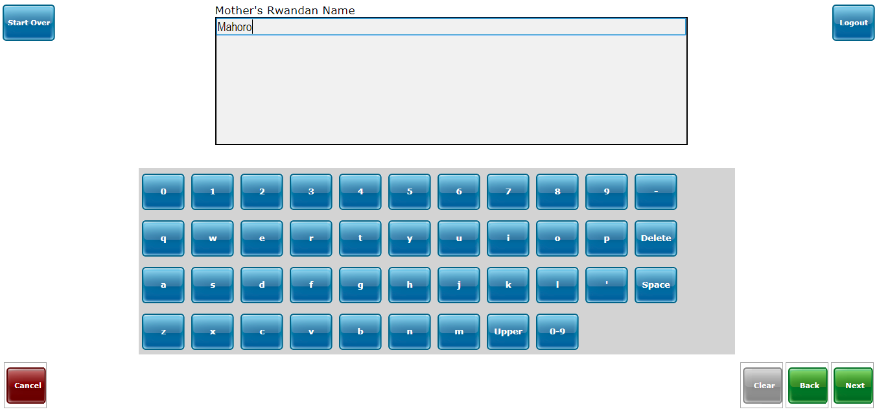

1. Enter **father’s name**

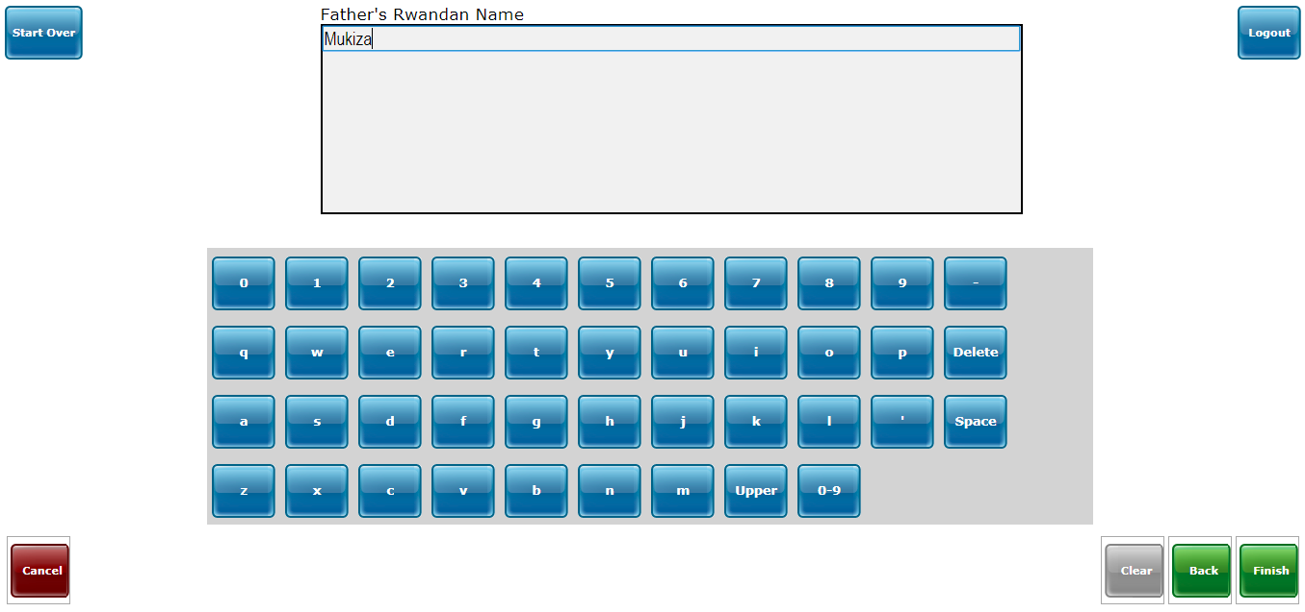

1. Verify if the patient information is correct then click on **[Yes]** to continue

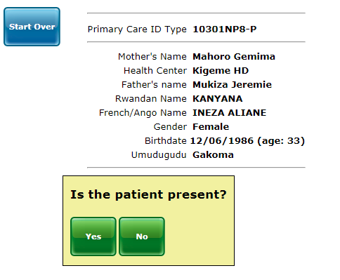

1. Click on **[Yes]** button to print barcode if any printer is connected and continue to the next step. Or click on **[No]** button to directly continue to the next step.

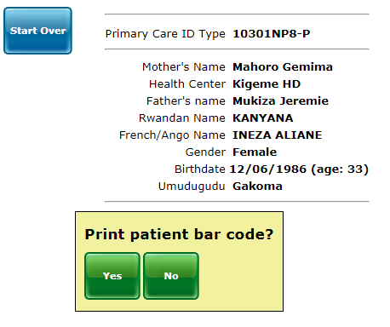

1. Orient a patient into service by selecting a desired service from the list. E.g: **Consultation service**

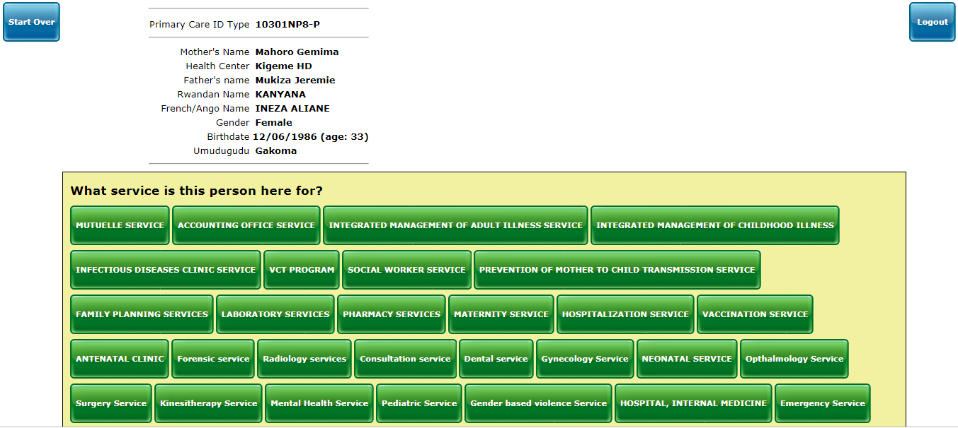

1. Select the **insurance type**

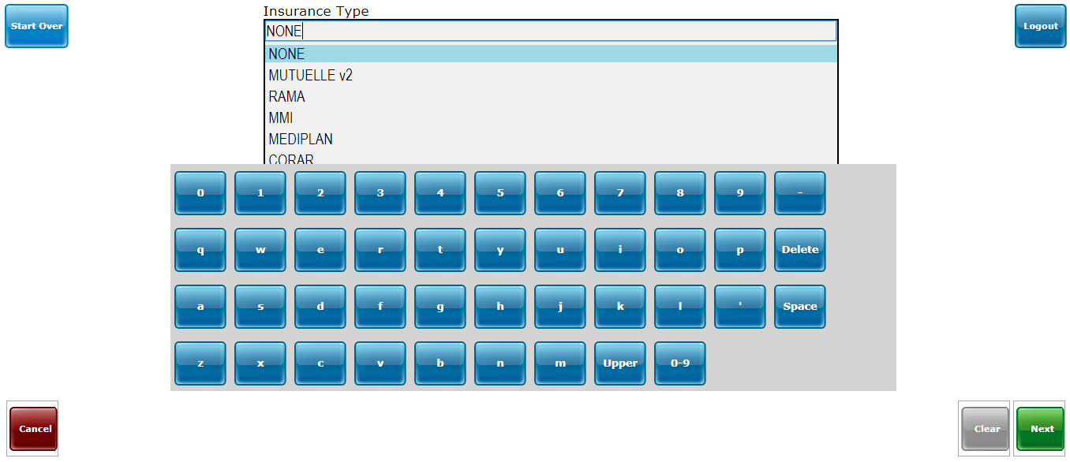

1. Enter the **insurance number**

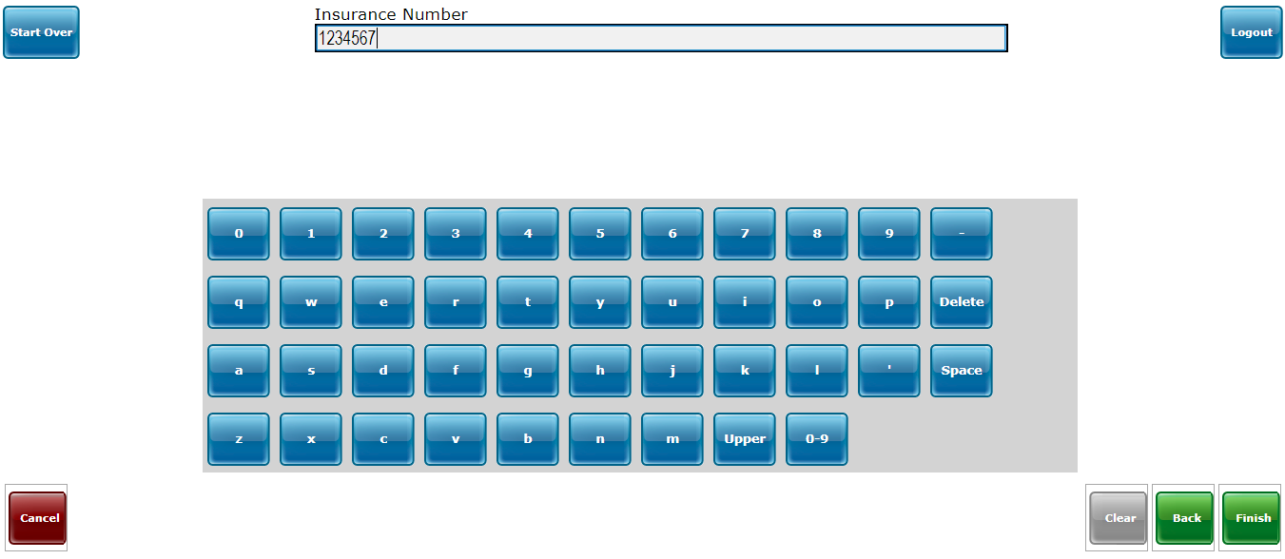

1. Click on **[Registration]** button to save the visit information

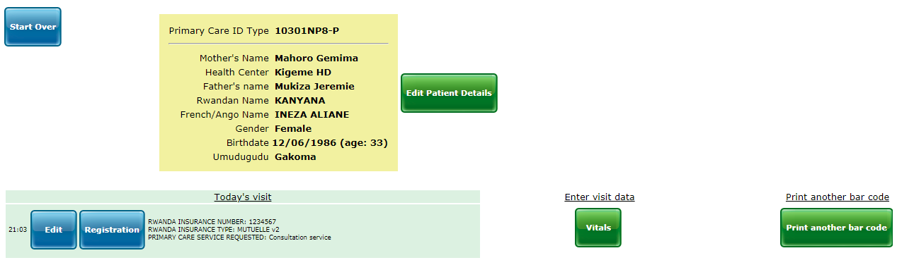

1. Click on **[Start over]** button to register new patient if any or click on **[Logout]** button to logout from EMR

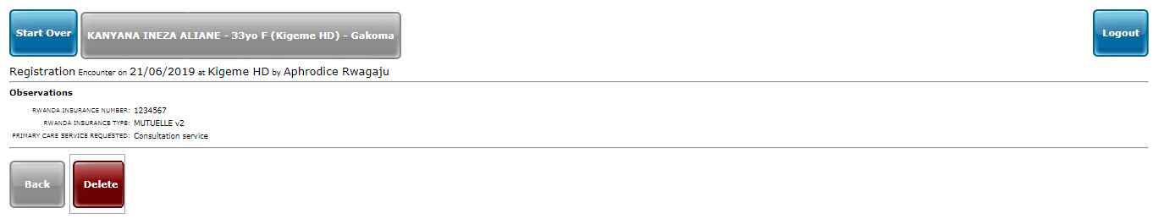

## 2.2 PATIENT’S DASHBOARD

The Patient Dashboard displays an overview of a patient's clinical personal information. This page is used to display the most crucial information of the patient to enable quick and efficient care.

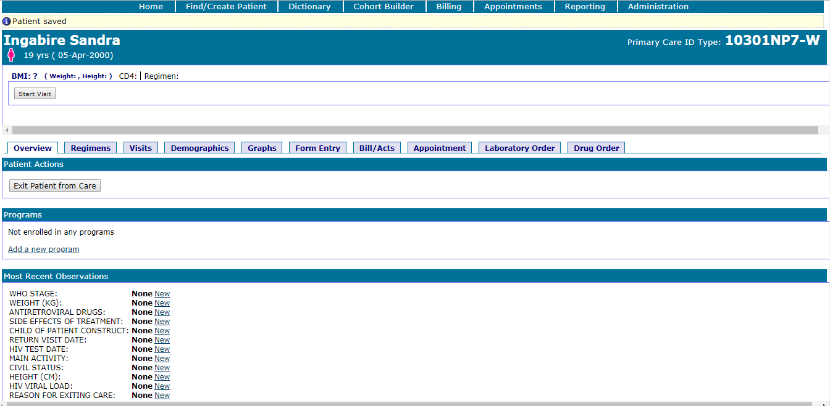

After recording a patient in EMR, the user can enroll the recorded patient in any **program** and fills other patient information like **weight**, **height**, **civil status**, **main activity, etc.**

The patient’s dashboard has 10 main tabs

|  |  |
| --- | --- |
|  | **Available tabs and description**   1. **Overview:** displays the **actions** to apply to the current patient**, program** a patient is enrolled to, **the most recent observation**, **relationships, allergies** and **problem list.** 2. **Regimens:** displays the current, future and completed patient’s regimens + Calendar view. You can **add**, **edit**, **stop** and **delete** drugs from this tab 3. **Visits:** displays a patient’s visits at health center or hospital. For each EMR form completed for a patient, a new encounter is created. Each with an **encounter id** and **encounter type** 4. **Demographics:** displays patient basic information (names, address, etc). You can edit patient’s information from this tab 5. **Graphs:** displays a graphical image of a patient’s lab results 6. **Form entry:** lists all forms that are used in different services for the enhanced EMR 7. **Bill/Acts:** It is used to manage bills 8. **Appointment:** It adds feature to schedule patients’ appointments 9. **Laboratory order:** It is used to manage lab tests and results 10. **Drug order:** It isused to manage drug orders |

### 2.2.1 Overview

It displays the **patient actions**, **program** a patient is enrolled to, **the most recent observation**, **relationships**, etc.

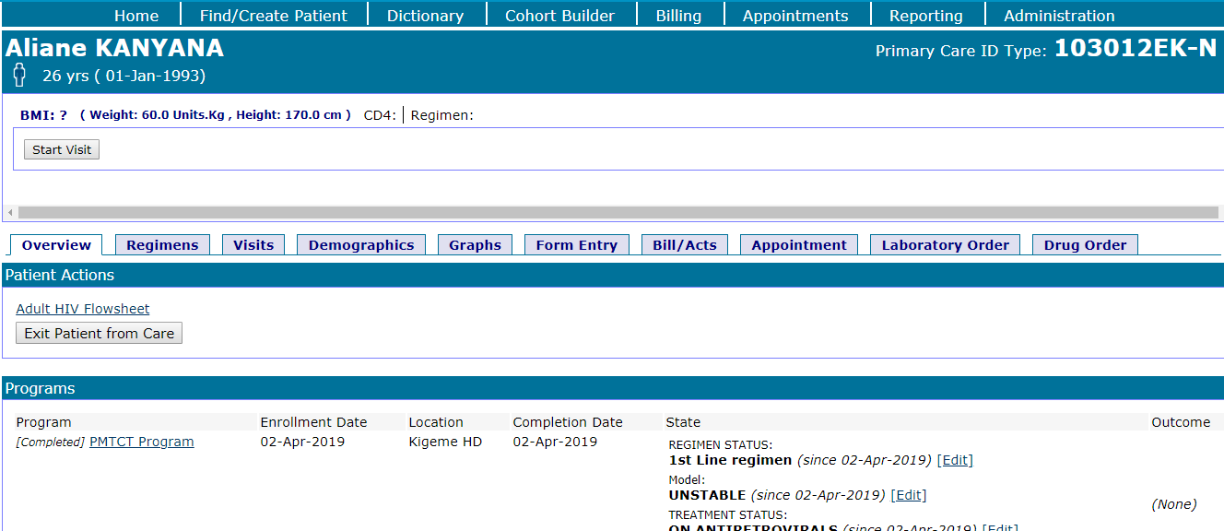

#### 2.2.1.1 Patient actions section

It helps to change patient state to another e.g: from one program to other program.



#### 2.2.1.2 Programs section

This section helps user to enroll a patient into program

Program is a service in which a person is identified as a member or belonging to a certain group. Eg: HIV Care Treatment, NCDs, PMTCT, TB, ANC etc. It helps to record entry and exit date of patient and the program workflow (treatment status and treatment group).

**Steps:**

1. Click on “**Overview**” from main menu
2. Go to **Programs** section
3. Click on “**Add a new program**” link. A form to enroll a patient into program is opened.
4. Select the **program name, enrollment date, location, model, treatment group, regimen status and treatment status**
5. Click on **“Enroll”** button to complete the process

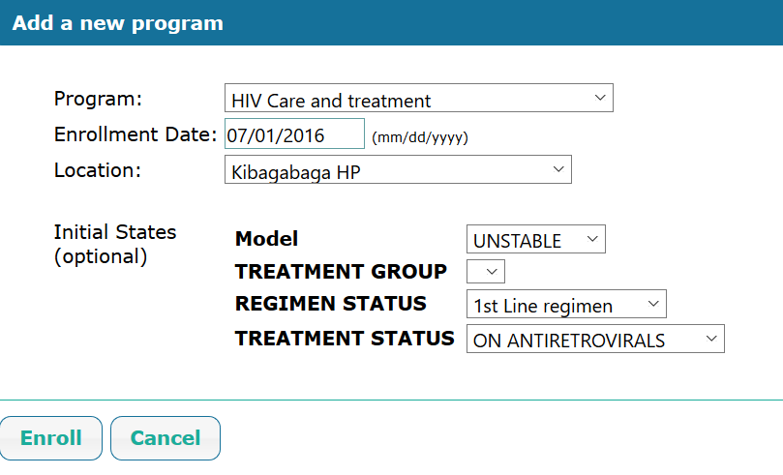

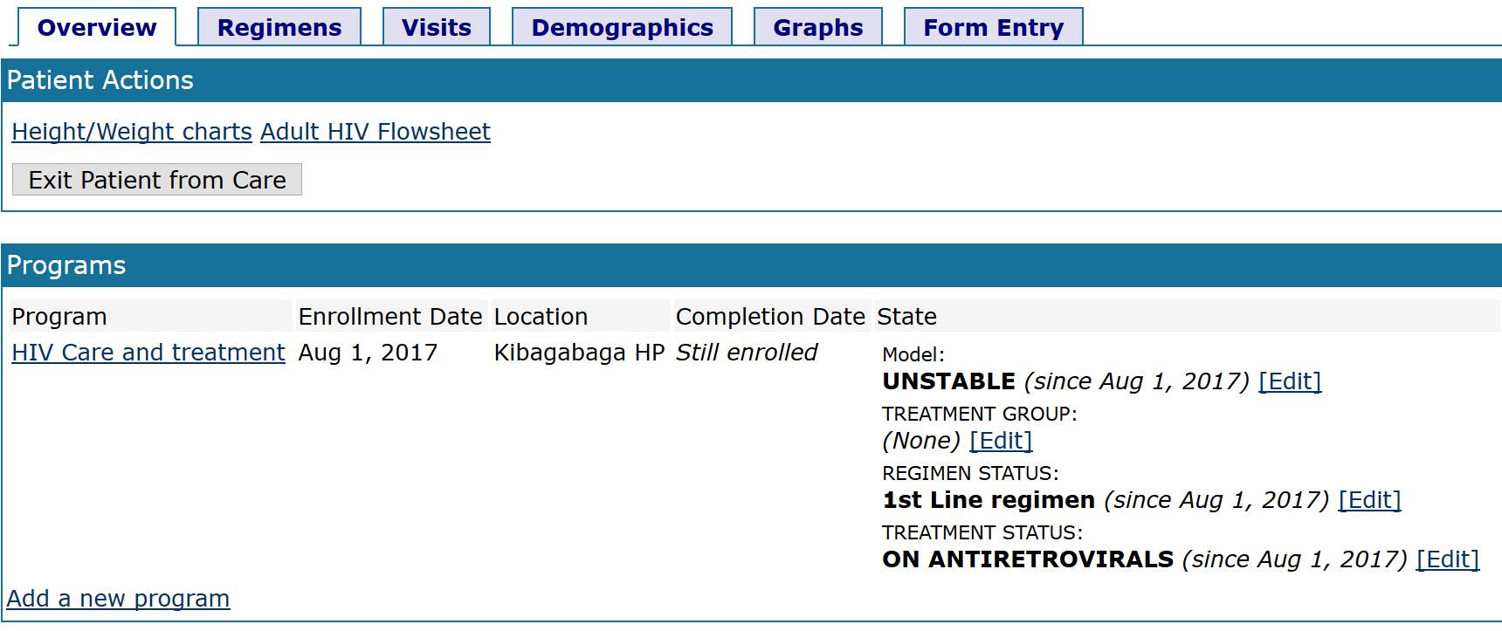After saving the form, the program listing will look like the following from:

|  |  |
| --- | --- |
| Image result for information icon | **Note:**  In the program selection combo box, user can chose one program from different options based on which program a patient is going to be enrolled in.  Availabe options:   1. PMTCT Program 2. HIV Care and treatment 3. HIV Exposure 4. TB Program 5. Chronic respiratory disease program 6. Hypertension program 7. Chronic Kidney Disease 8. Health failure program 9. Diabetes program 10. ANC program |

#### 2.2.1.3 Changing a patient model

To change a patient model, treatment status and treatment group is done on the “**Overview”** tab.

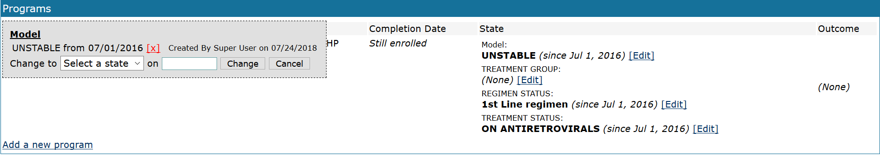

2.2.1.3.1 Changing a patient treatment status

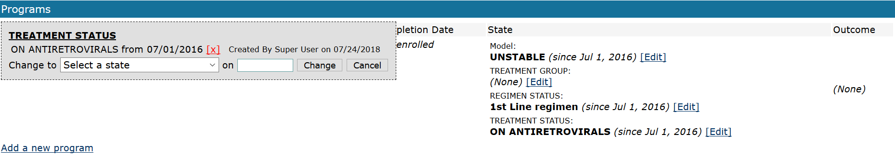

2.2.1.3.2 Changing a patient treatment group

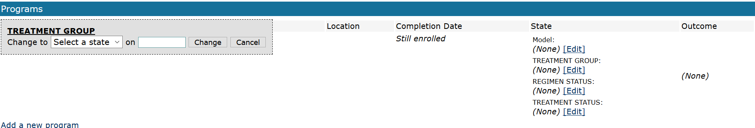

2.2.1.3.3 Changing a patient regimen status

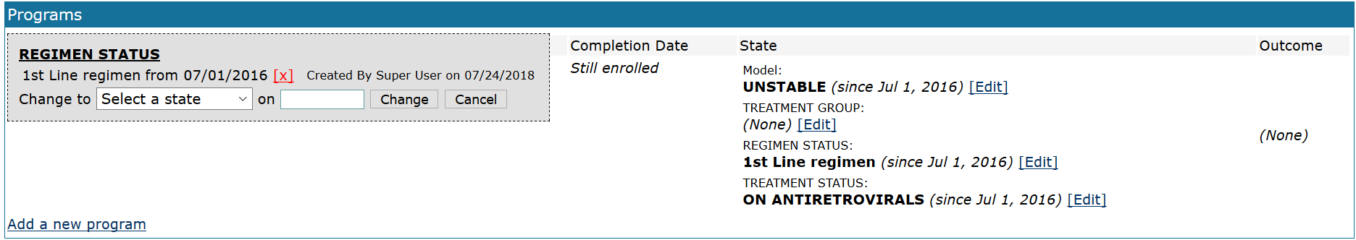

#### 2.2.1.4 Height / Weight chart: Courbe d’evolution du BMI

The growth chart is designed for patients under 18 years old. It allows easy entry of height and weight information in real time into an encounter. After entry, historical information of patient weight and height at each visit is presented in table format.

The **Height / Weight chart** is displayed on the **Overview** tab on the patient dashboard

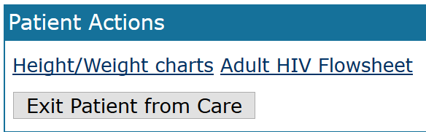

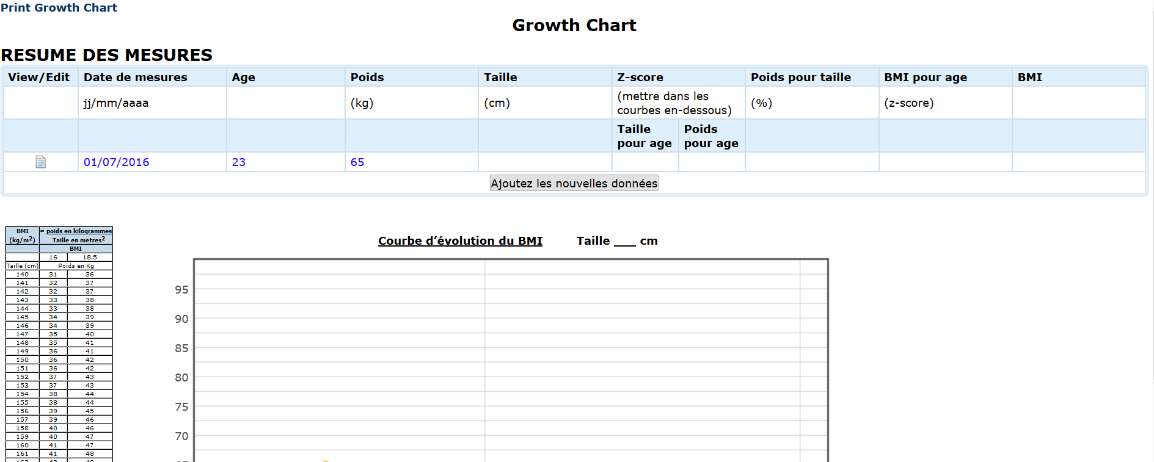

#### 2.2.1.5 Most recent observations section

User uses this section to record and view general observations for the patient.

e.g: Anthropometric measurements (height, weight), civil status, HIV test date, etc.

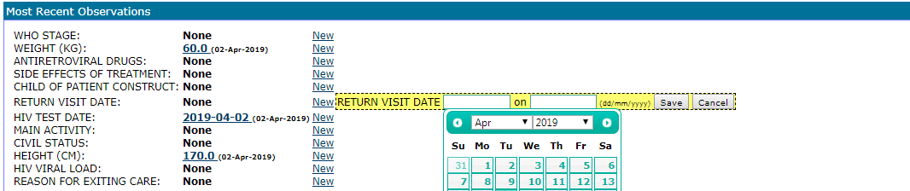

#### 2.2.1.6 Relationships

This is the patient relationship with health care providers, family members, etc. Select the person in the relationship and the relationship date, and then click on **[Save]** button.

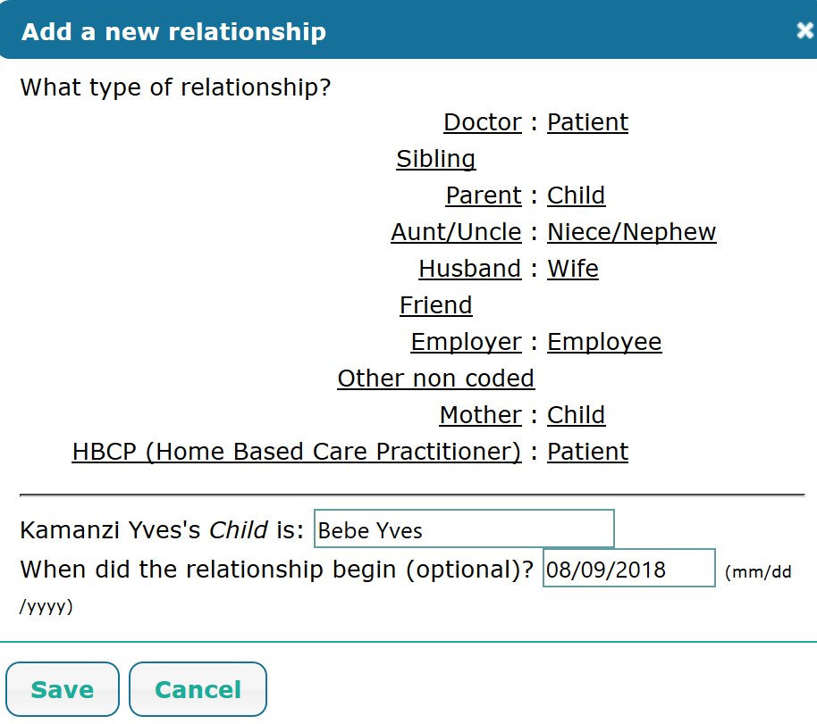

#### 2.2.1.7 Allergies section

This section is used to record and view the allergies for the patient. Fill the form and click on **[Save]** button.

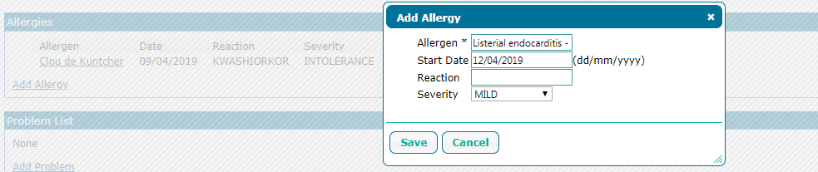

#### 2.2.1.8 Problem list section

This section is used to record and view the problems for the patient. Fill the form and click on **[Save]** button.

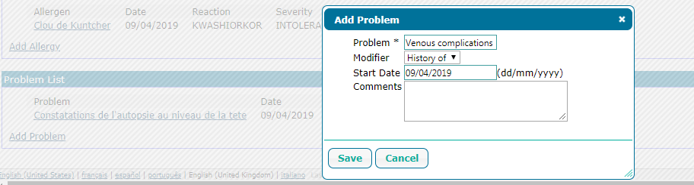

### 2.2.2 Regimens

It displays the current, future and completed patient’s regimens including calendar view. User can **add**, **edit**, **stop** or **delete** drugs from this tab.

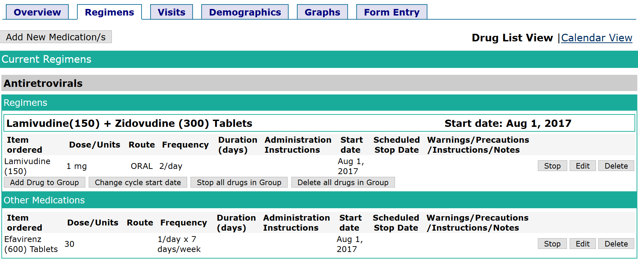

From the following form, user can select add a **pre-defined order set** (combination of drugs)

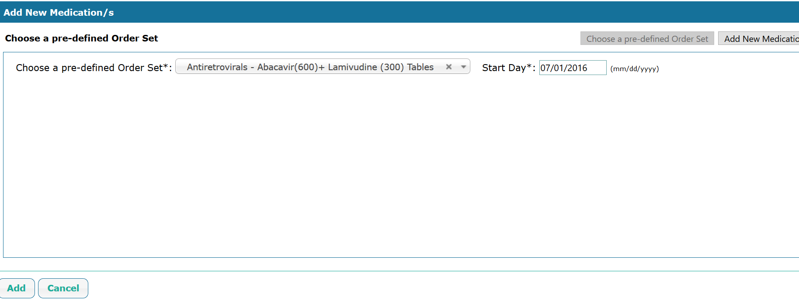

As alternative, user can add a new medication (not a combination).

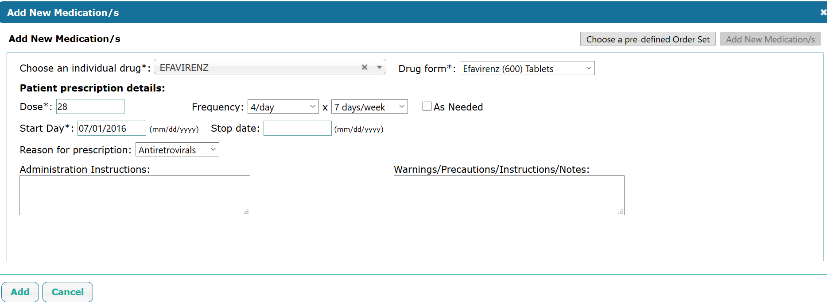

### 2.2.3 Visits

This tab displays a patient’s visits at health center or hospital attended. For each EMR form completed for a patient, a new encounter is created. Each visit with an **encounter date** and **encounter type, providers, location** and the user **(enterer)** who created the visit.

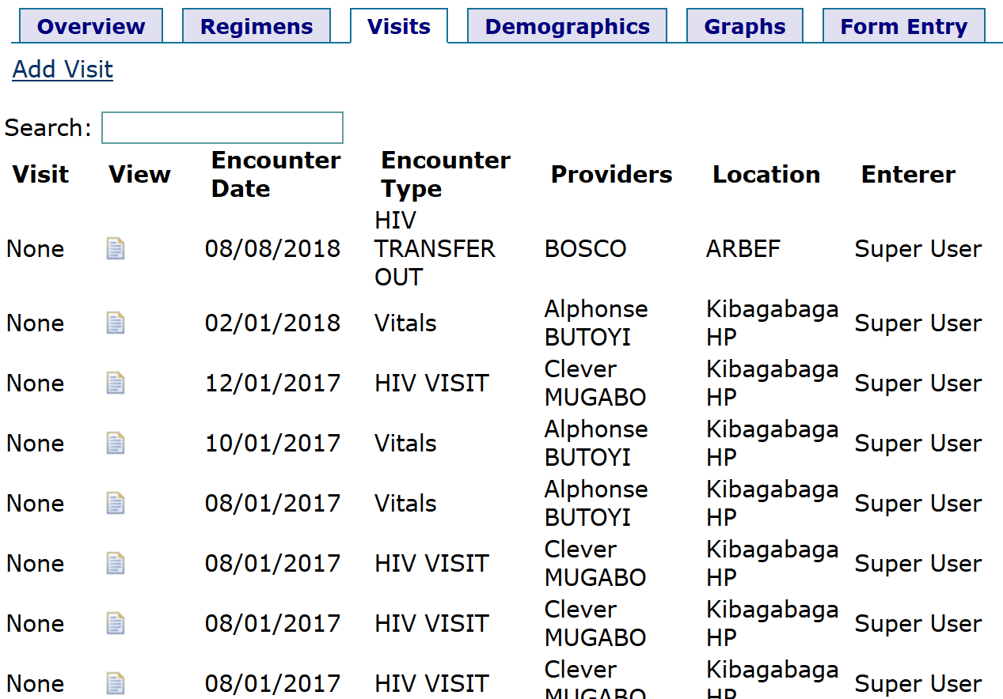

User can edit a visit from the **View** tab

### 2.2.4 Demographics

It displays patient basic information (names, address, etc). User can edit patient’s information from this tab

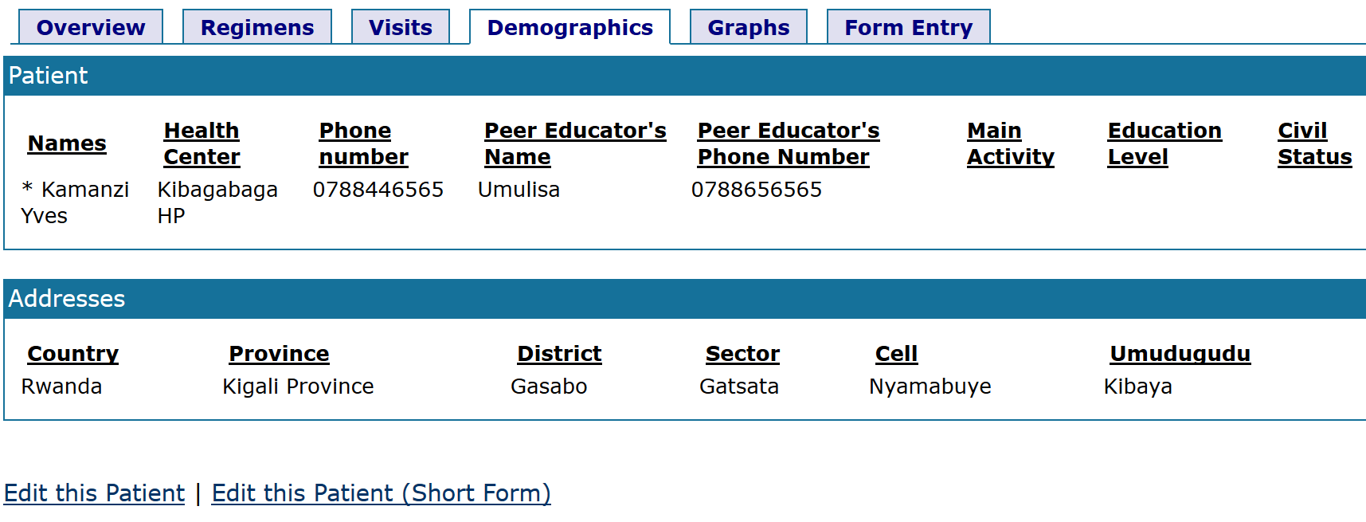

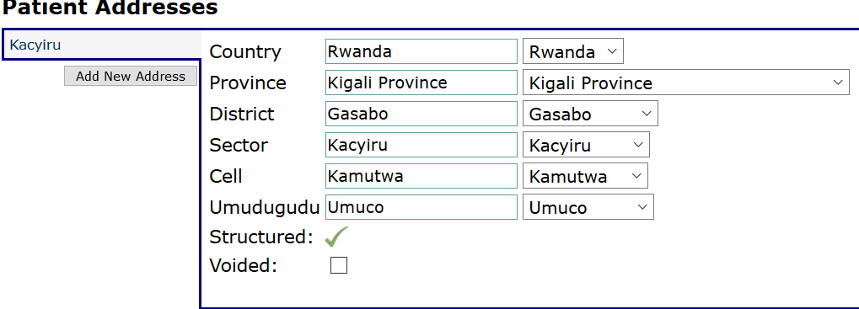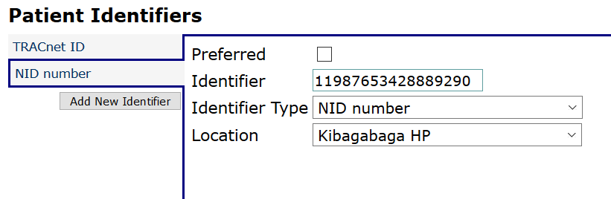

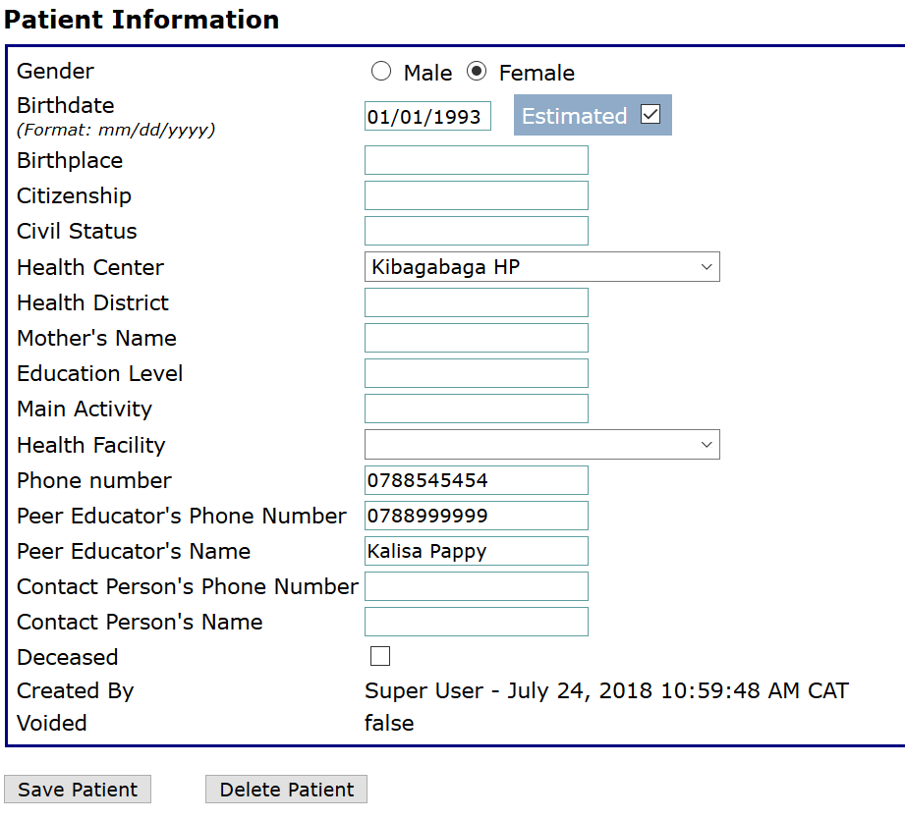

### 2.2.5 Graphs

Graphs tab displays a graphical image of a patient’s lab results

### 2.2.6 Form entry

Form entry tab lists all forms that are used in different services and programs in EMR

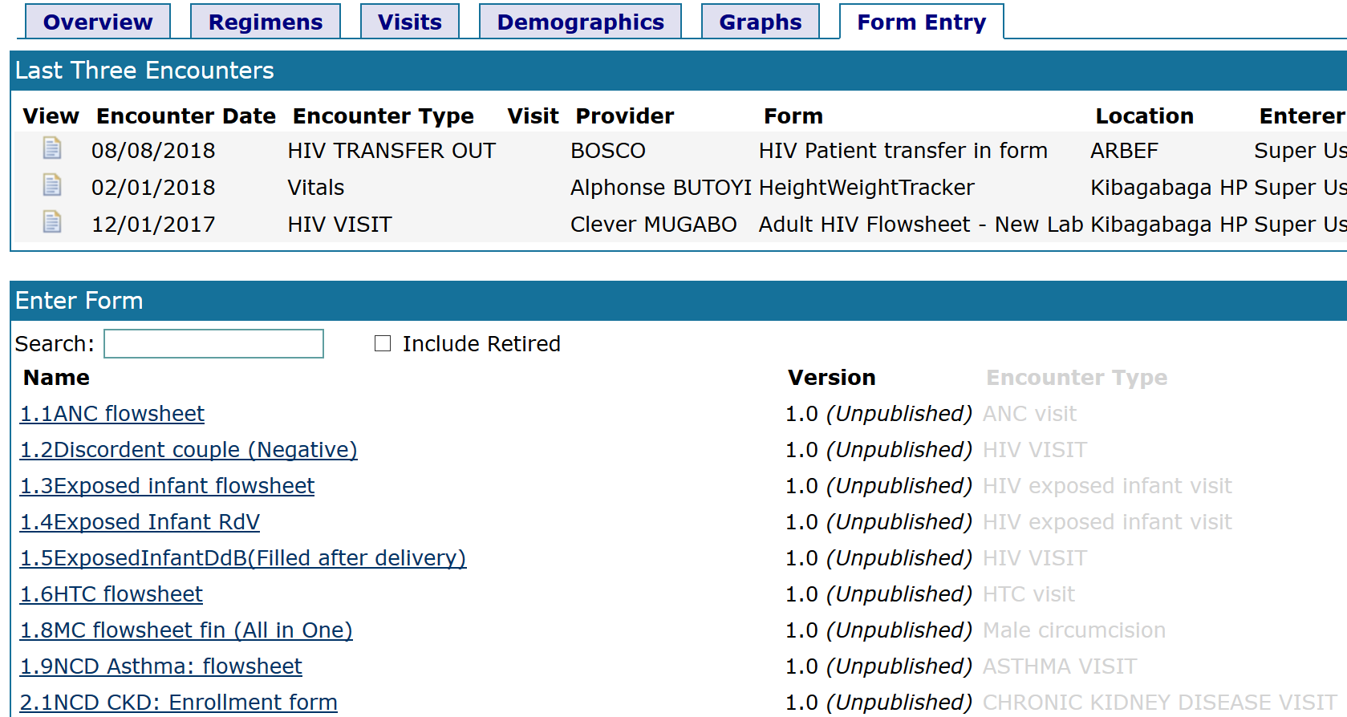

The following are the steps to navigate to the form entry selection:

**Step 1:** Log into EMR using your username and password

**Step 2:** Select a patient from **find patient** section by typing his/her name or patient identifier

**Step 3:** In case many patient are listed, select the exact patient you want from that list

**Step 4:** Click on “**form entry**” tab to have access on different forms available in the system.

**Step 5:** In **enter form** section; there is a search field you can use to search for any kind of forms based on the needed forms and services

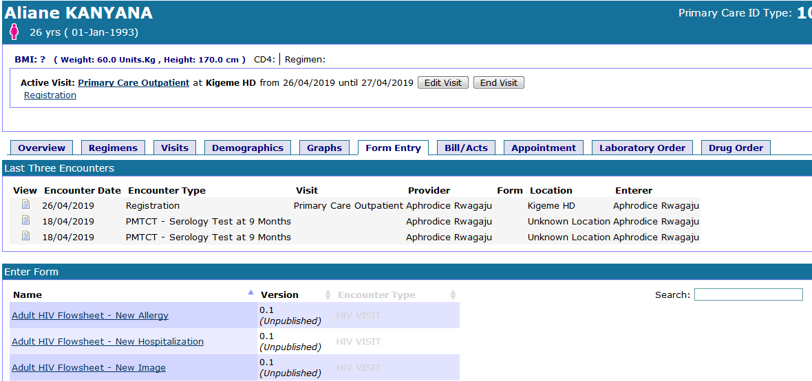

|  |  |
| --- | --- |
|  | **Items description**   1. **Patient details:** it displays the current selected patient 2. **Form listing:** displays a list of all possible forms 3. **Form entry tab:** click on the tab to access forms 4. **Search:** It is used to search for form by typing its name or any content on its name. |

#### 2.2.6.1 Using forms

**2.2.6.1.1 Adult / Pediatric HIV flowsheet**

After a patient’s enrollment to a program for example **HIV care and treatment program**, an **Adult HIV flowsheet** is displayed on the **Overview** tab

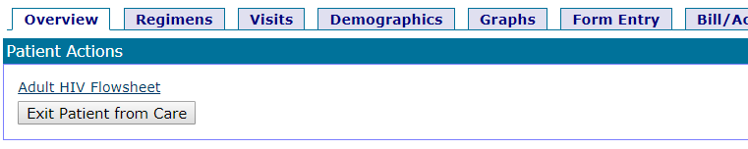

* 1. **Regimens**

This page helps only to visualize the patient’s regimen and it cannot be edited. To add a new regimen, go to **Regimen** tab on the patient dashboard and edit or create new regimen). This page can be printed out.

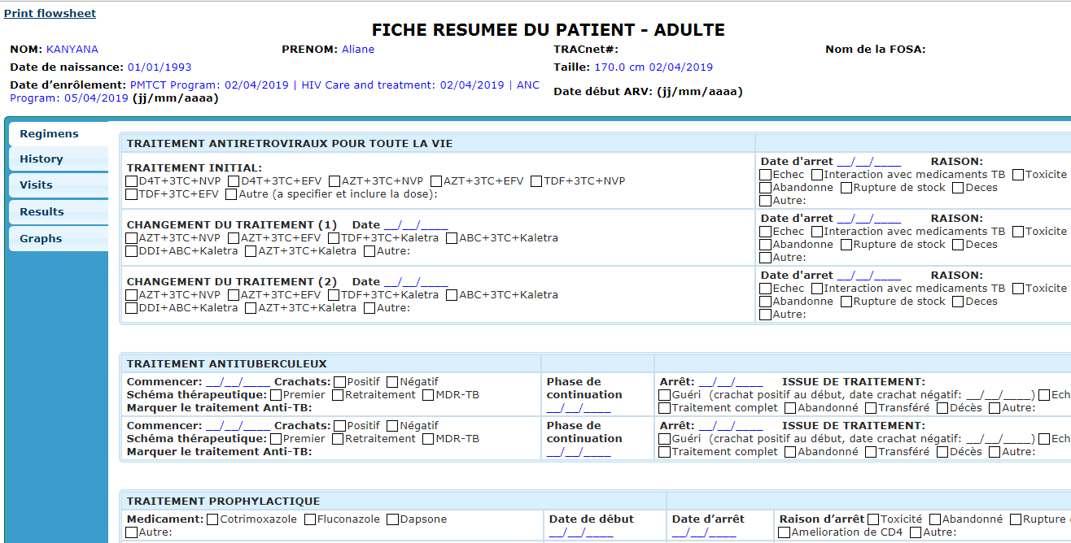

* 1. **History**

It displays allergies, hospitalization, IO & chronic of a patient. You can also add new allergies, hospitalization, IO & chronic

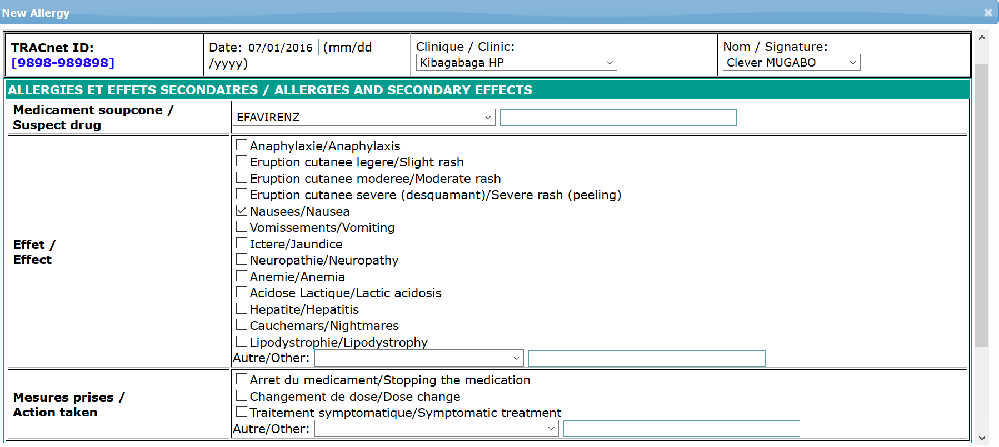

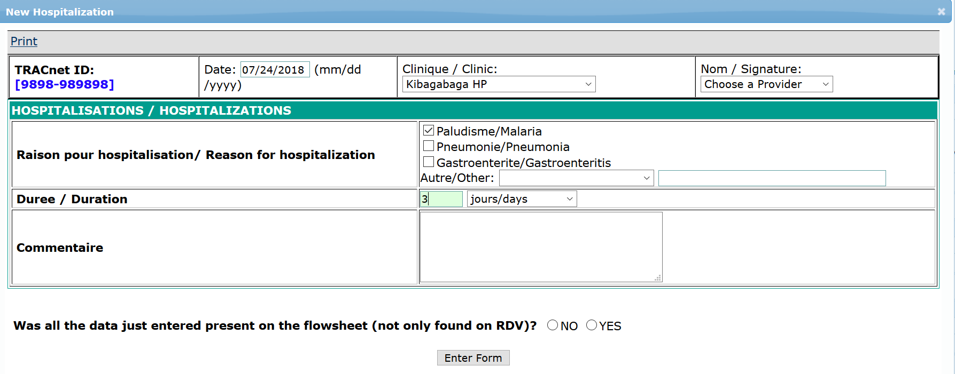

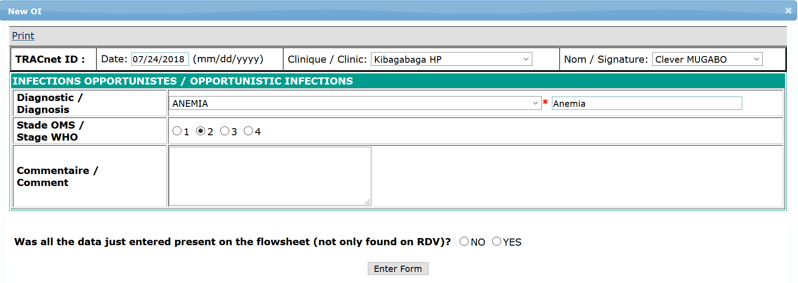

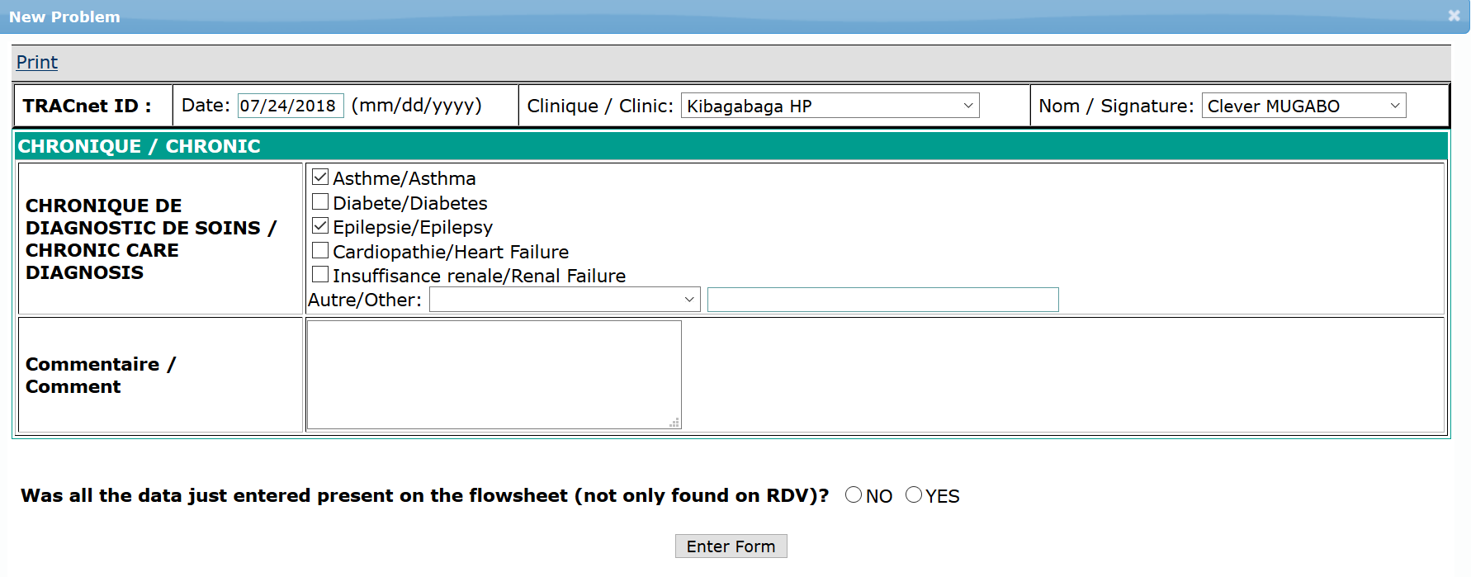

* 1. **Visits**

Visits form displays the summary of all the visits of a patient at a health facility.

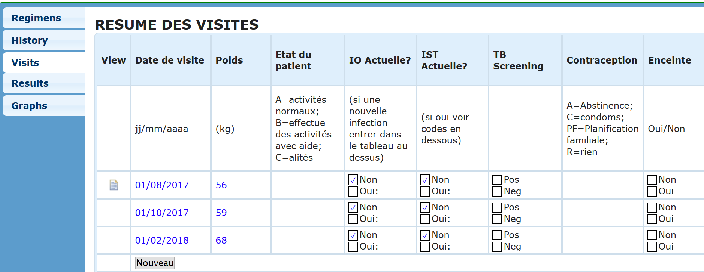

* 1. **Results**

It displays lab exams and results.

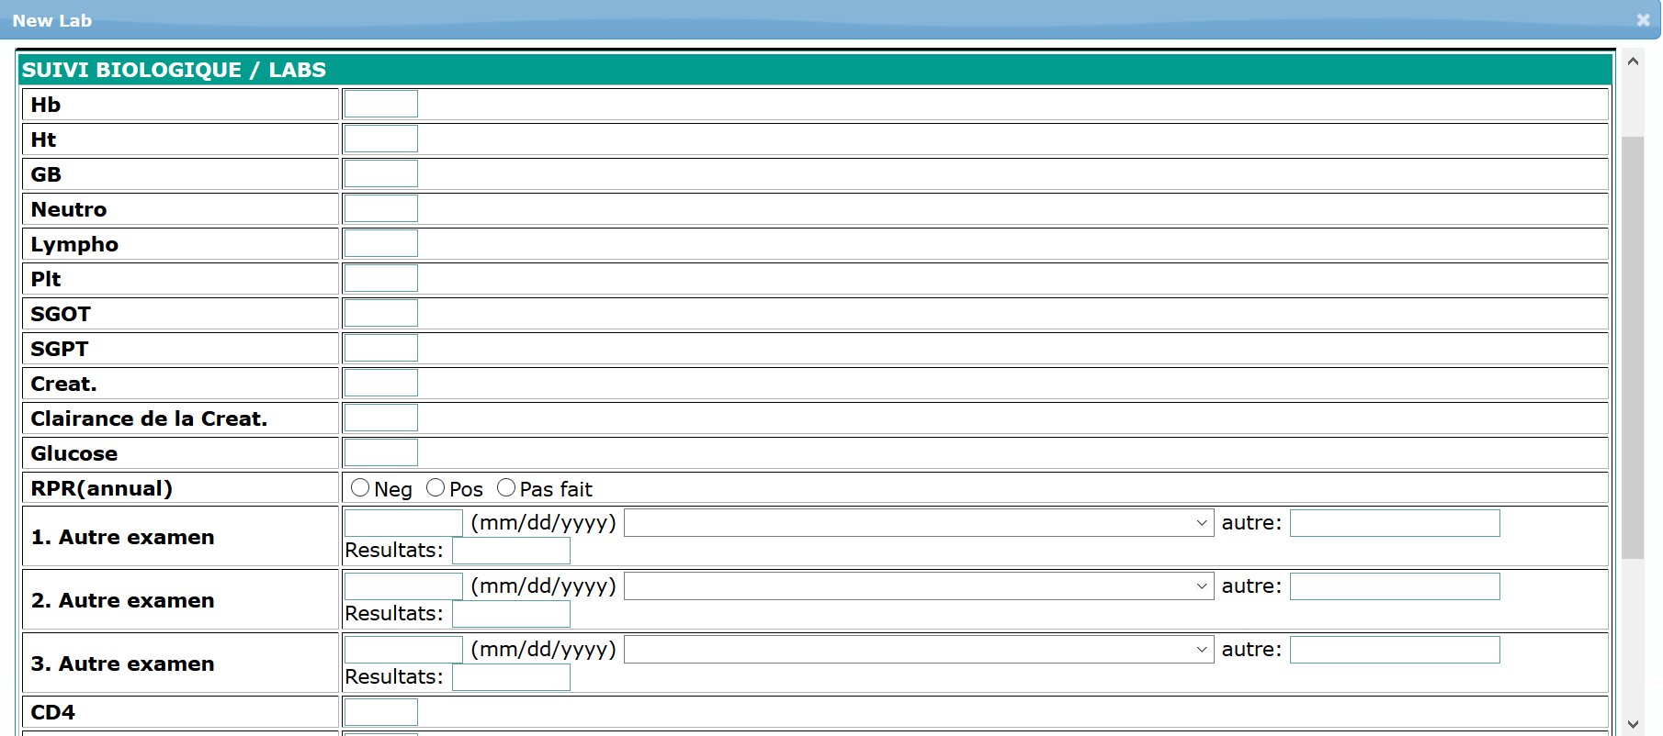

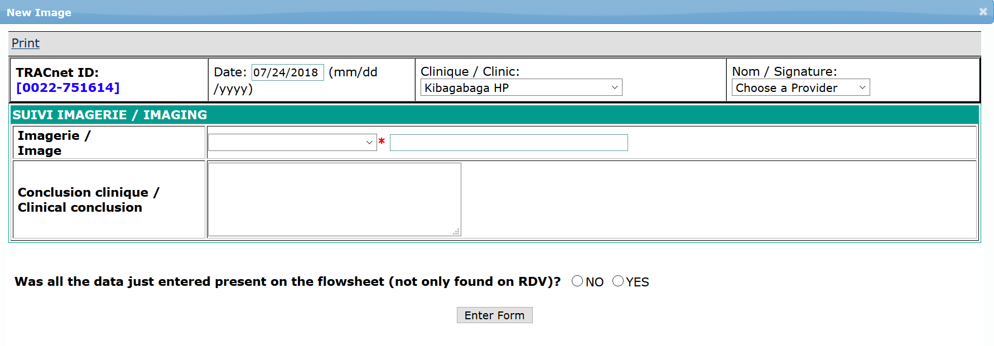

* 1. **Graphs**

Graphs form displays a graphical image of a patient’s lab results.

**2.2.6.1.2 HIV Patient Transfer in Form**

**Find the patient** and go to **Form Entry**

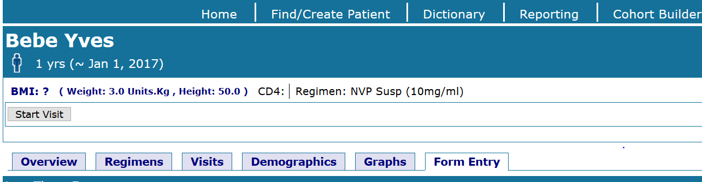

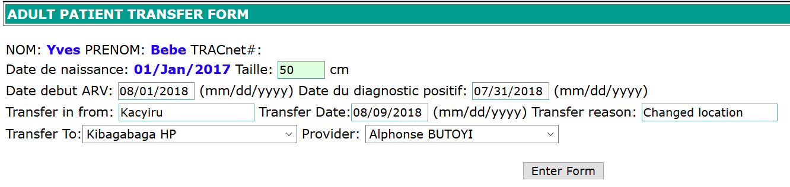

Once clicked on **Adult / Ped flowsheet** a new window pops up with different vertical tabs.

|  |  |
| --- | --- |
|  | **Available tabs and description**   1. **Regimens:** displays the ARVs treatment of a patient 2. **History:** displays allergies, hospitalization, IO & chronic of a patient 3. **Visits:** displays the summary of all the visits of a patient 4. **Results:** displays lab exams & results 5. **Graphs:** displays a graphical image of a patient’s lab results |

**2.2.6.1.3 Exit patient from care**

Exiting a patient from care is done from the ‘**Overview’** tab. It is used to change one patient’s state to another (eg: From active to died, transferred, etc).

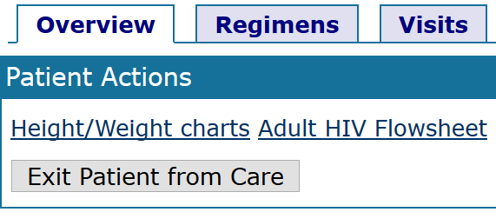

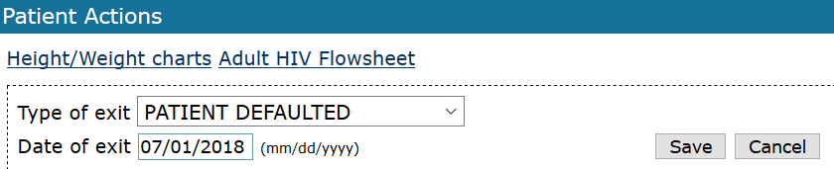

Complete the reason why a patient is exiting from current state and the date of exit then save the changes.

|  |  |
| --- | --- |
| Image result for information icon | **Note:**  There are many different reseans for exiting care. The user shose from the list based on patient state.   1. Patient HIV negative 2. Patient defaulted 3. Patient refused 4. Patient died 5. Patient transferred out] 6. Patient cured 7. Other cause of exit |

#### 2.2.6.2 Specific programs

**2.2.6.2.1 HIV testing and counselling (HTC)**

HTC services include both Voluntary HIV counselling and testing (VCT) and Provider Initiated counselling and testing (PIT). VCT services are provided to the client who decides on his / her own to undertake HTC while PIT services are when the health care providers offer HTC for a client who consulted for any other health problem.

**Steps**:

1. Log into EMR using your username and password
2. Click on “**Find/Create a patient**” menu from main menu
3. Find a patient from search field available on opened form.
4. Click on “**Form entry**” tab
5. Find the “**HTC flowsheet**”

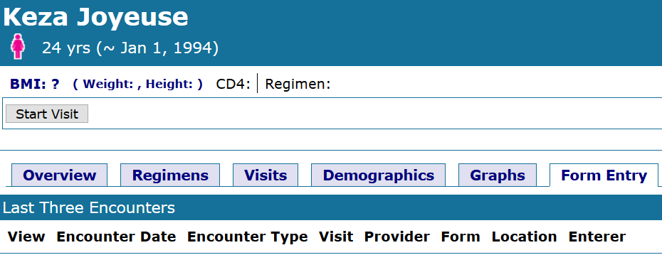

Find ‘**HTC Flowsheet’**

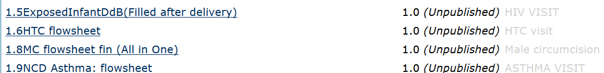

**2.2.6.2.1.1 VCT / PIT Counselling**

First update the **clinic** and the **date,** then click on Add new on **VCT counselling and testing**

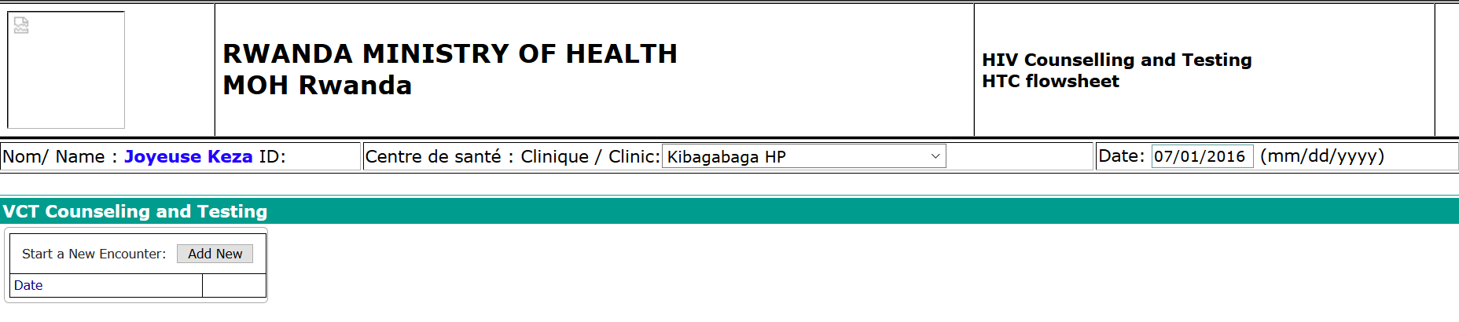

Update the **provider**, **type of counselling** and enter form

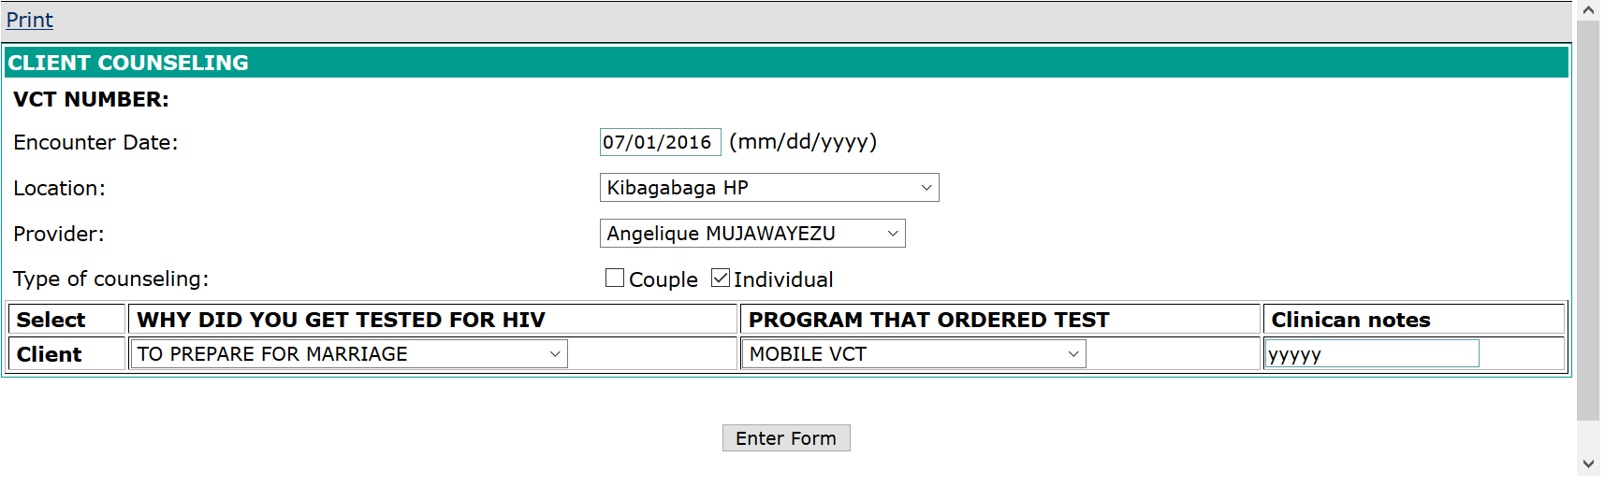

**2.2.6.2.1.2 HTC Testing**

Add new HTC testing

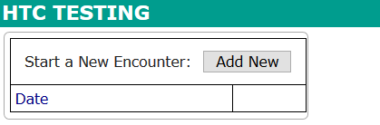

Complete the testing code and enter the form

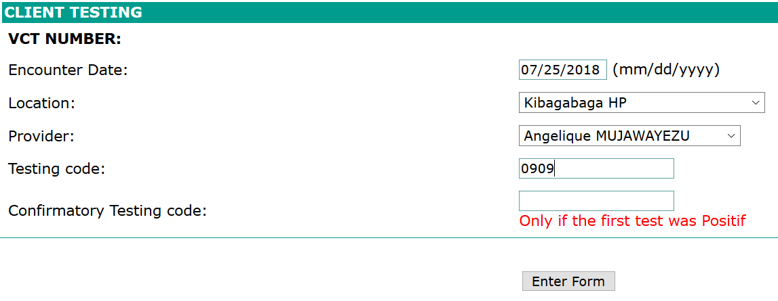

**2.2.6.2.1.3 HTC Results**

If the first result is positive, a confirmatory test will be required.

**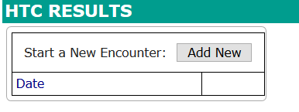  
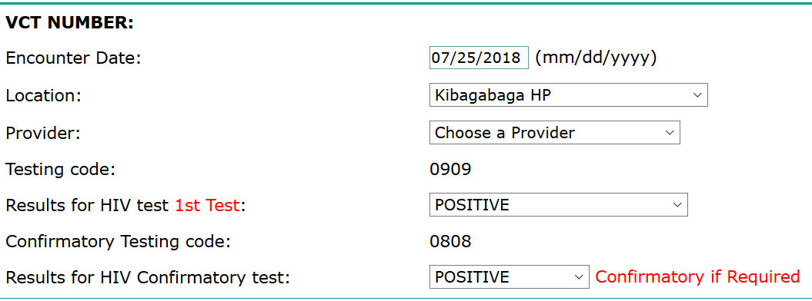**

**2.2.6.2.1.4 HTC reception**

Once a patient has received his / her testing results and are **Positive**, he / she is counselled and the patient can choose to be enrolled in the HIV care and treatment program.

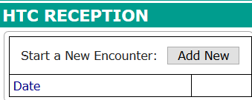

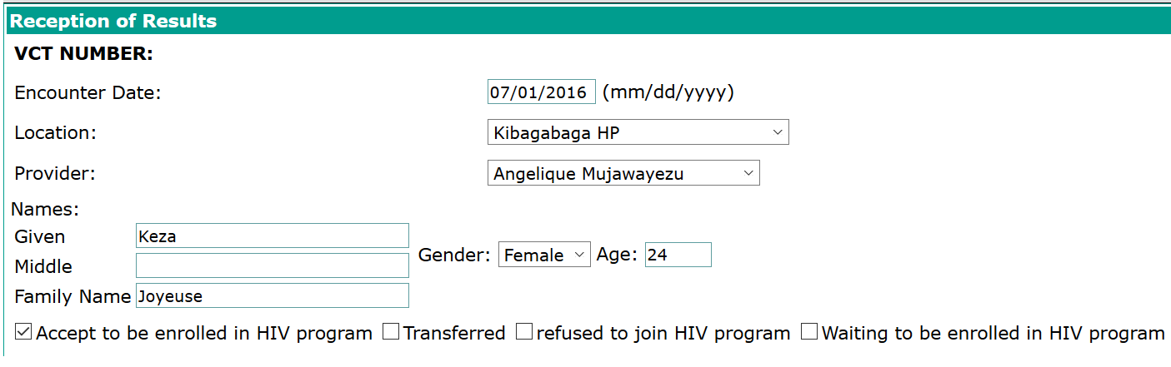

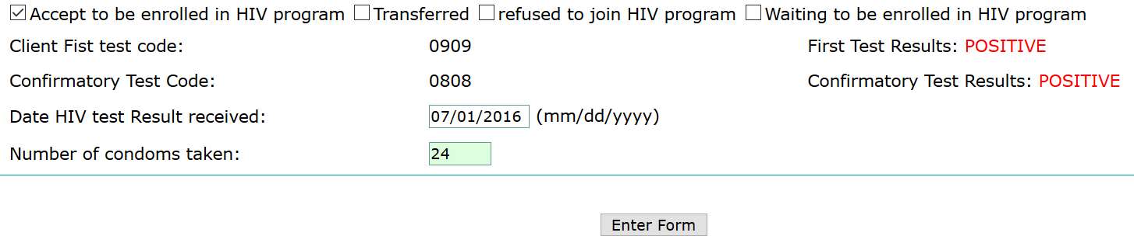

**2.2.6.2.1.5 HTC patient enrollment**

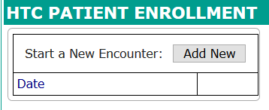

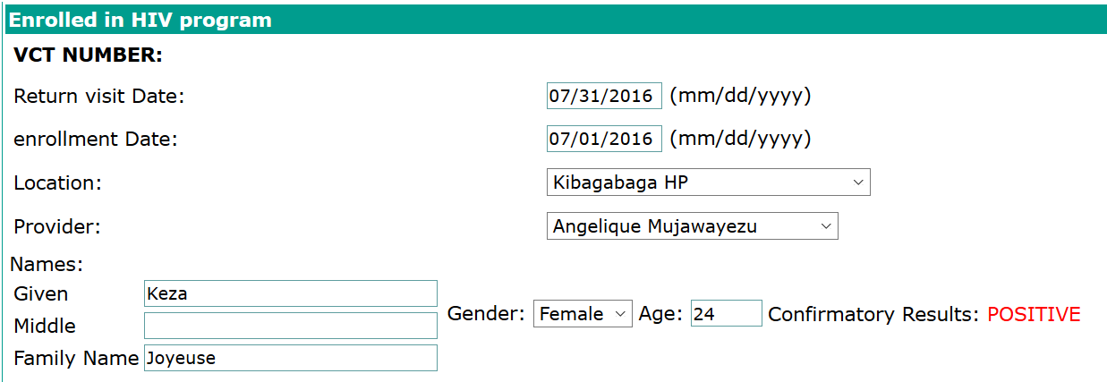

**2.2.6.2.2 PMTCT program**

Prevention of Mother-To-Child Transmission (PMTCT) program follows a HIV positive mother during pregnancy, labor, delivery and during breastfeeding to reduce the transmission of HIV from HIV-infected pregnant women to their babies.

**Steps**:

1. Log into EMR using your username and password
2. Click on “**Find/Create a patient**” menu from main menu
3. Find a patient from search field available on opened form
4. Click on “**Form entry**” tab

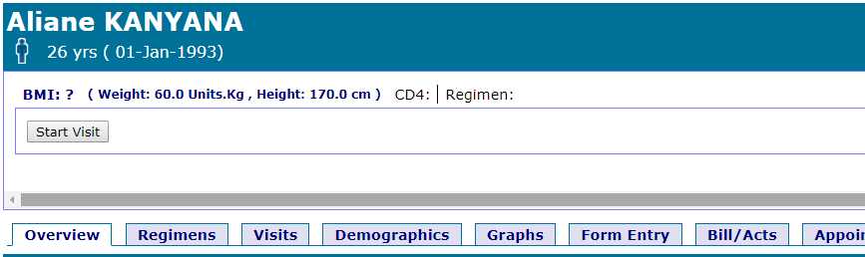

Search PMTCT forms by typing “**pmt**” in search field

PMTCT uses 3 flowsheets, one for PMTCT **enrollment**, **during delivery** and **after delivery.**

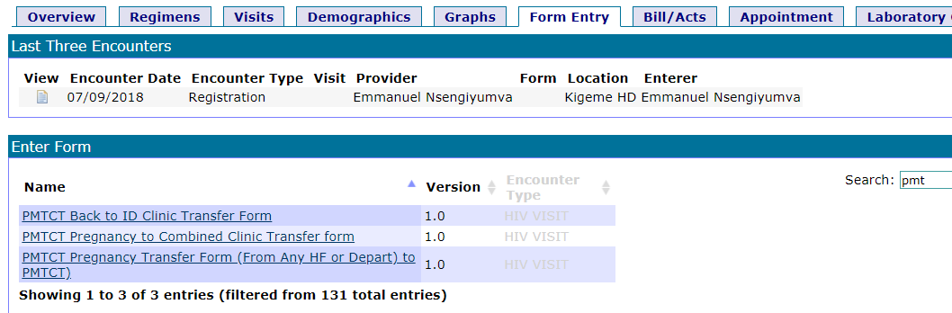

Form search results

**2.2.6.2.2.1 PMTCT Pregnancy Transfer Form**

This is a transfer form (from any service, department or another health facility) to enrollment in PMTCT program.

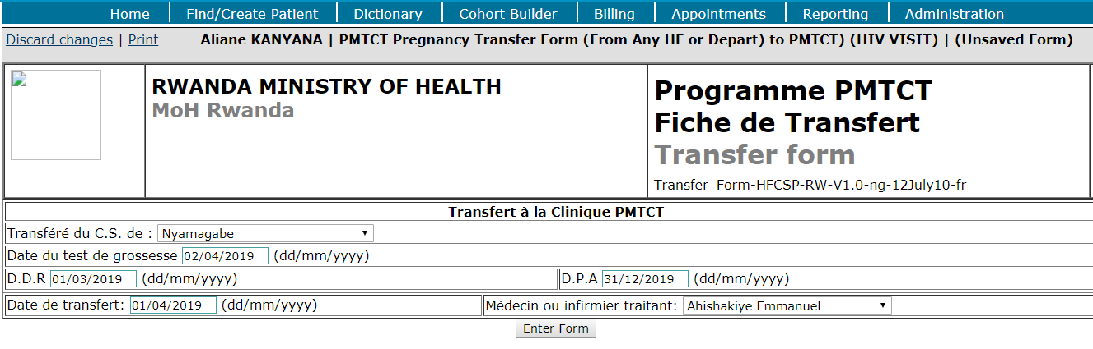

**DDR** = Date de Dernier Regles (Last menstrual period)

**DPA** = Date Probable d’Accouchement (Expected delivery date)

After saving the form, the patient is automatically enrolled in **PMTCT Program**.

For verification of the current program of this patient, go to “**Overview”** to see the patient’s dashboard

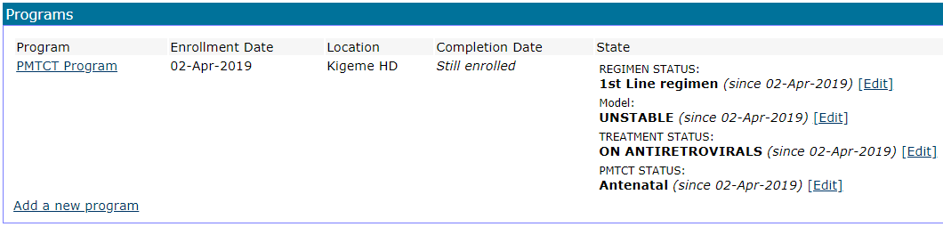

User can edit the treatment and PMTCT status at this stage

**2.2.6.2.2.2 PMTCT Pregnancy to Combined Clinic Transfer Form**

This form is used during delivery

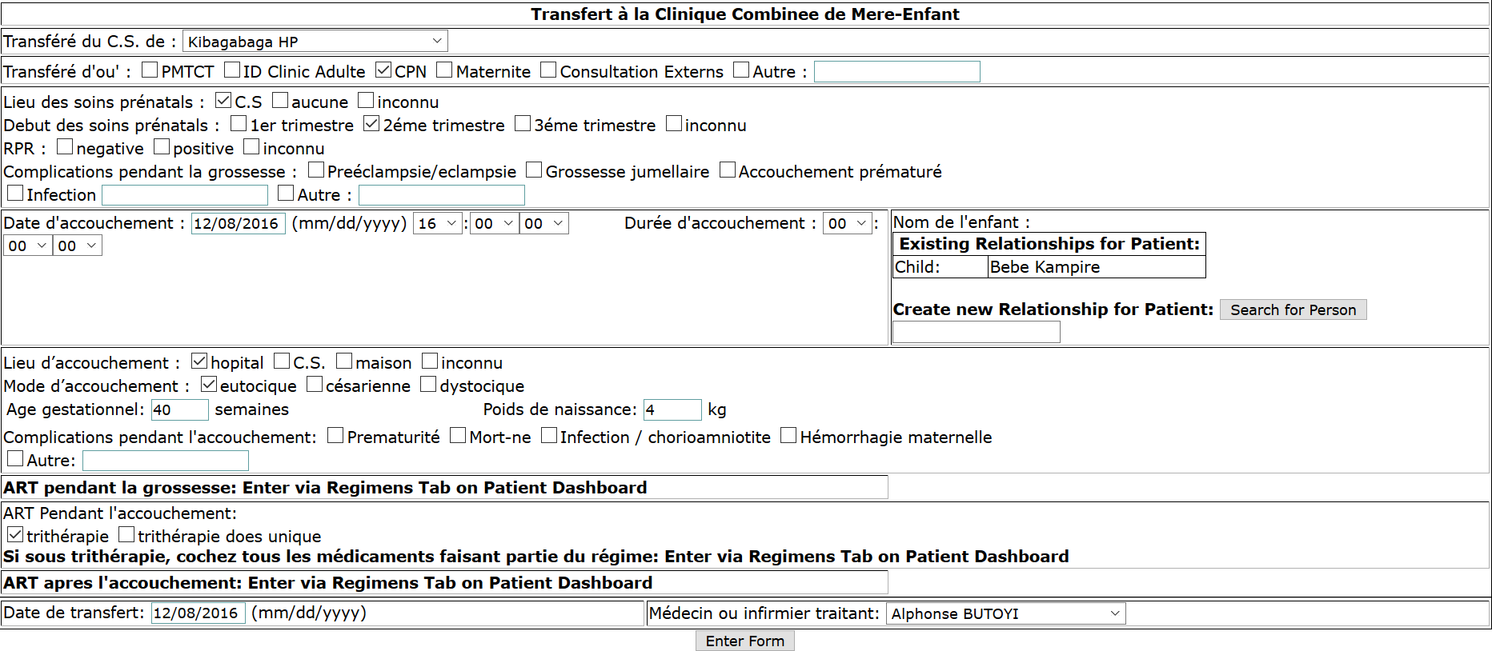

**2.2.6.2.2.3 PMTCT Back to ID Clinic Transfer Form**

This form is used to exit the patient from the PMTCT program, back to HIV Care and Treatment.

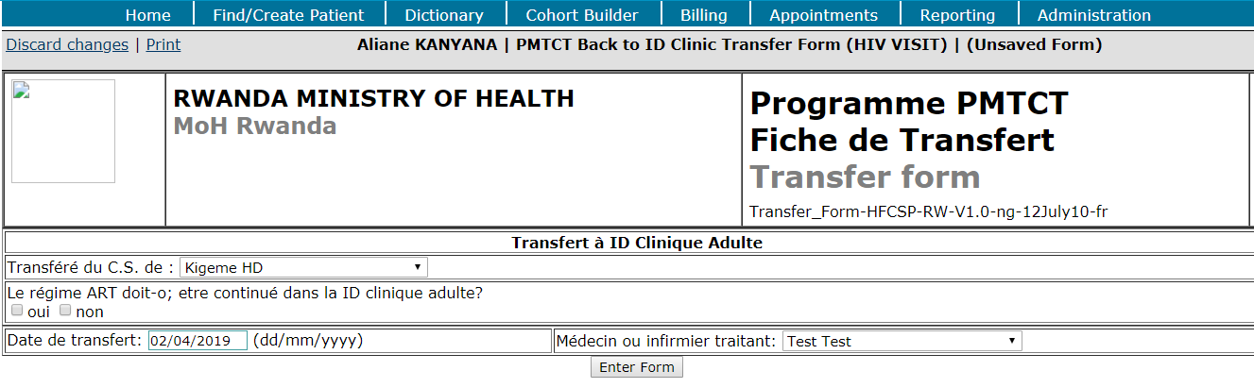

On the patient dashboard, PMTCT program is completed while ANC & HIV care and treatment program are still open.

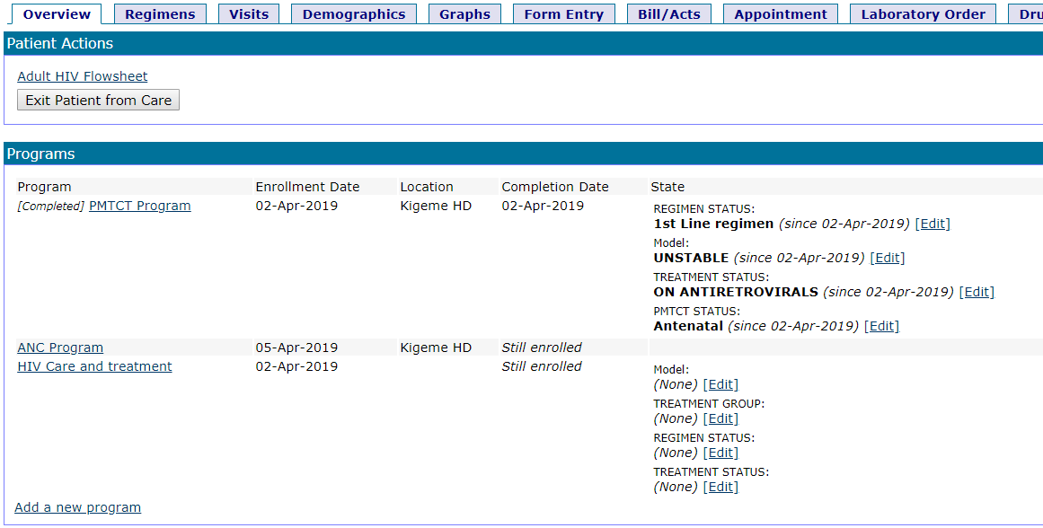

**2.2.6.2.3 EXPOSED INFANT FORMS**

**2.2.6.2.3.1 Exposed Infant Donnees de Base (Filled after delivery)**

**Steps**:

1. Log into EMR using your username and password
2. Click on “**Find/Create a patient**” menu from main menu
3. Create a patient **if not exist in the EMR** (see the form bellow)

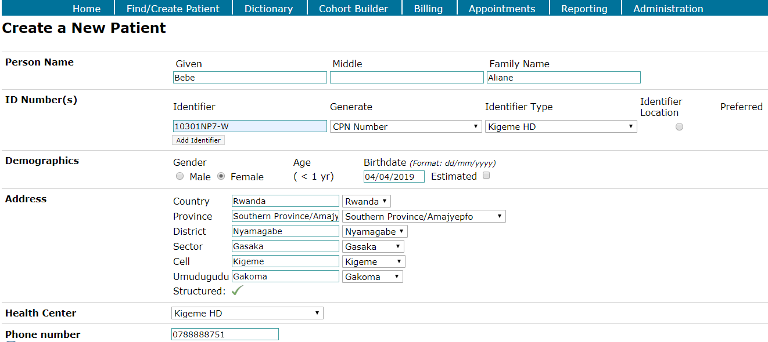

1. Find a patient from search field available on the opened form
2. Set the relationship between mother and child as described in the following sub steps
   1. Click on “**Add new relationship**” link
   2. Click on “**Parent**” link of “**Parent:Child**” in relationship section from “**overview**” tab
   3. Search by parent ID or name and select start date of relationship and save.

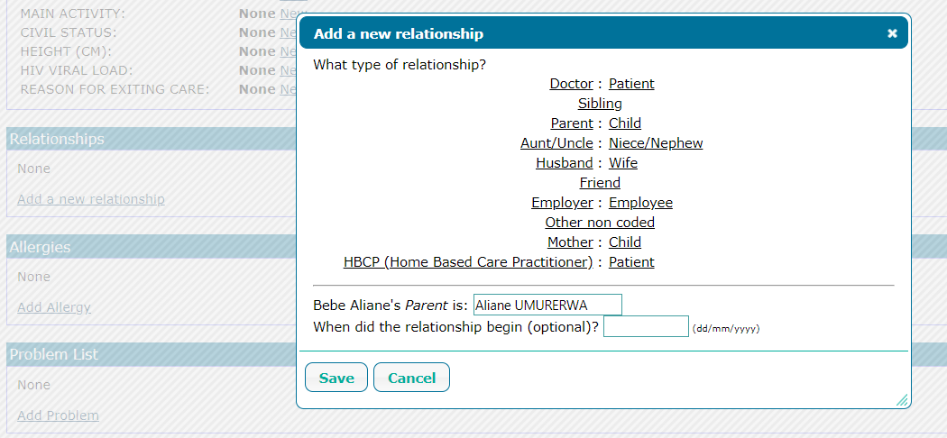

1. Click on “**Form entry**” tab
2. Type “**Exposed**” in form search field

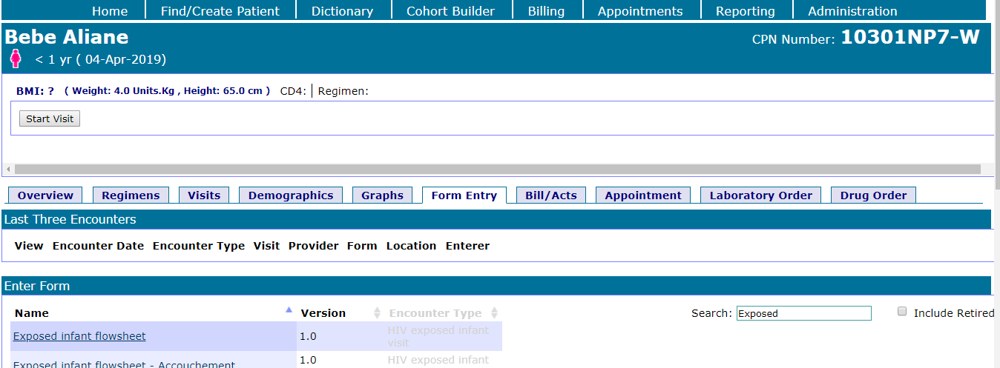

1. Select “**ExposedInfantDbB(Filled after delivery)**” link to open the form

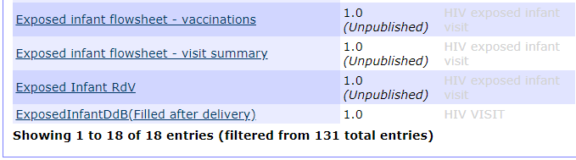

1. Fill the following form and save it.

This form is only filled after delivery

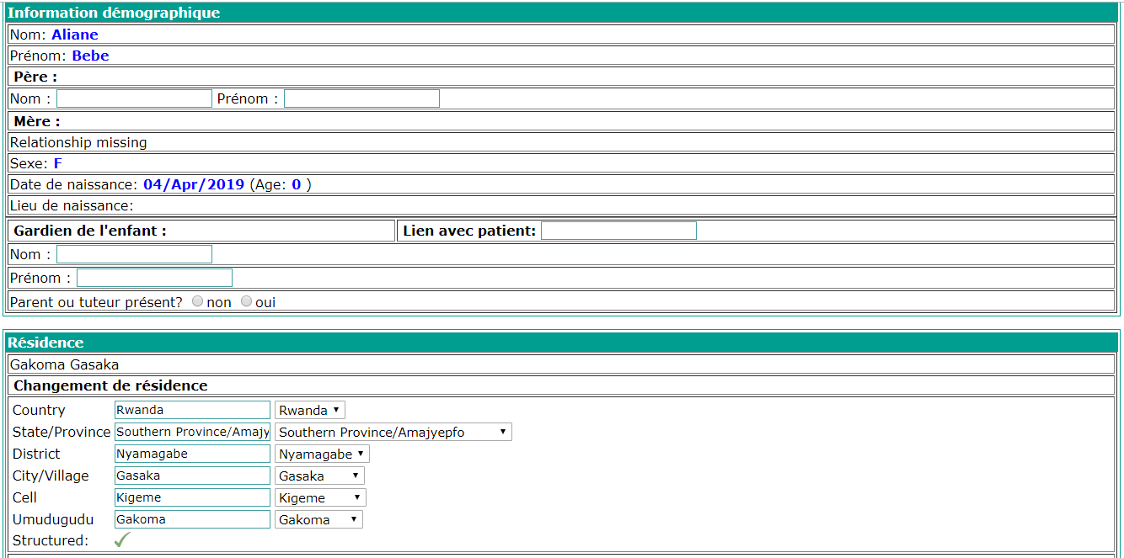

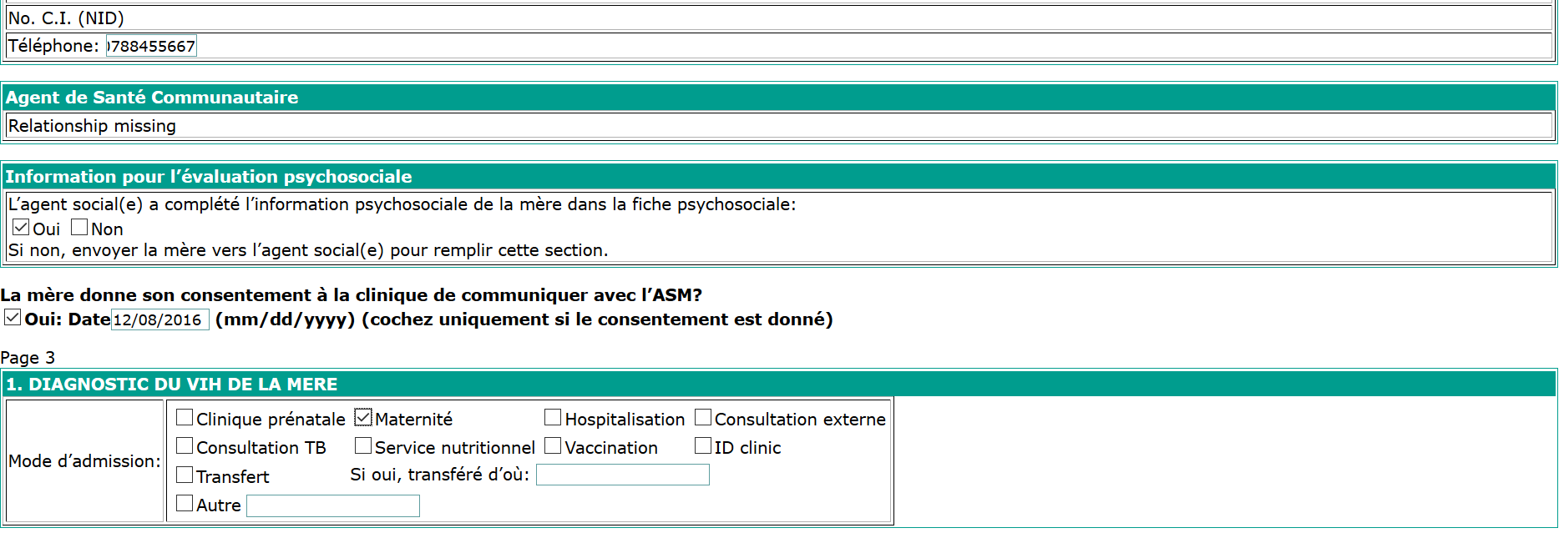

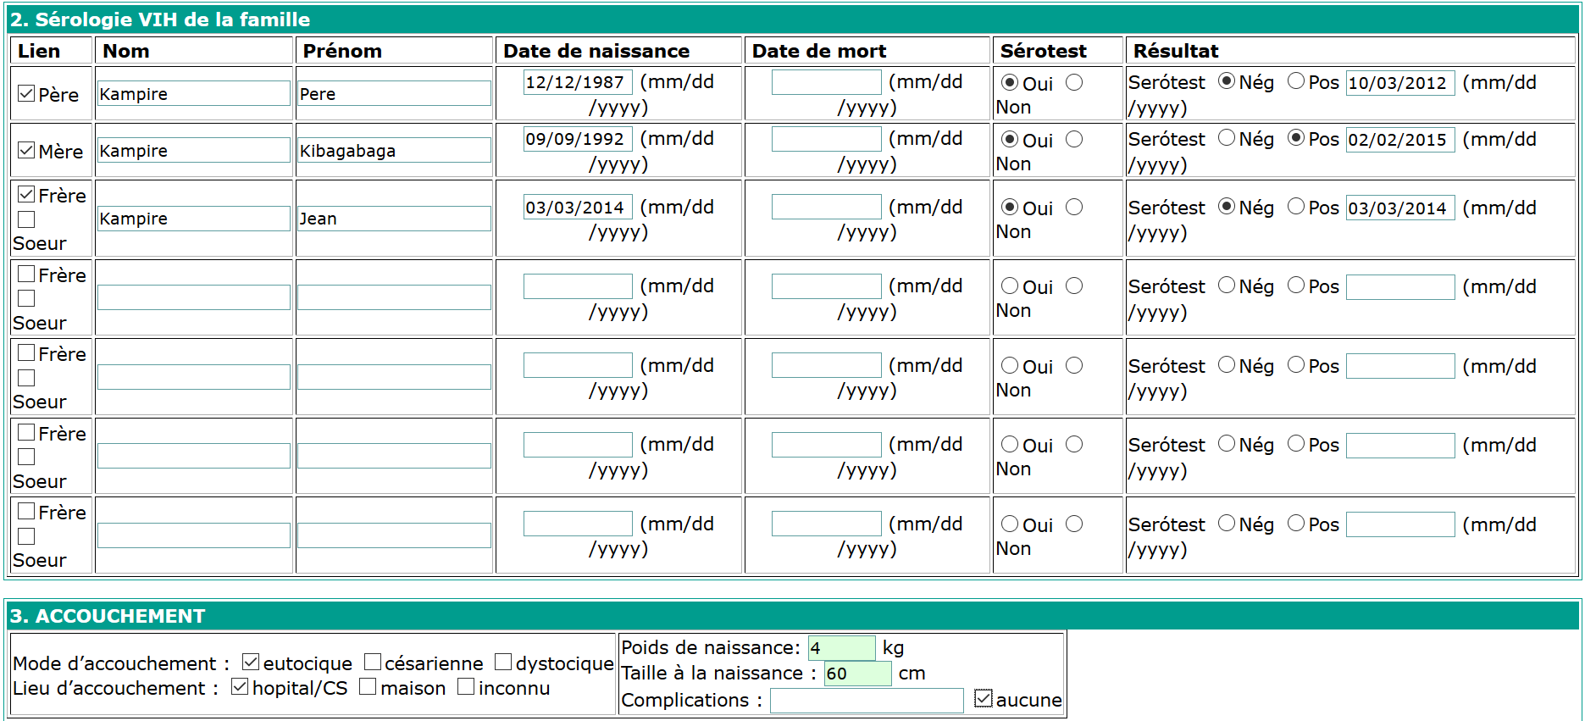

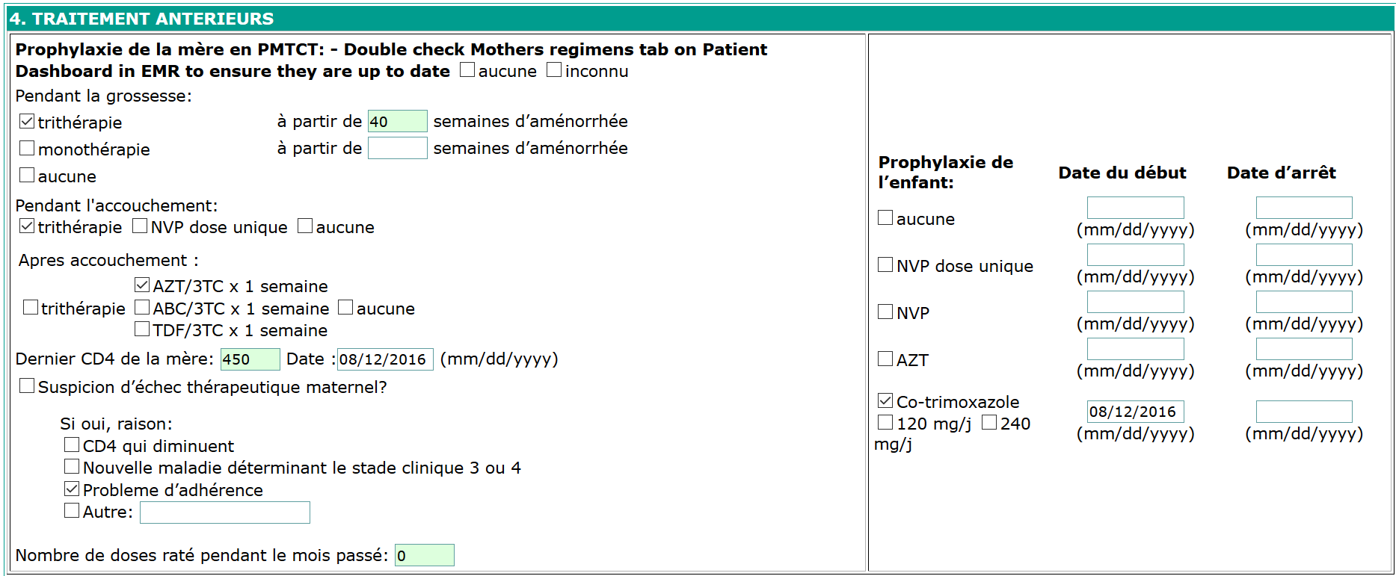

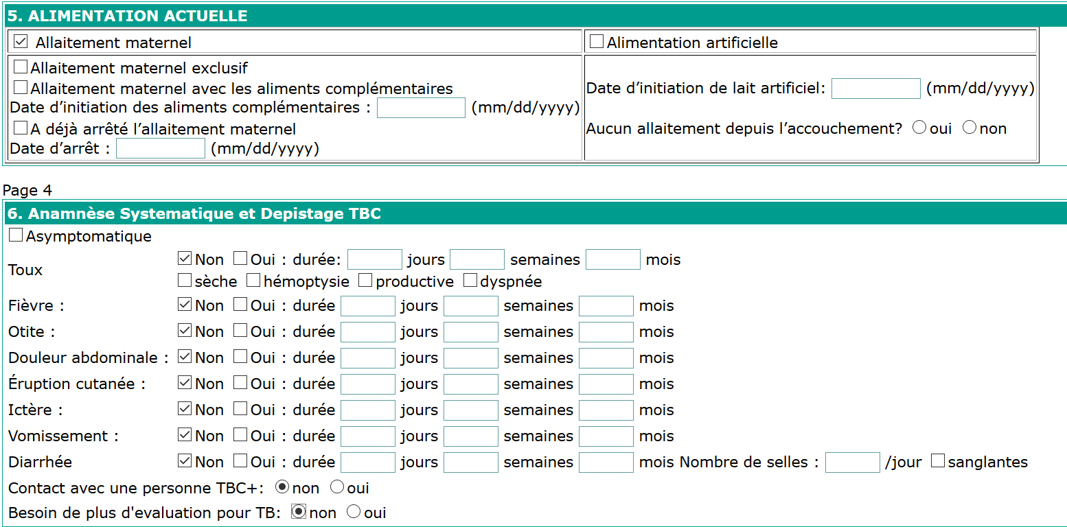

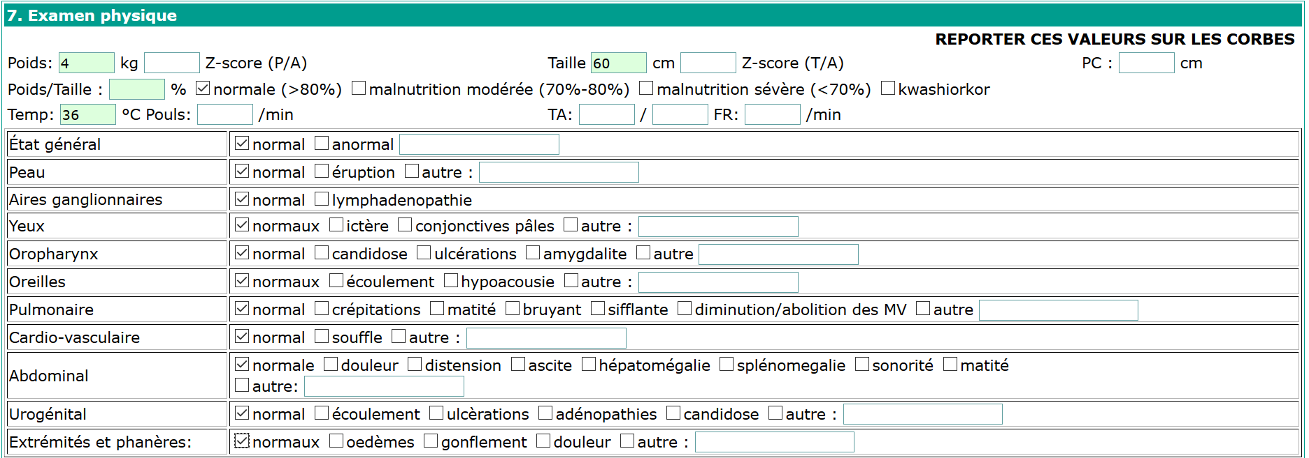

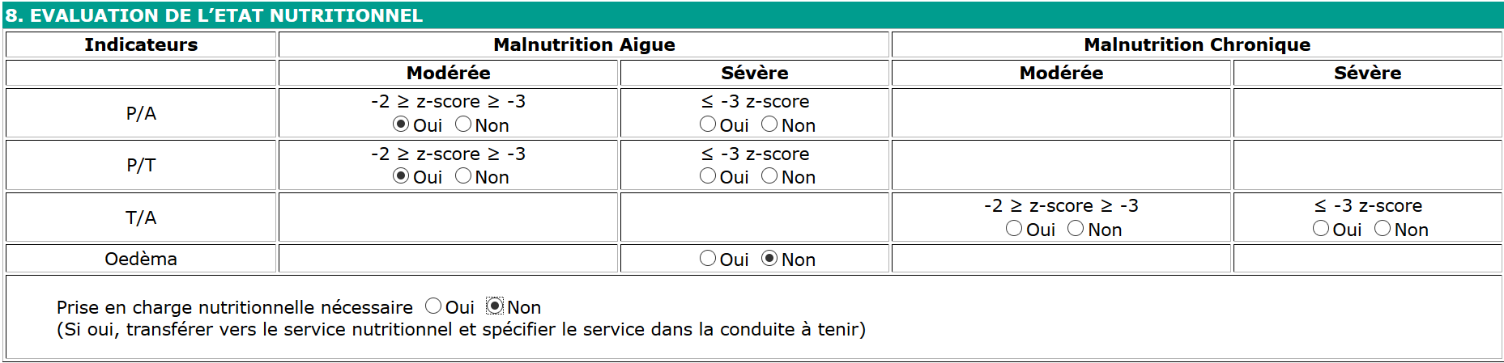

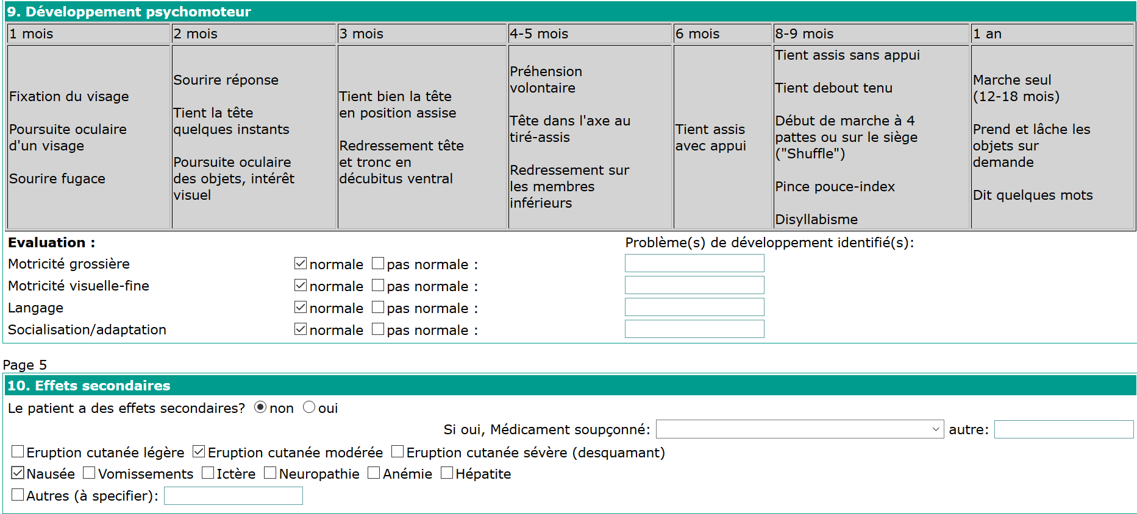

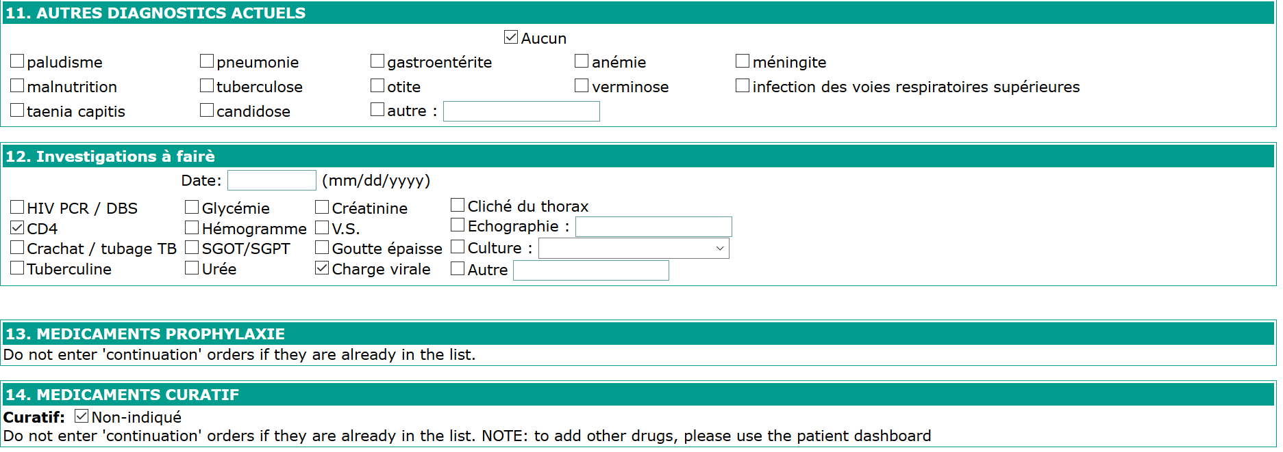

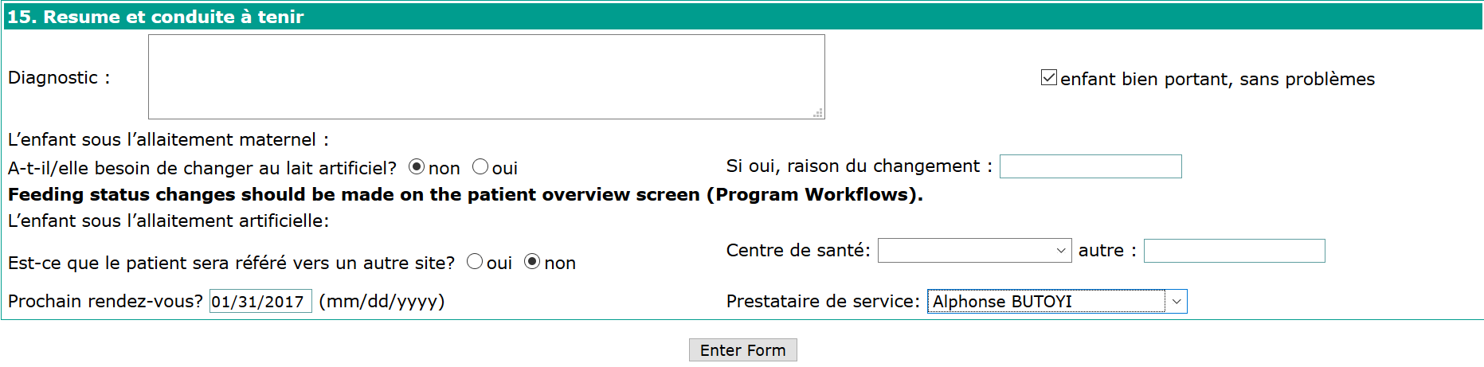

**2.2.6.2.3.2 Exposed Infant Flowsheet**

These are the forms used for the HIV exposed infant up to 24 months

* 1. **Information demographique, serologie de la famille & Accouchement**

This information was completed in the first form of exposed infant “donnees de base”.

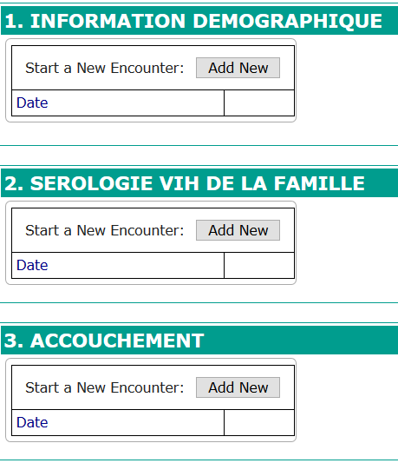

**2.2.6.3.2.3.3 Anamnese systematique et depistage TBC de l’enfant**

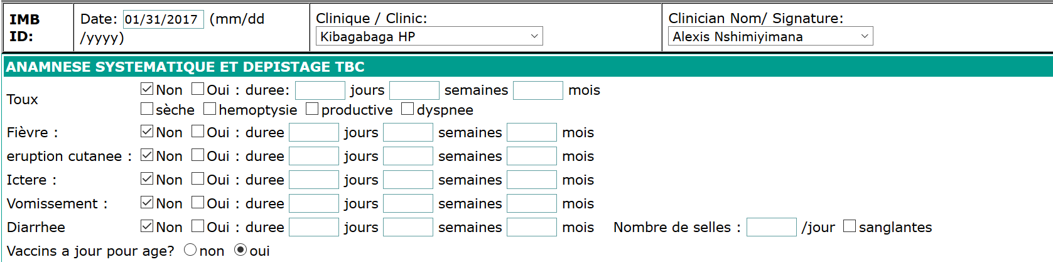

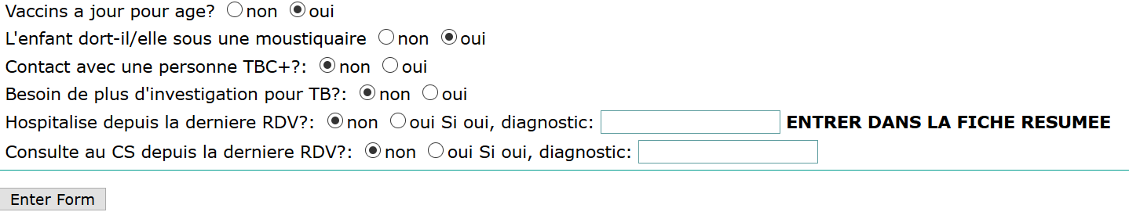

**2.2.6.3.2.3.4 Examen Clinique**

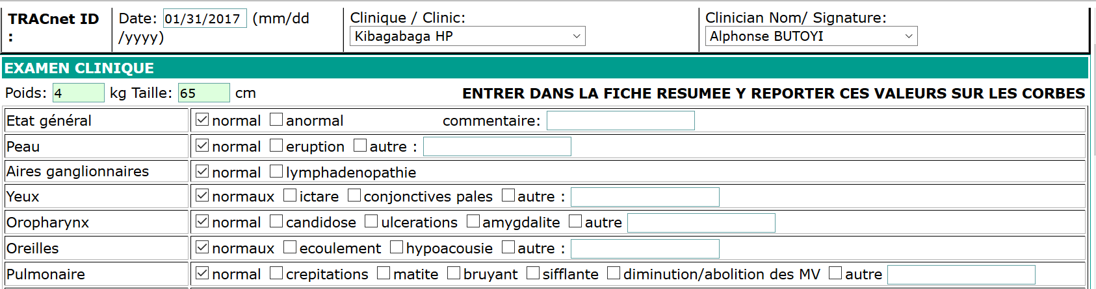

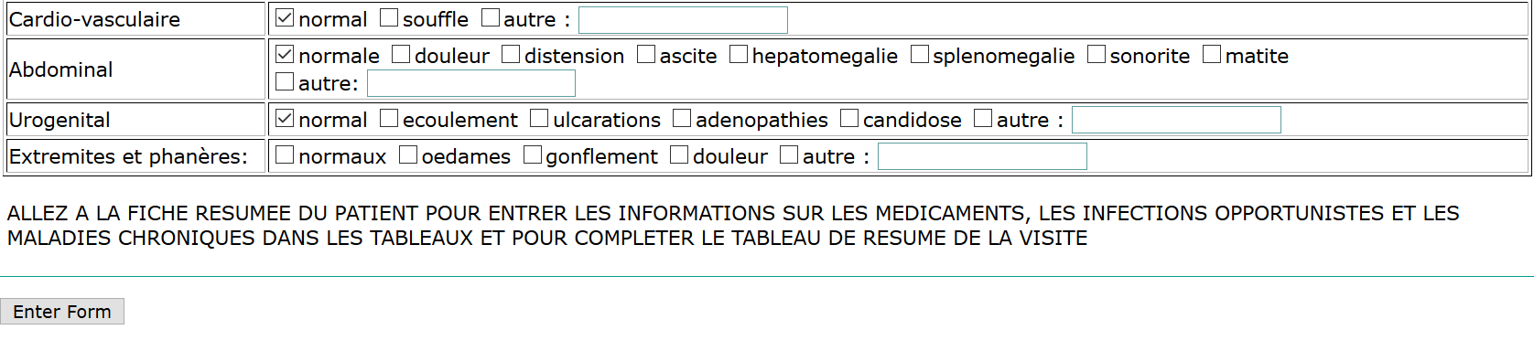

**2.2.6.3.2.3.5 Infection opportuniste et autres maladies**

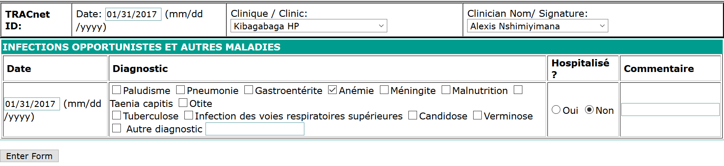

**2.2.6.3.2.3.6 Prophylaxis**

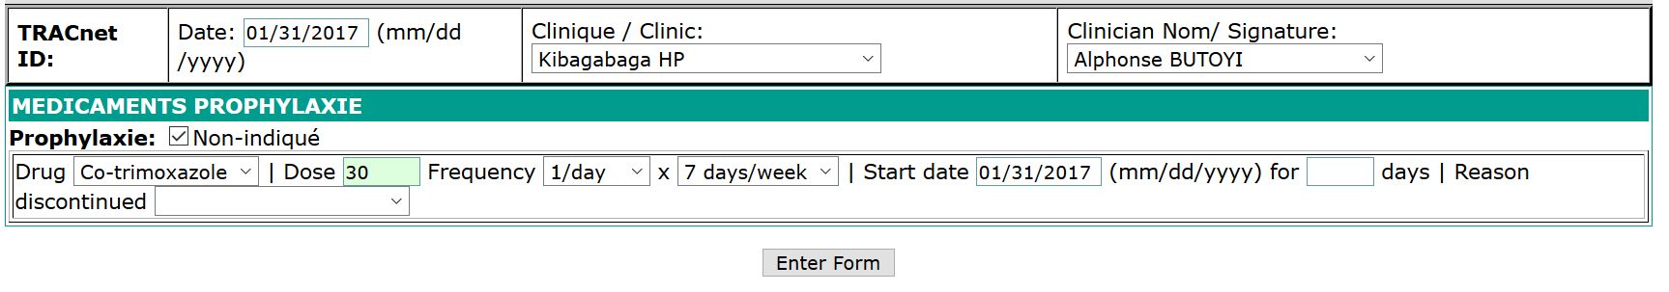

**2.2.6.3.2.3.7 Suivi biologique**

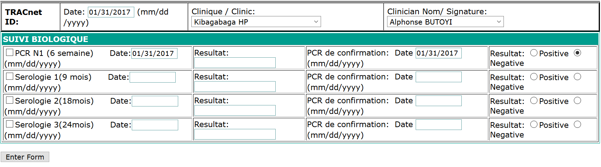

**2.2.6.3.2.3.8 ARV tritherapie**

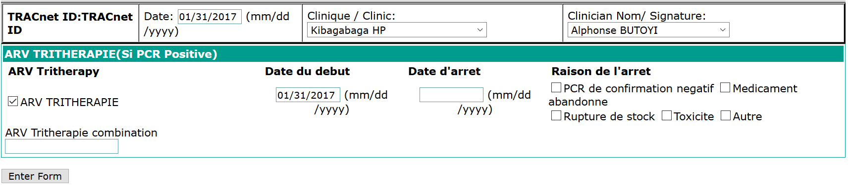

**2.2.6.3.2.3.9 Allergies et effets secondaires**

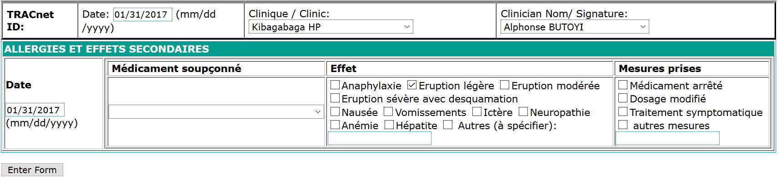

**2.2.6.3.2.3.10 Resume des visites**

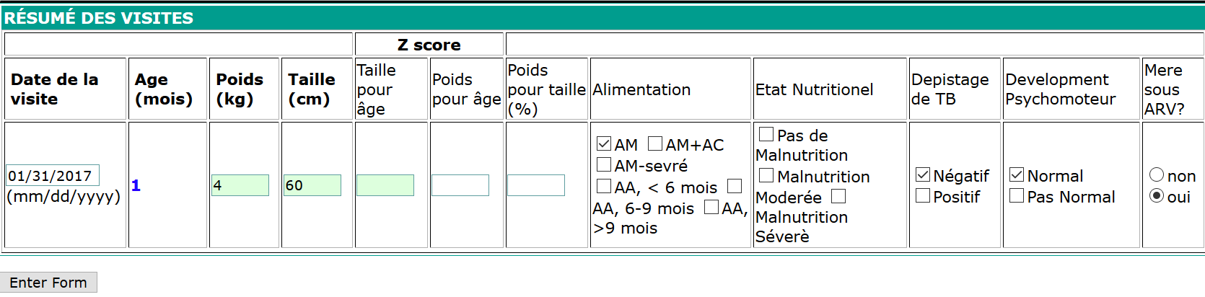

**2.2.6.3.2.3.11 Conclusion de suivi**

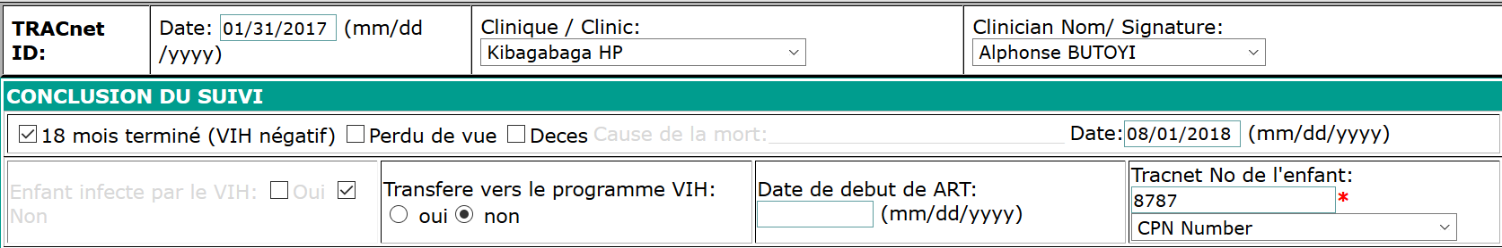

**2.2.6.3.3 DISCORDANT COUPLE**

This form follows couples where one partner is HIV-infected and the other is not. Each of these persons is referred to as “**Partner”** in the relationship.

**Steps**:

1. Log into EMR using your username and password
2. On home page, search for a patient from discordant couples
3. Click on “**Form Entry**”tab
4. Find **Discordant couple (negative)** Form:

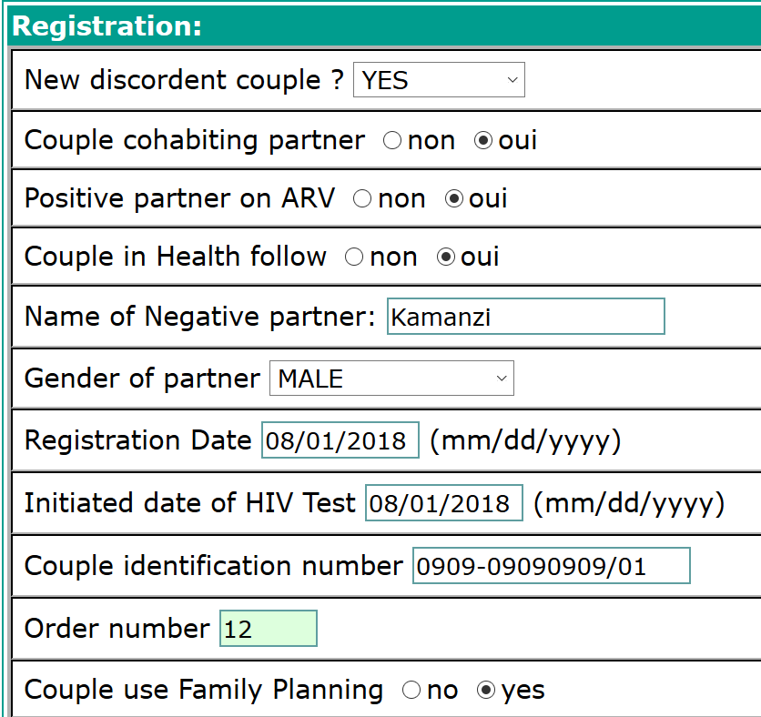

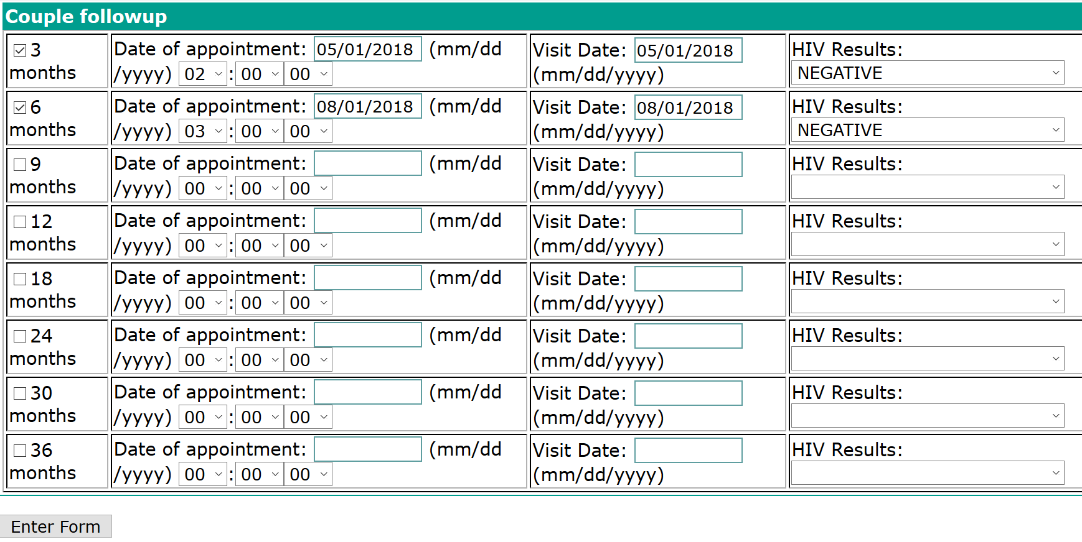

**2.2.6.3.4 ANTENATAL CARE (ANC) PROGRAM**

This is the care you receive from [healthcare professionals during your pregnancy](https://www.pregnancybirthbaby.org.au/health-professionals-involved-in-your-pregnancy). For HIV tested positive pregnant women, they are enrolled in both ANC & PMTCT Program.

**Find the patient** and go to **Overview** to see the patient Dashboard. **Add a new program** to enroll the patient in ANC program.

**Steps**:

1. Log into EMR using your username and password
2. Click on “**Find/Create a patient**” menu from main menu
3. Find a patient from search field available on opened form
4. Click on “**Form entry**” tab
5. Click on “**Add a new program”** link

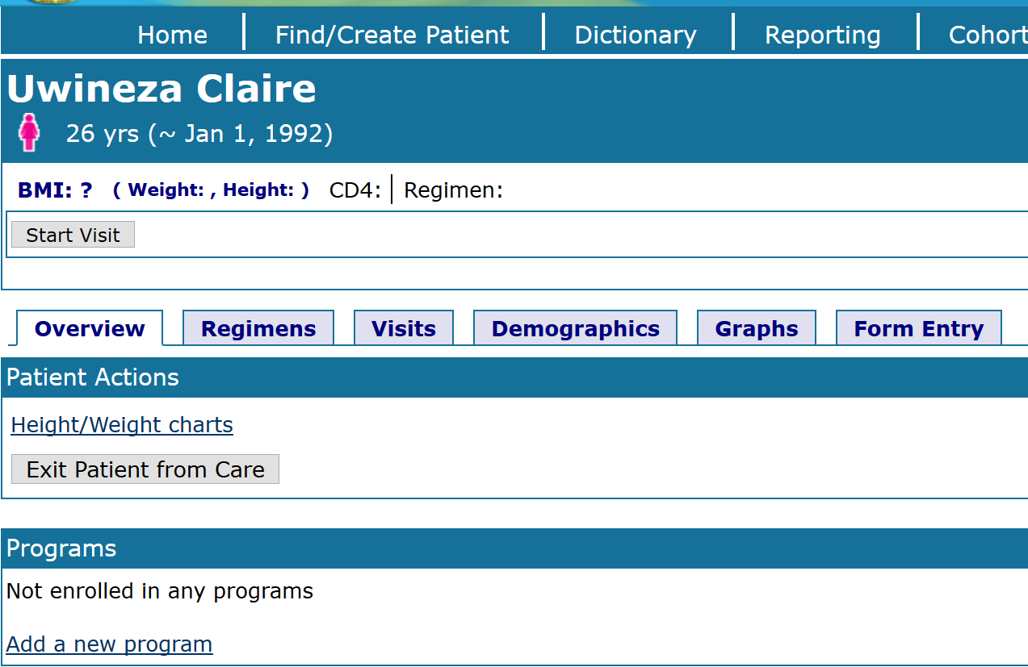

1. Fill the form and click on **[Enroll]** to save the changes

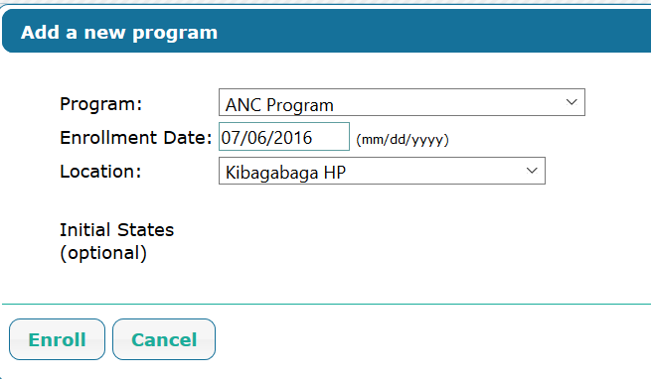

**ANC Flowsheet** is divided in 6 forms:

**2.2.6.3.4.1 Past Medical History**

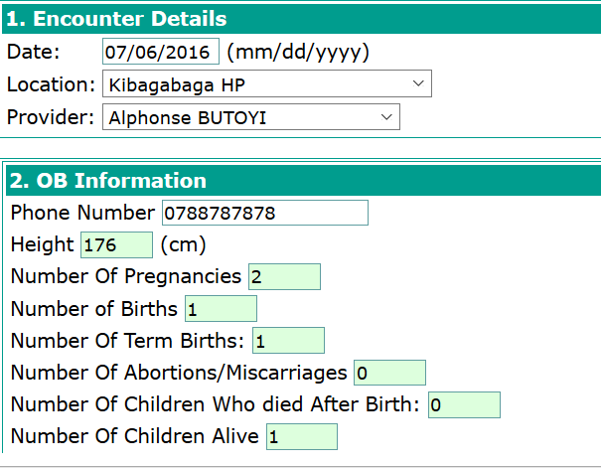

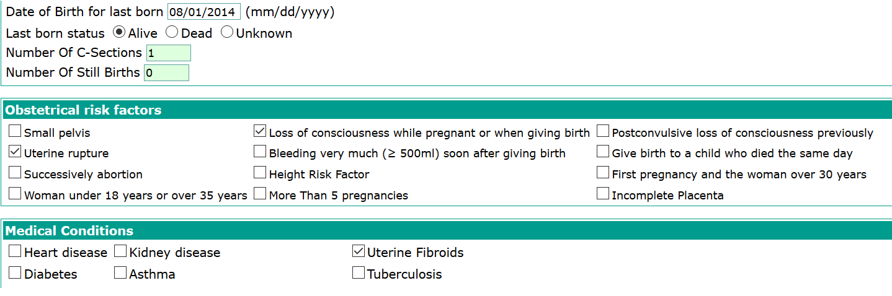

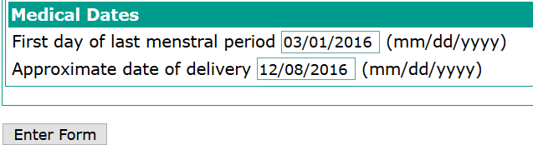

**2.2.6.3.4.2 Physical Examination**

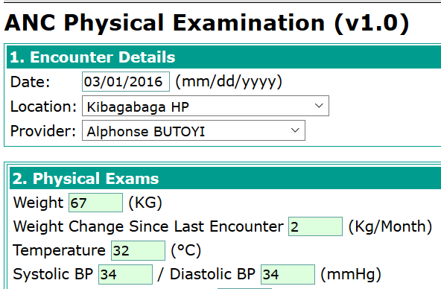

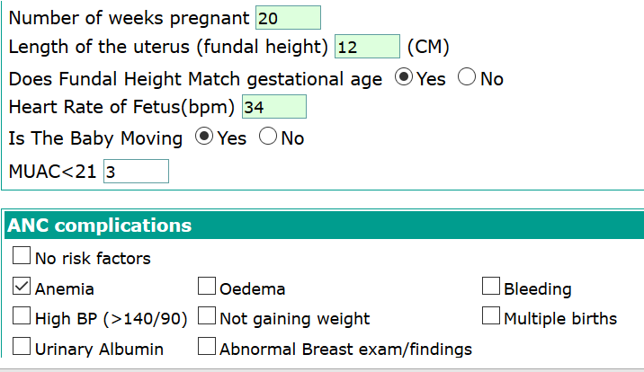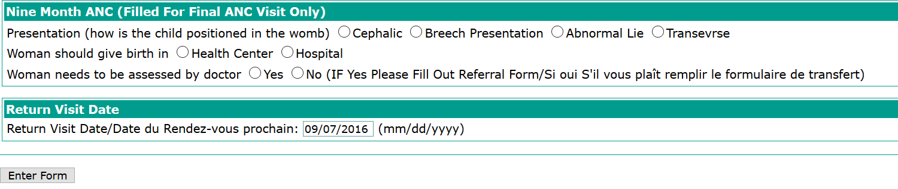

**2.2.6.3.4.3 Investigation**

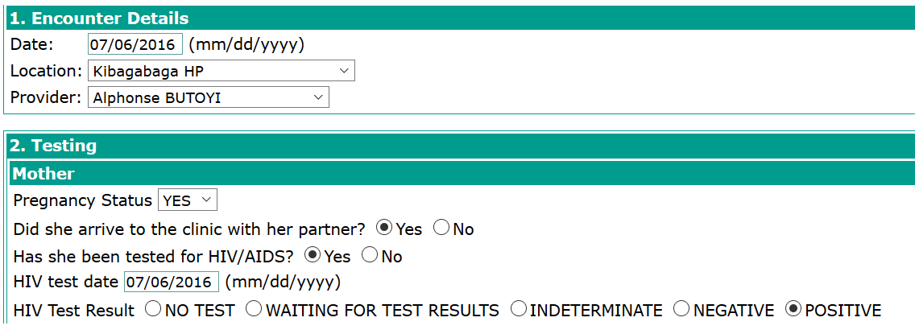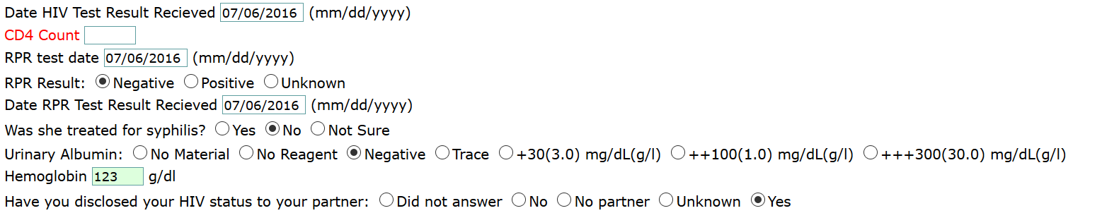

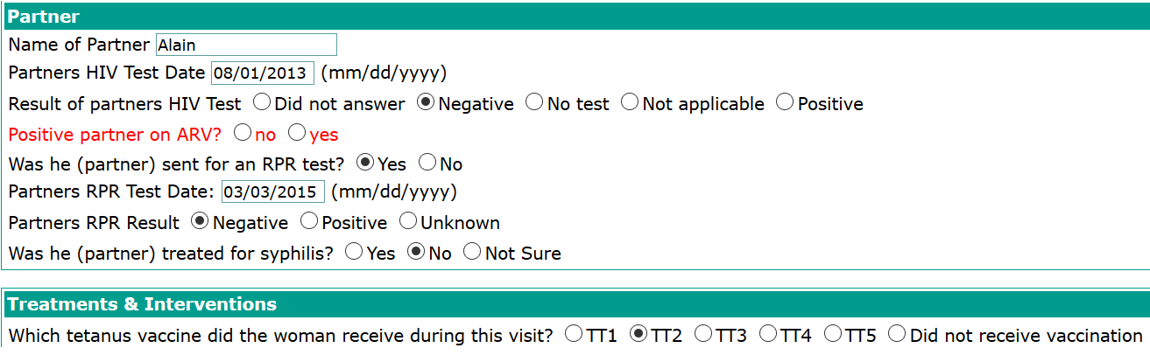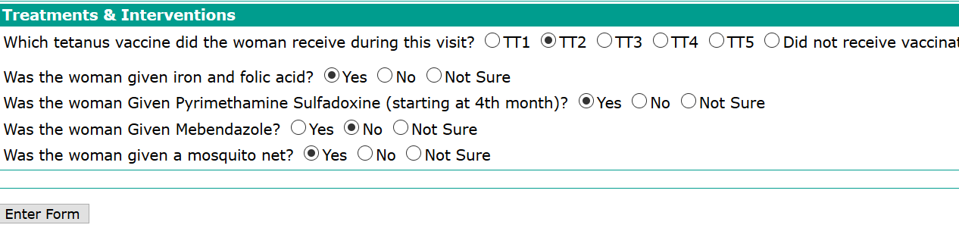

**2.2.6.3.4.4 Referral form**

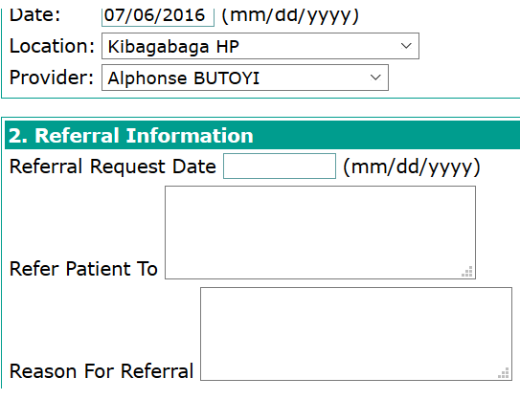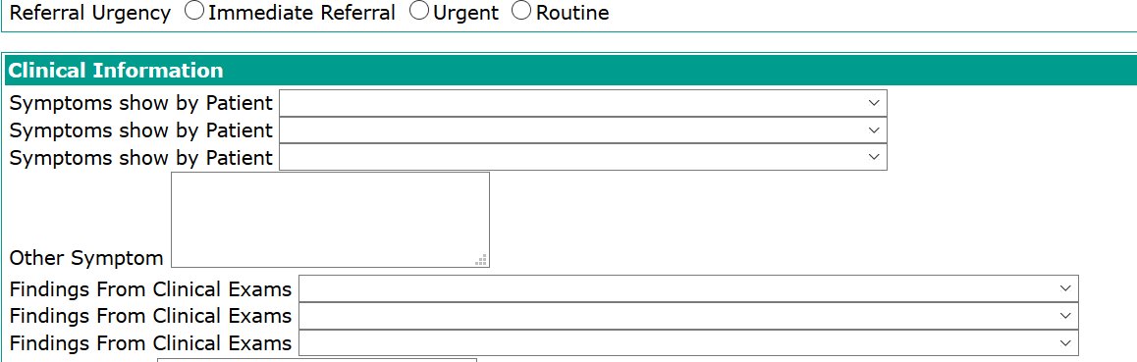

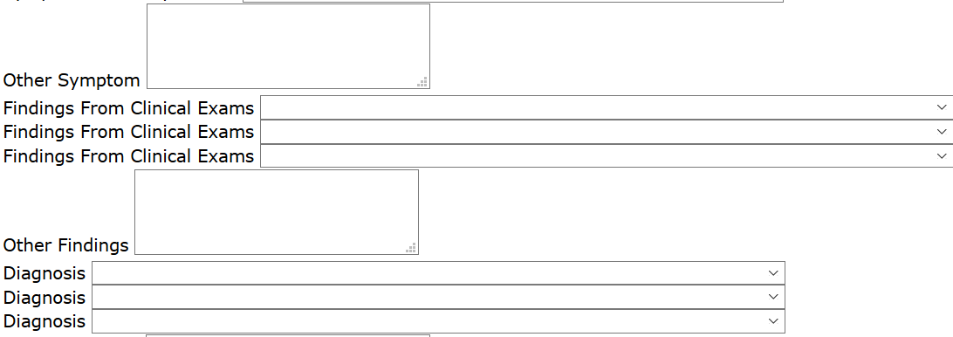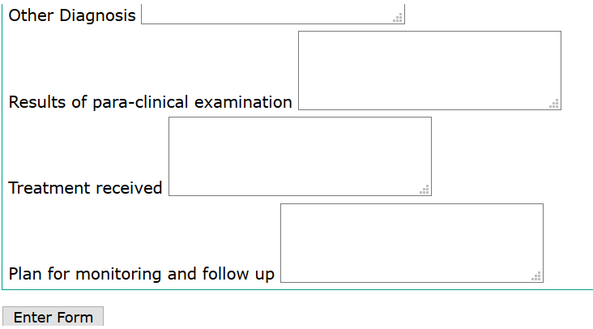

**2.2.6.3.4.5 Referral confirmation form**

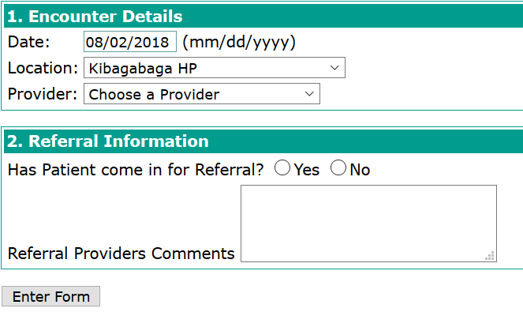

**2.2.6.3.4.6 Delivery report**

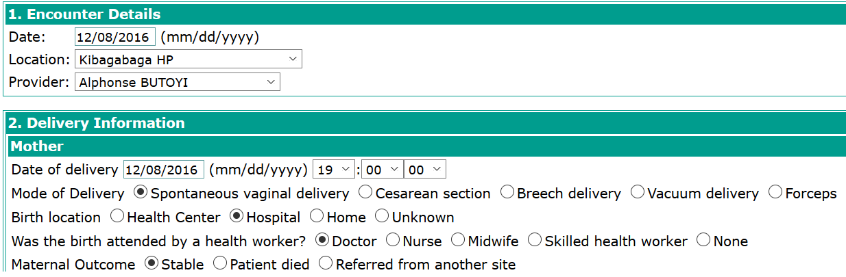

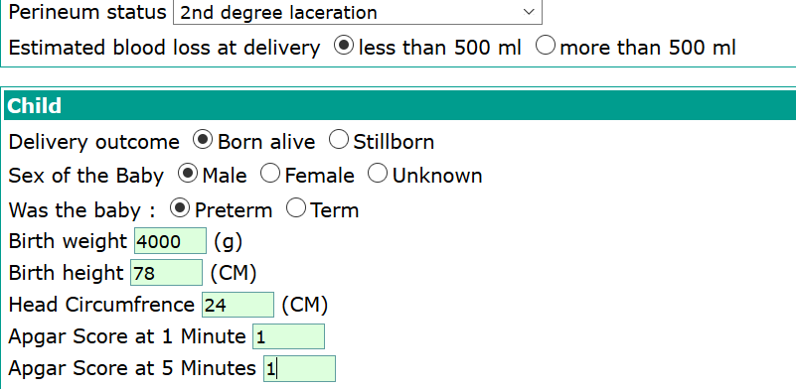

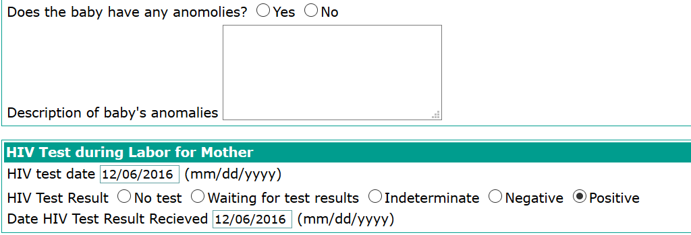

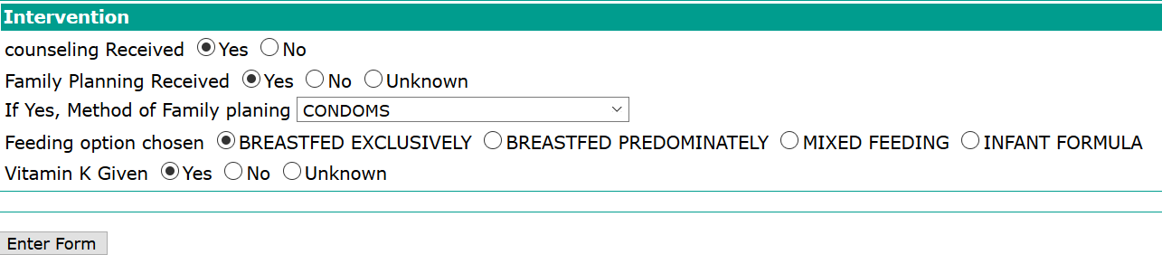

**2.2.6.3.5 POST EXPOSURE PROPHYLAXIS (PEP) PROGRAM**

This program provides short-term antiretroviral treatment to prevent HIV infection after a recent possible exposure to the virus

**Steps**:

1. Log into EMR using your username and password
2. Click on “**Find/Create a patient**” menu from main menu
3. Find a patient from search field available on opened form
4. Click on “**Form entry**” tab



**2.2.6.3.5.1 HIV Exposure enrollment**

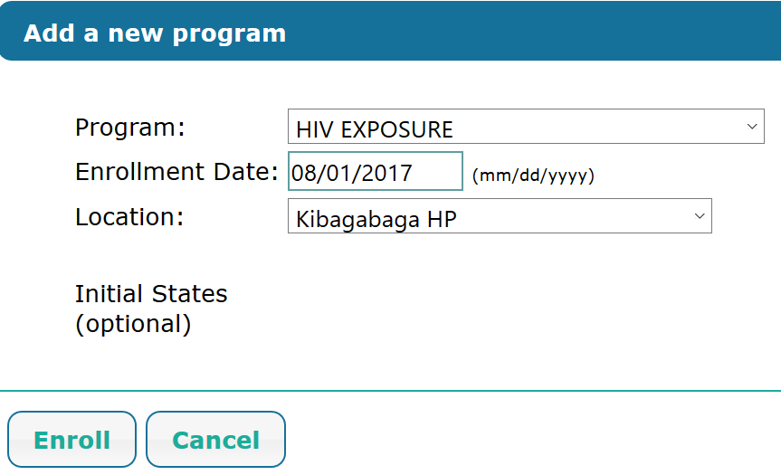

**2.2.6.3.5.2 Prophylaxis forms**

Go to **form entry** to find the prophylaxis form

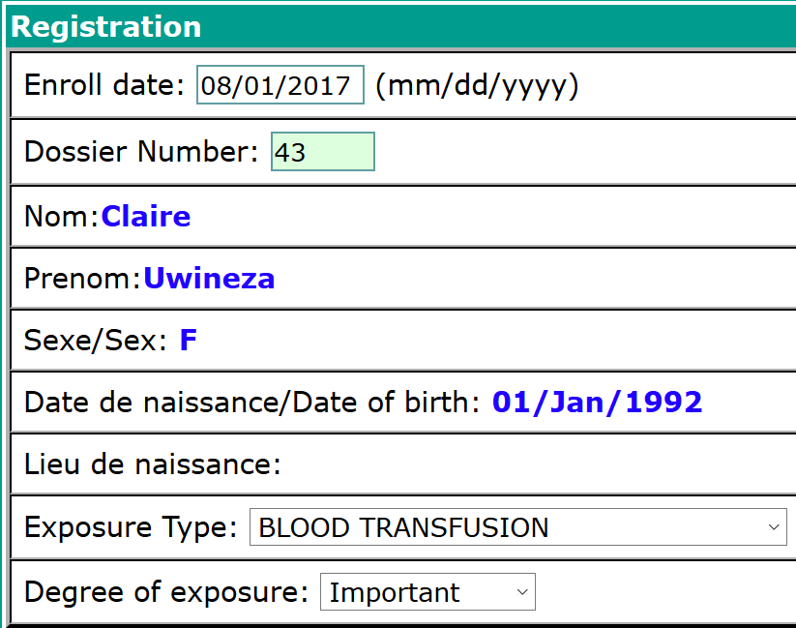

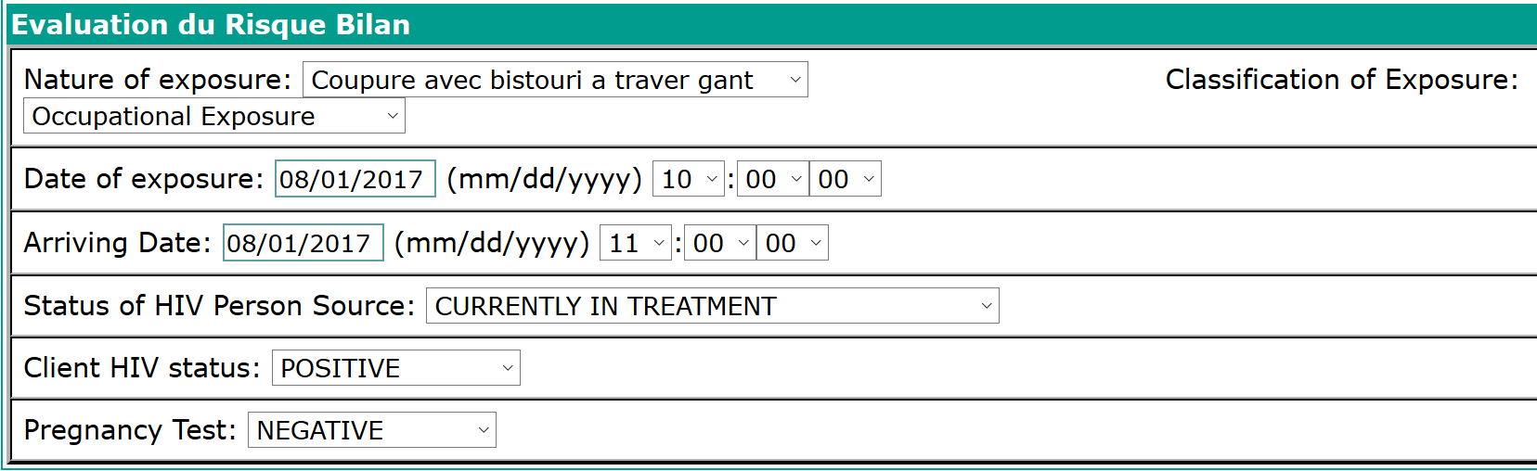

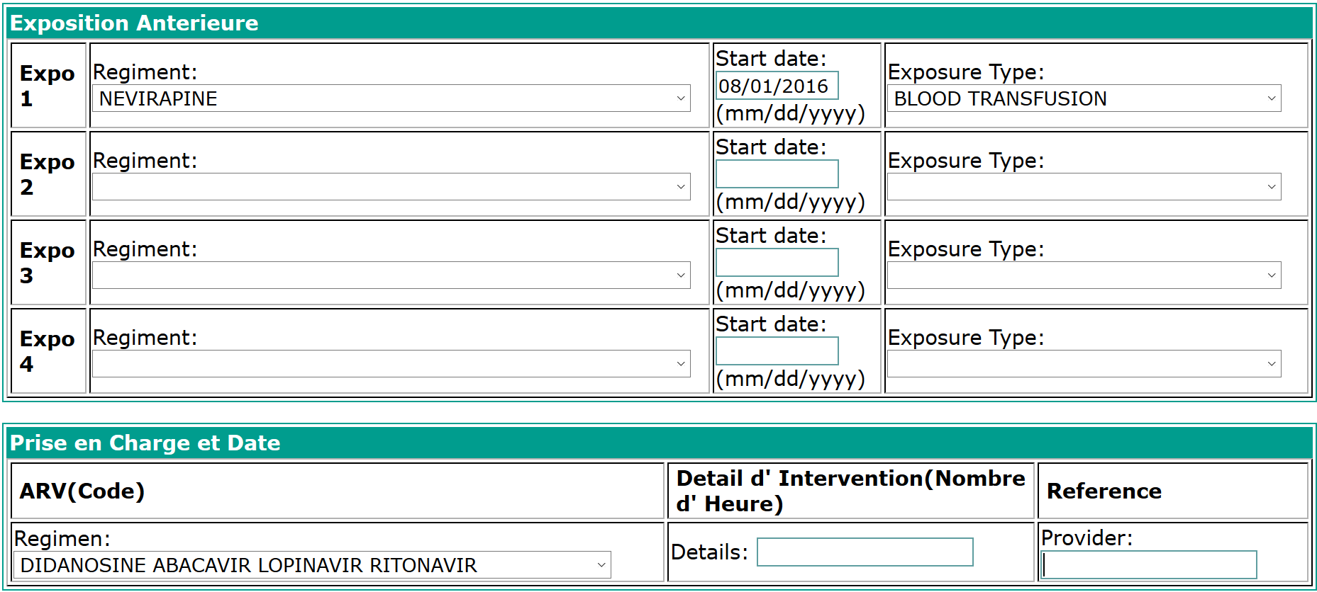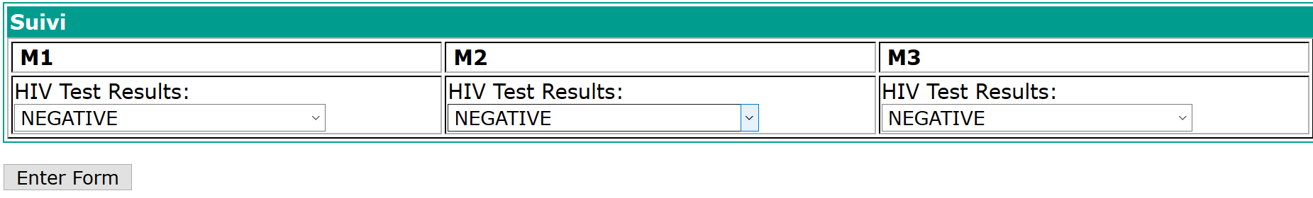

**2.2.6.3.6 ALE CIRCUMCISION**

‘**Find the patient’** and go to **‘Form entry**’ to find Male circumcision flowsheet

**Steps**:

1. Log into EMR using your username and password
2. Click on “**Find/Create a patient**” menu from main menu
3. Find a patient from search field available on opened form
4. Click on “**Form entry**” tab

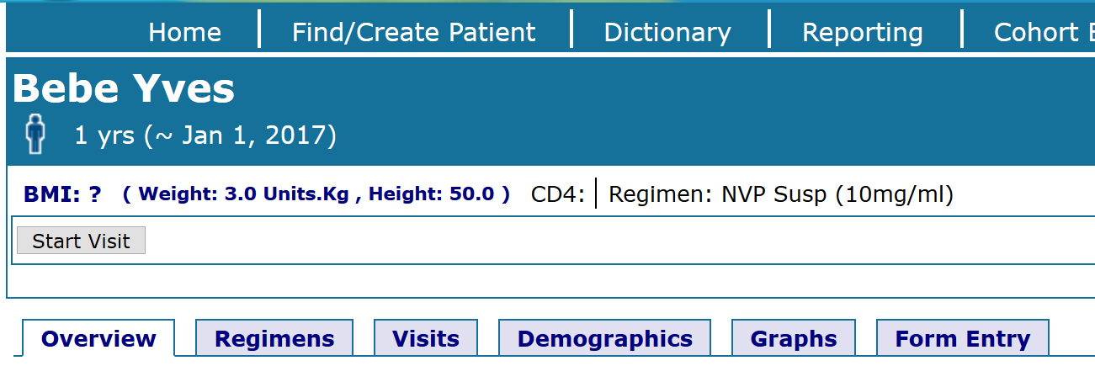

1. Find **Prepex and surgical consultation** form

**2.2.6.3.6.1 Prepex and surgical consultation form**

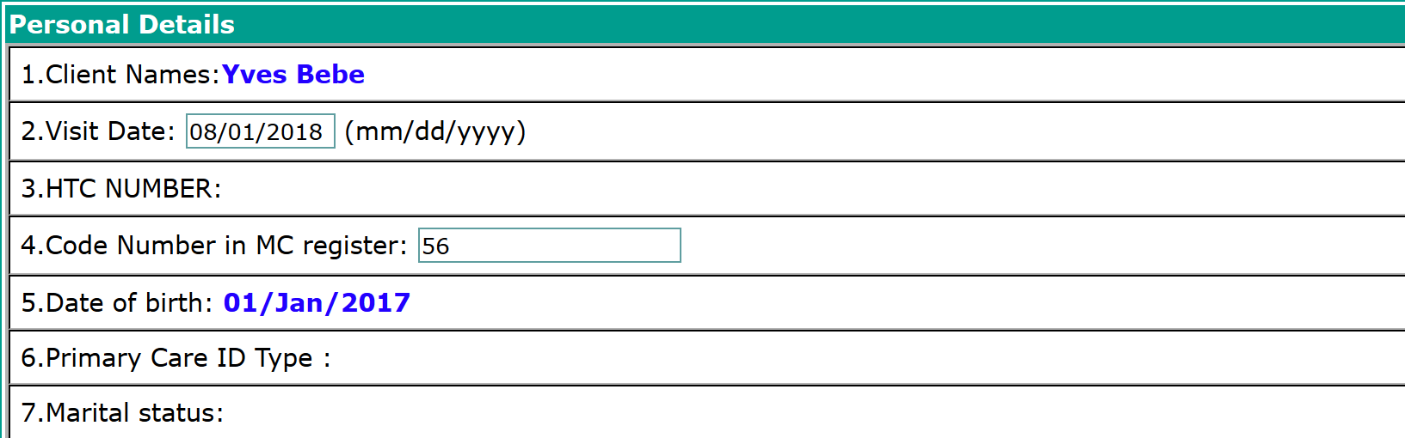

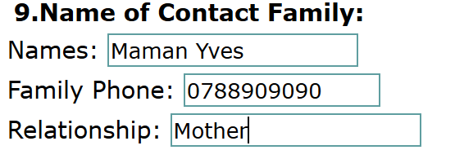

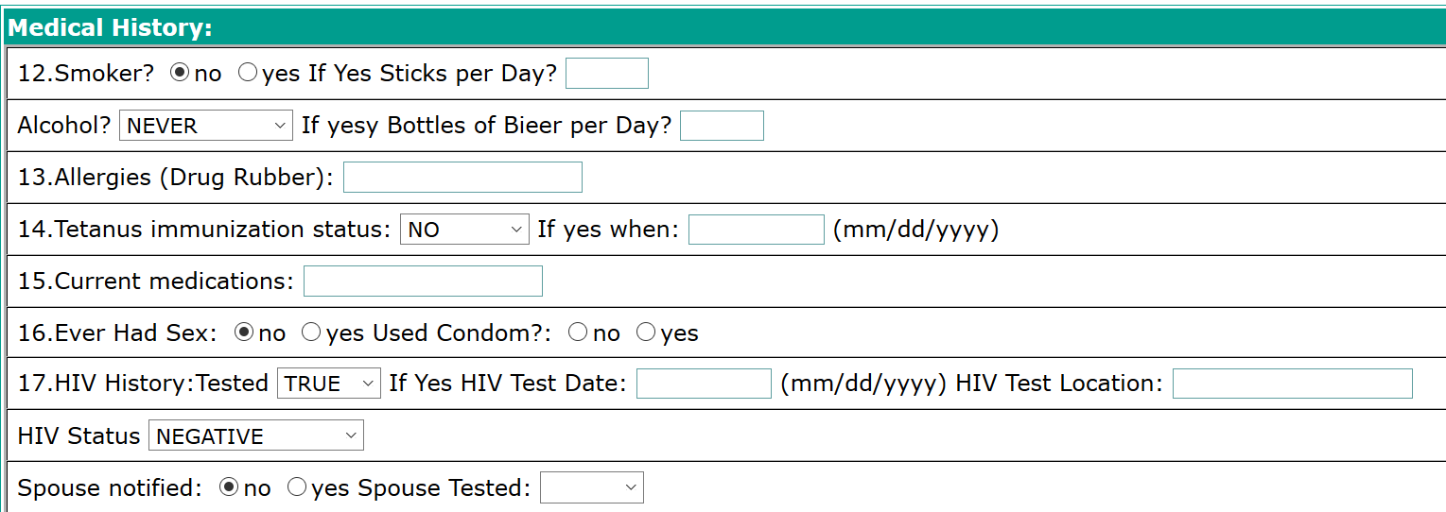

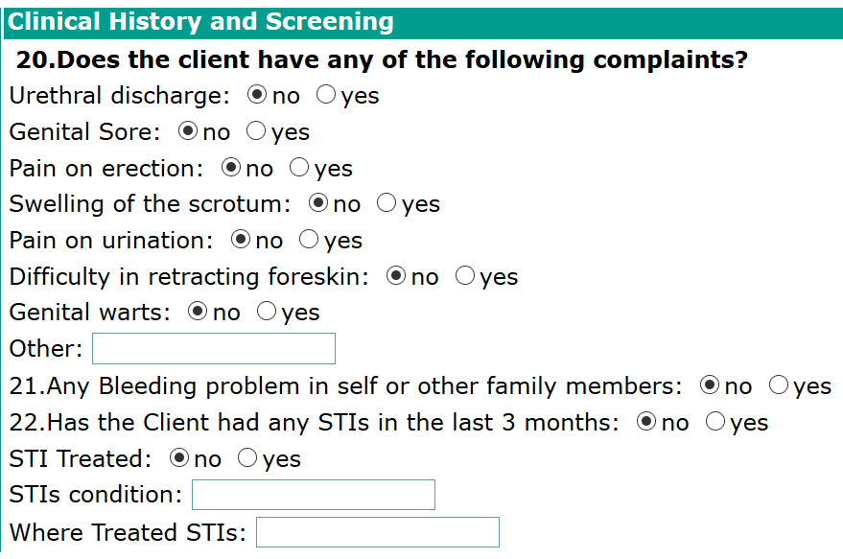

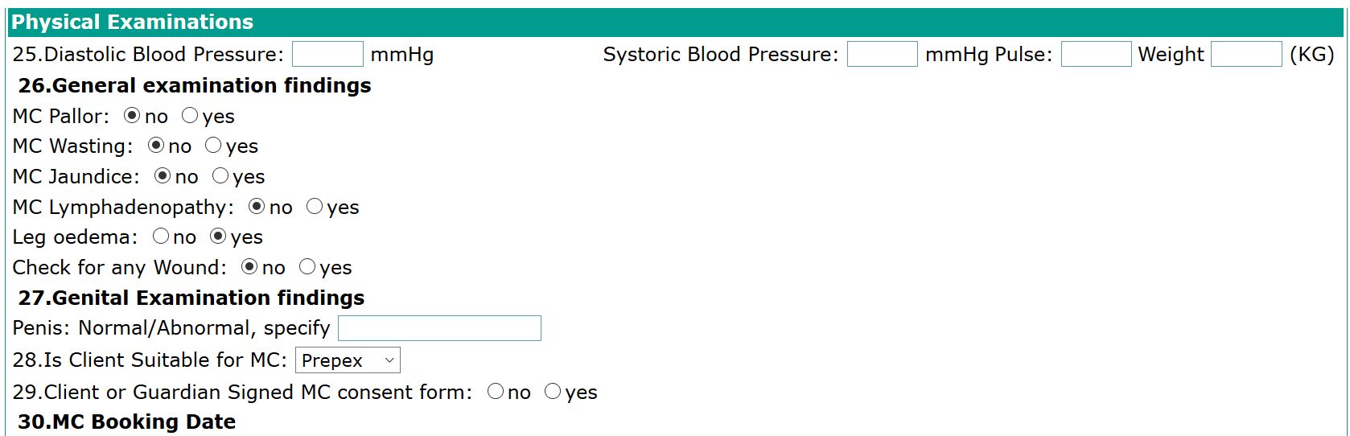

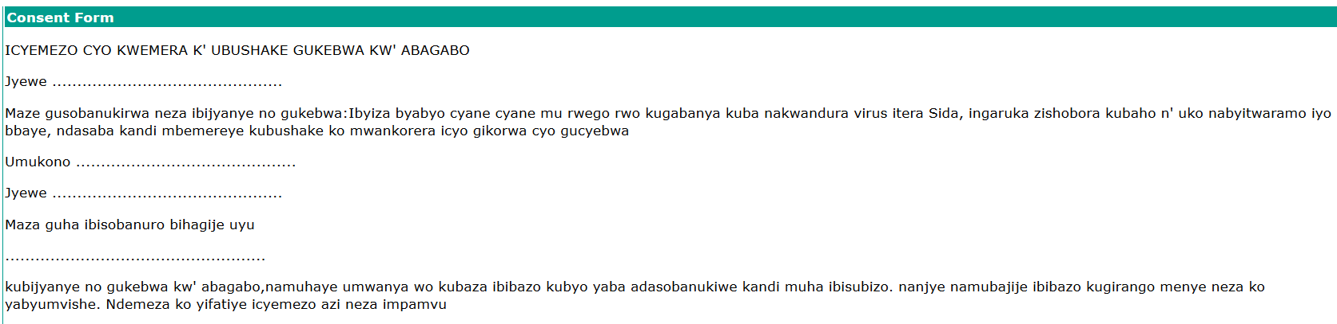

**2.2.6.3.6.2 Prepex form Fin**

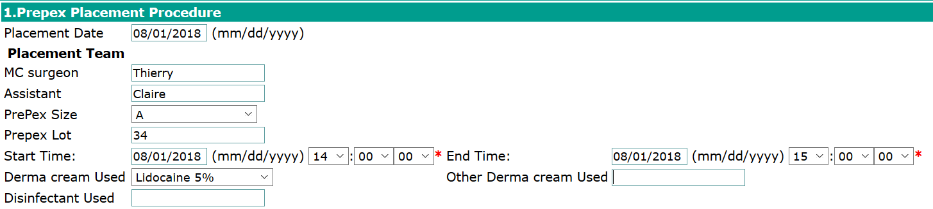

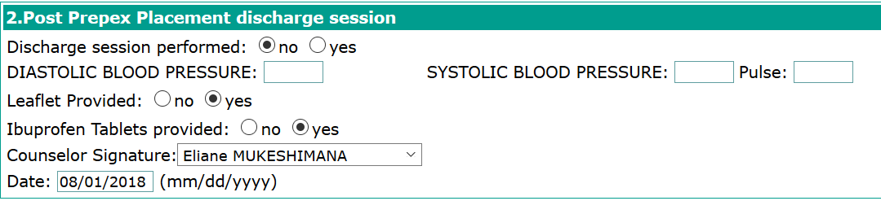

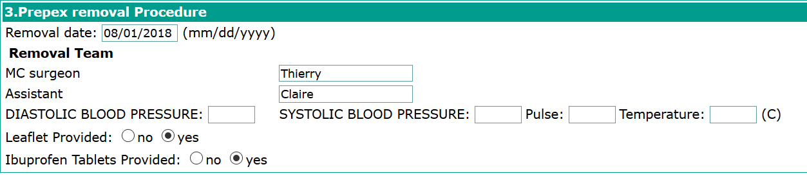

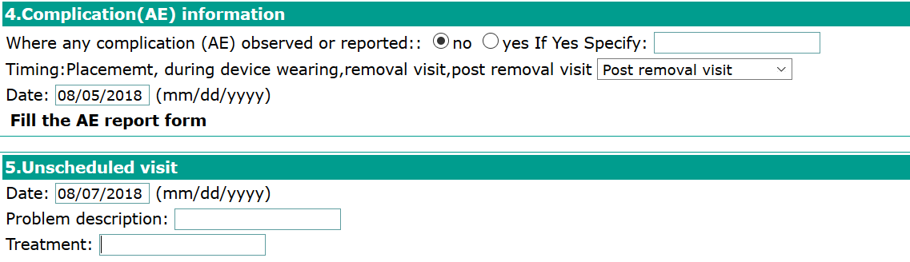

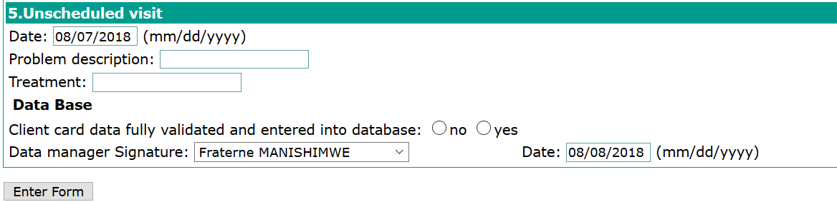

**2.2.6.3.6.3 MC surgical form fin**

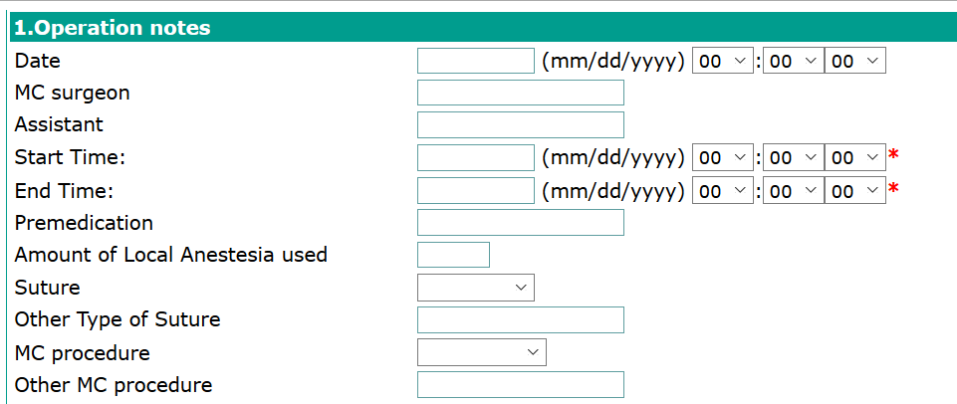

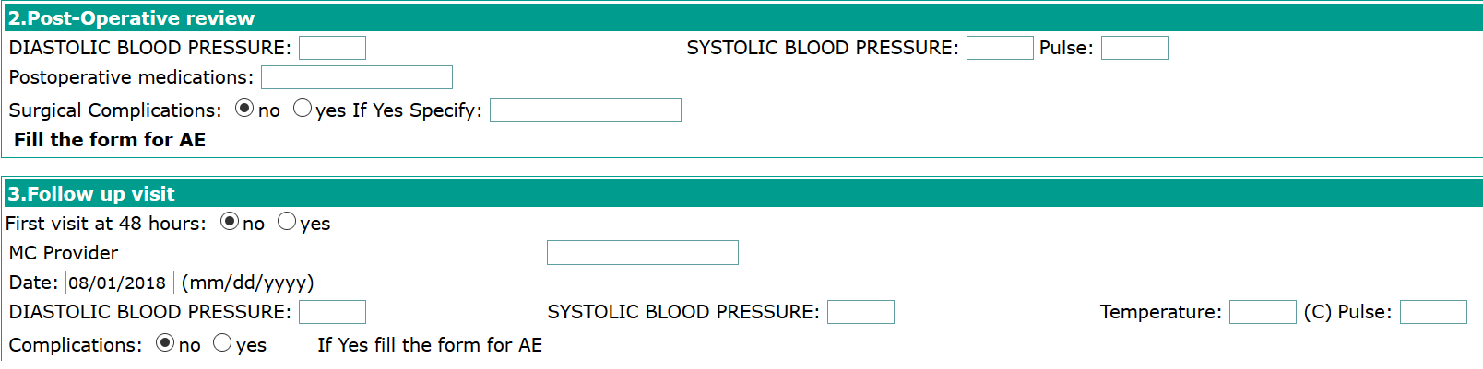

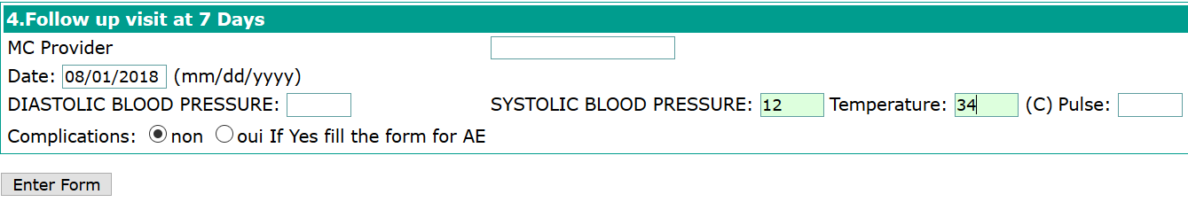

**2.2.6.3.7 NUTRITION FORMS**

**Steps**:

1. Log into EMR using your username and password
2. Click on “**Find/Create a patient**” menu from main menu
3. Find a patient from search field available on opened form
4. Click on “**Form entry**” tab

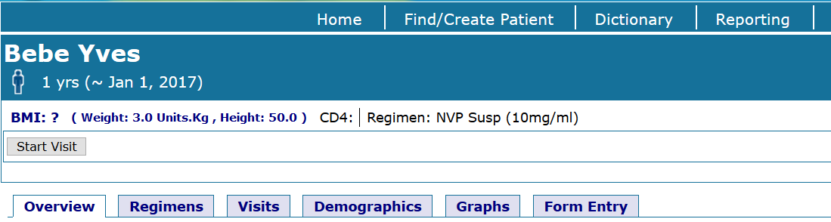

**2.2.6.3.7.1 Find Nutrition Flowsheet forms**

**2.2.6.3.7.1.1 Nutrition demographics form**

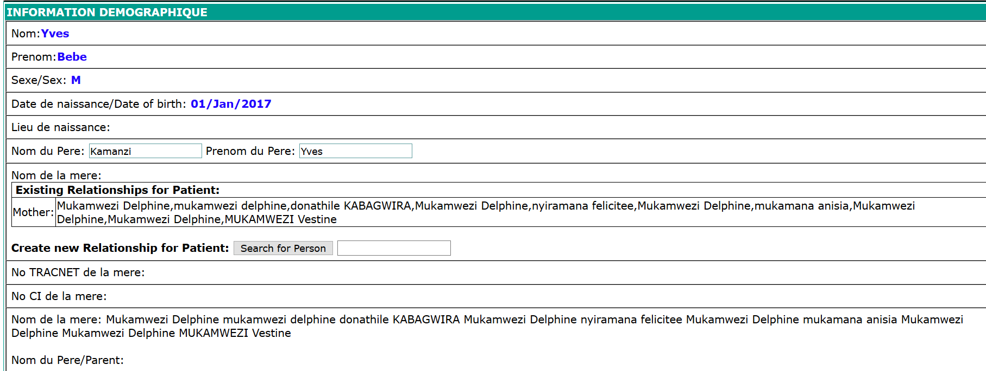

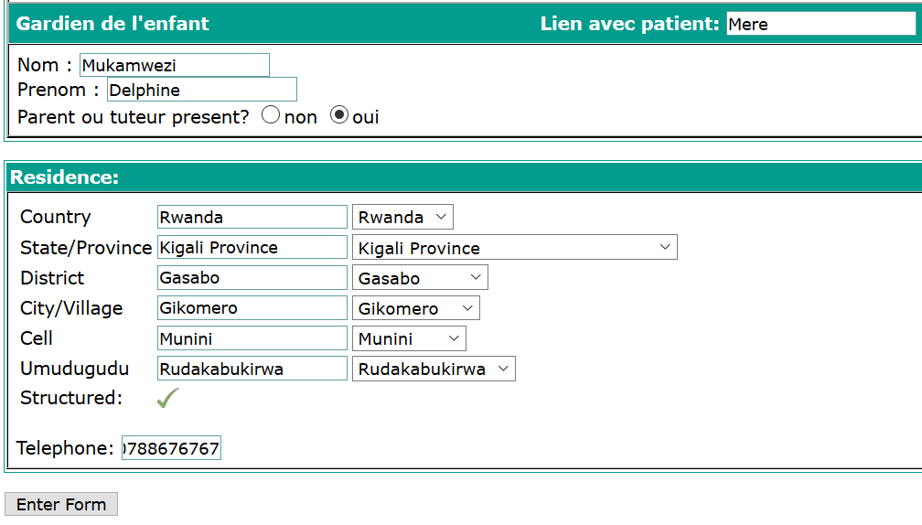

**2.2.6.3.7.1.2 Height / Weight tracker form**

Update the **date**, **clinic** and the **provider** name

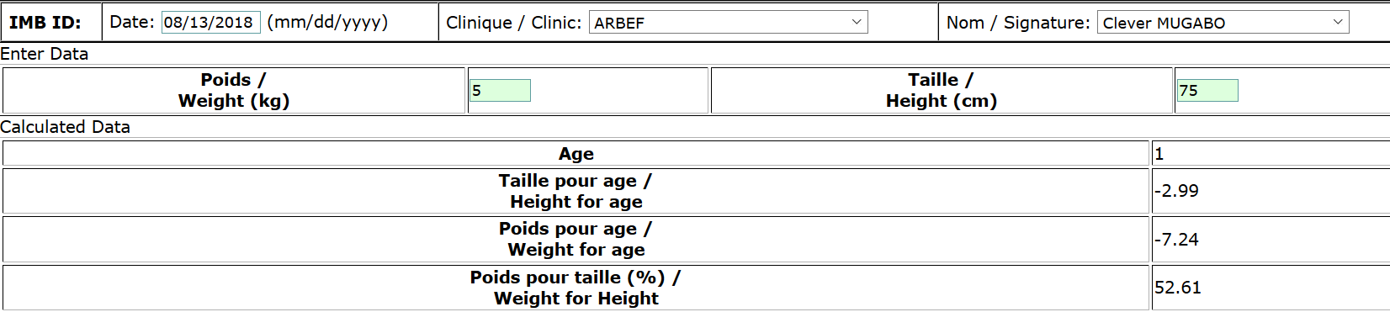

**2.2.6.3.7.1.3 Nutrition status monitoring form**

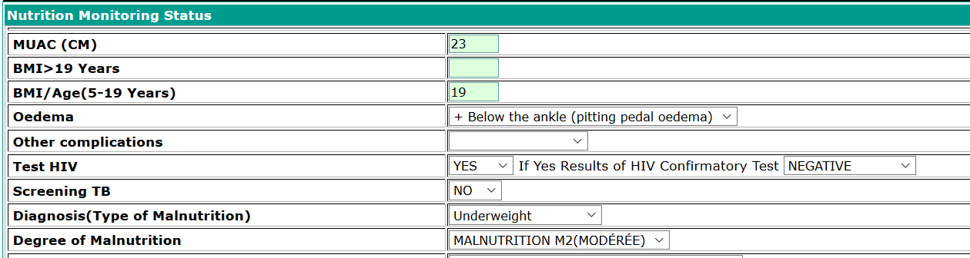

**Enter form** to save the form

**2.2.6.3.7.1.4 Nutrition follow-up form**

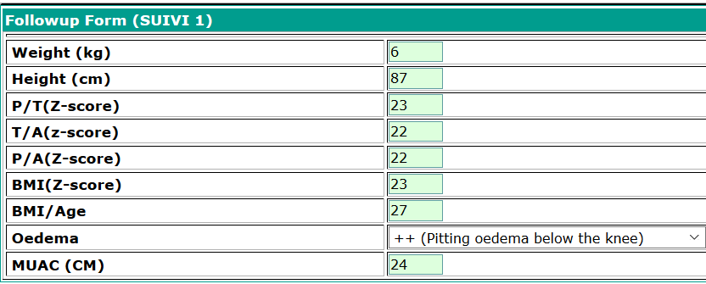

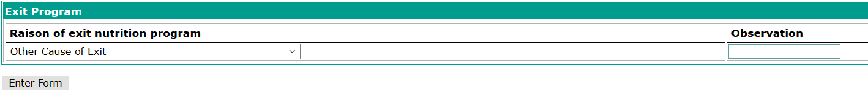

**2.2.6.3.8 OPD FORMS**

‘**Find the patient’** and go to **‘Form entry**’ to find OPD flowsheet

**Steps**:

1. Log into EMR using your username and password
2. Click on “**Find/Create a patient**” menu from main menu
3. Find a patient from search field available on opened form
4. Click on “**Form entry**” tab
5. Type OPD in the form searching area to find for “**OPD Flowsheet**” form
6. Click on “**OPD Flowsheet**” to open the form

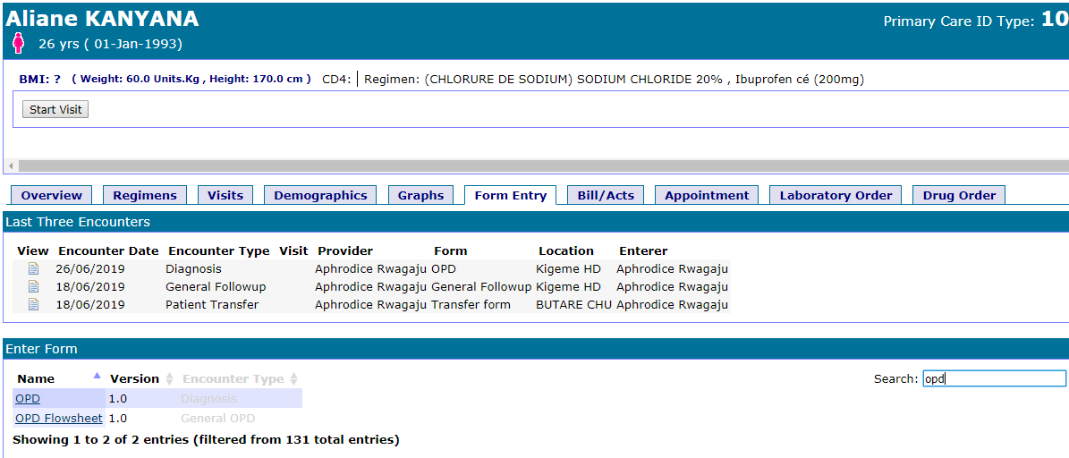

1. Click on **[Add new]** button under the general consultation section to record the consultation records.

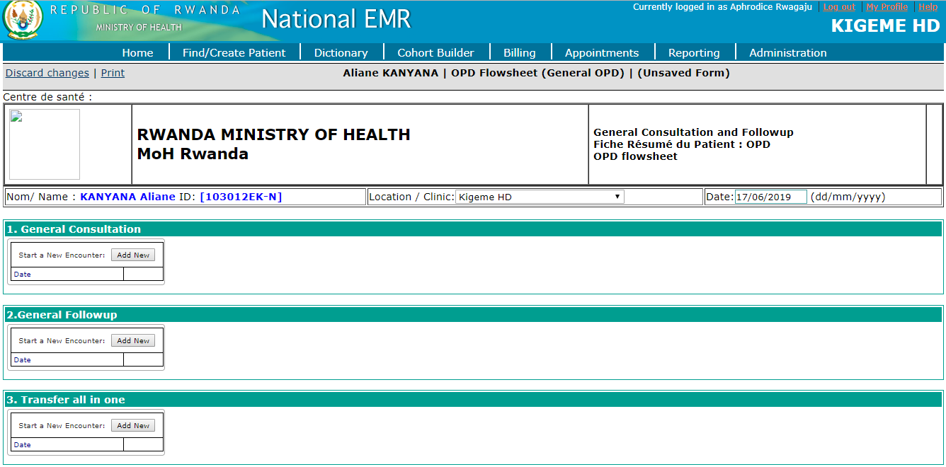

**1. General Consultation form section**

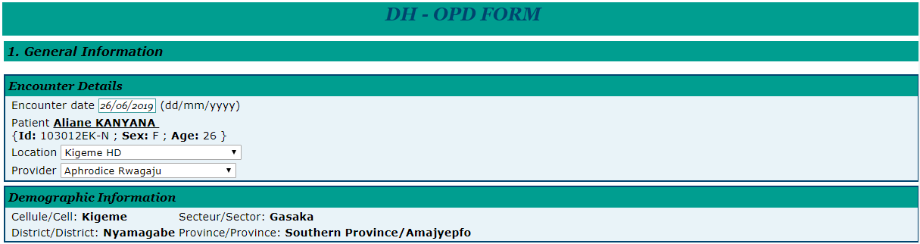

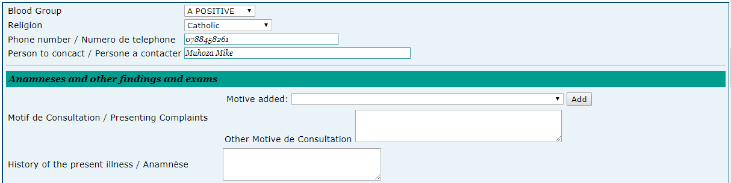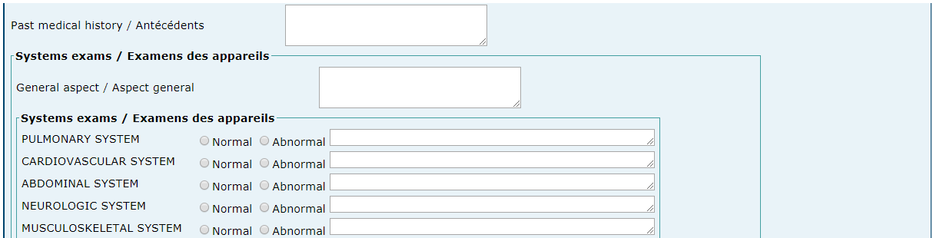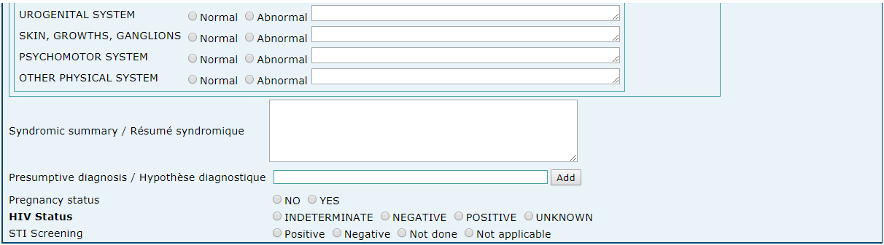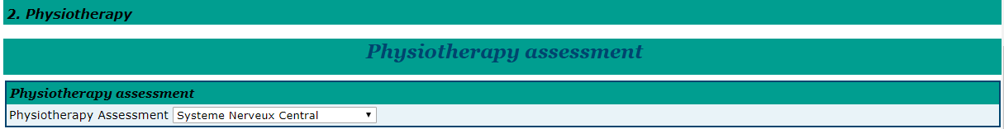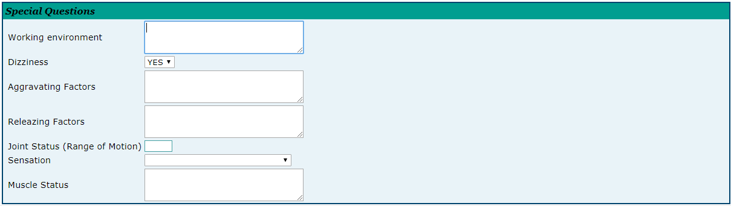

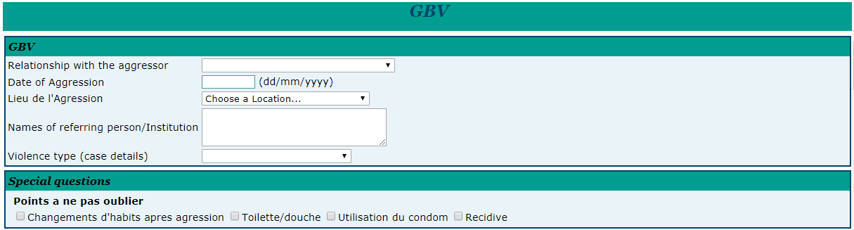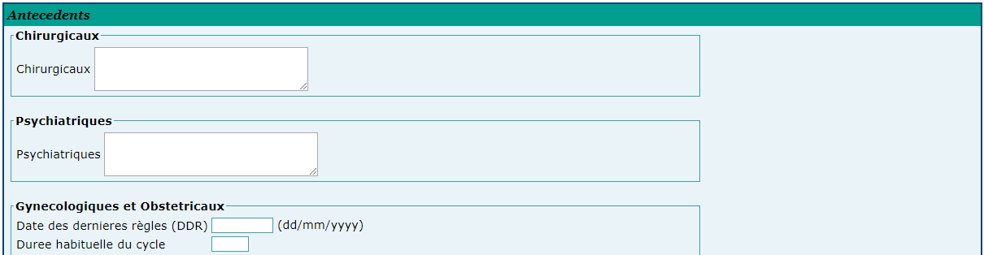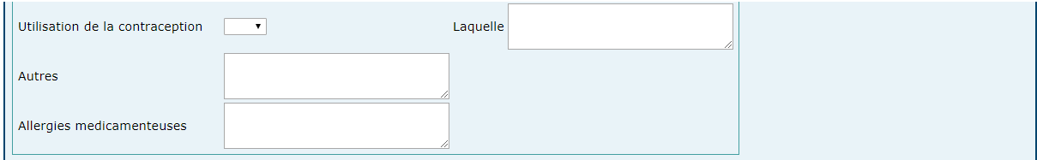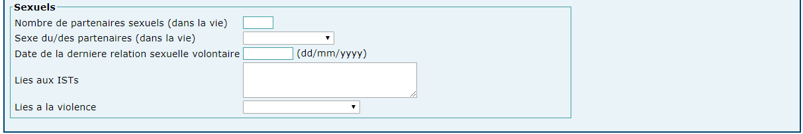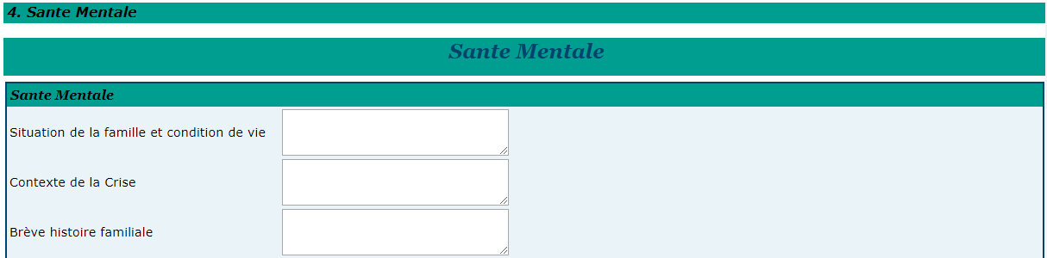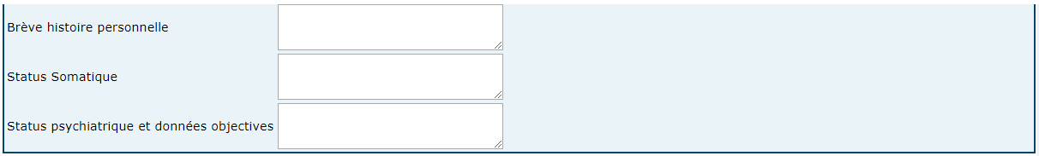

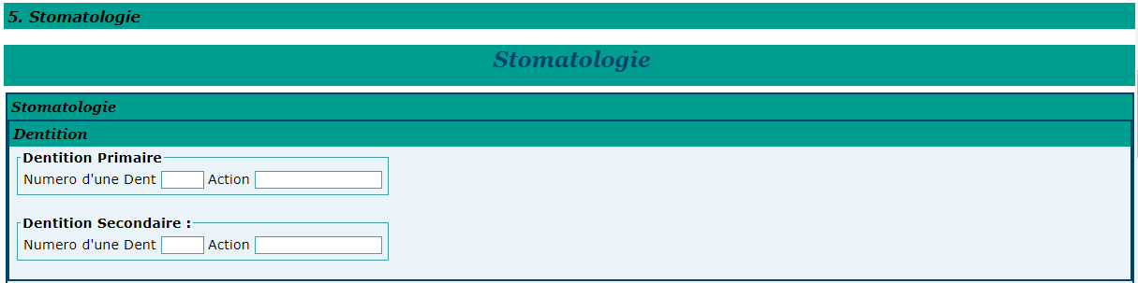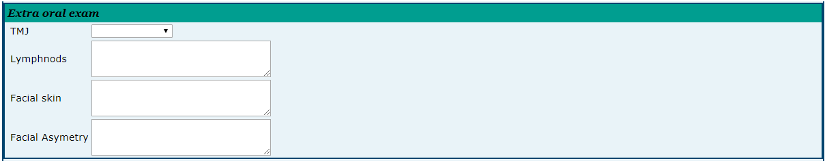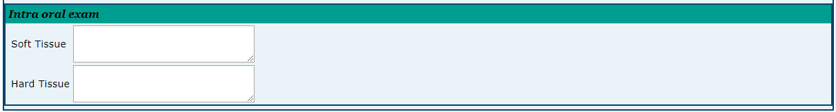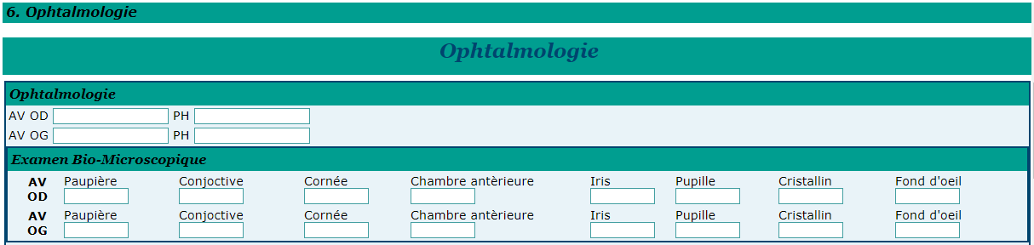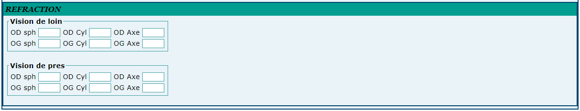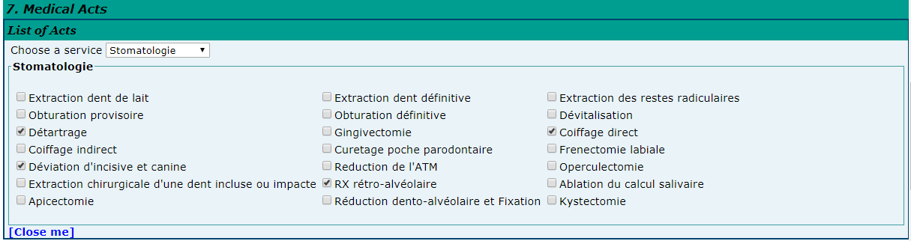

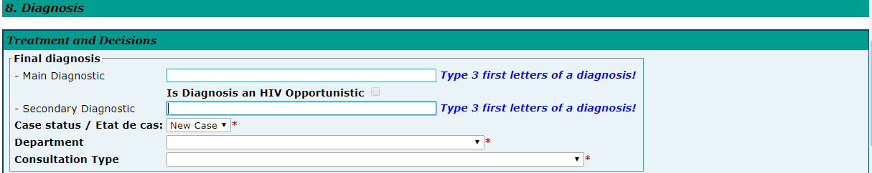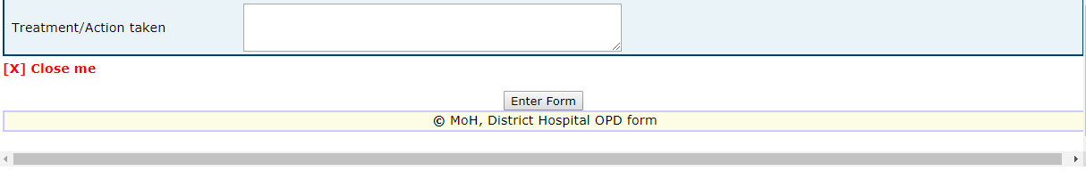

**2.General Follow-up form section**

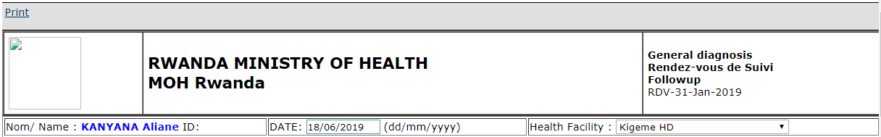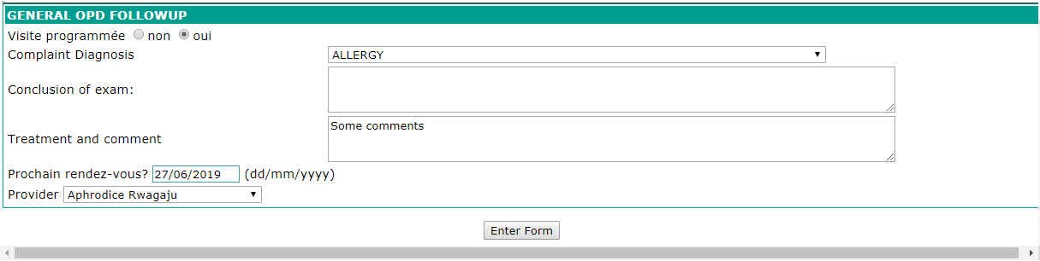

**3. Transfer all in one form**

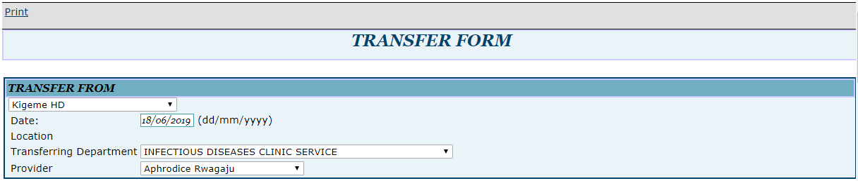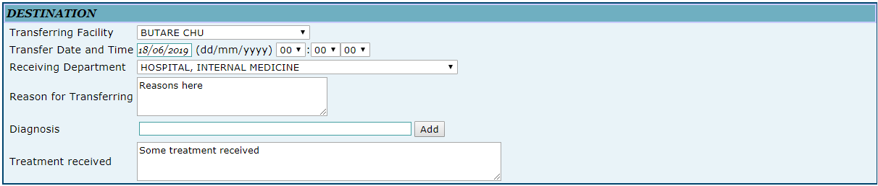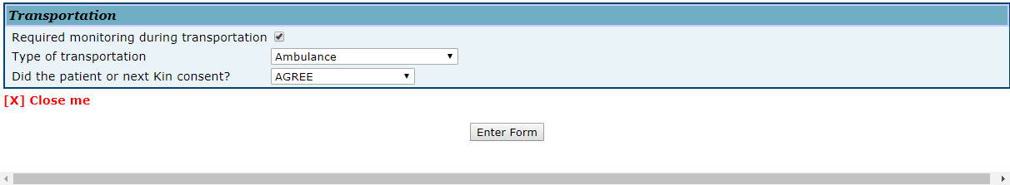

After entering all required information in OPD forms, the user can view or edit historical records based on the patient visit date/ record date.

See the form bellow:

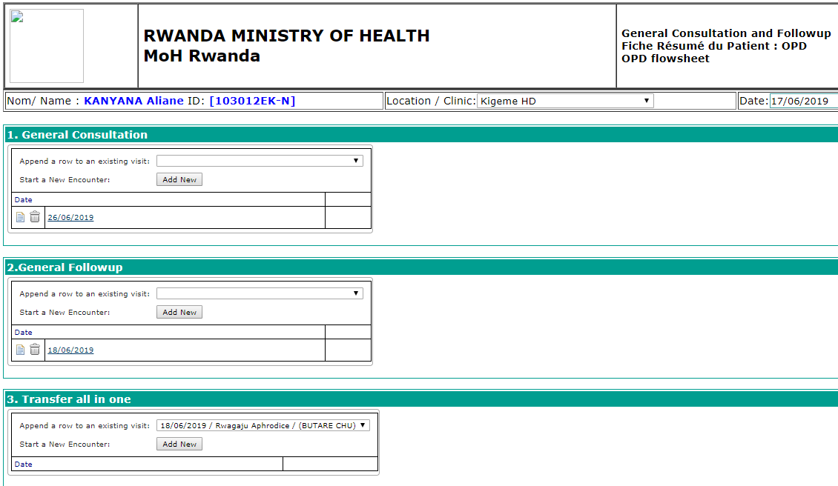

|  |  |
| --- | --- |
| Image result for information icon | **Note:**  Items description   1. Search field: Use this area to search for existing general consultation records 2. Add new: Use this button to fill new general consultation information 3. Date in format of dd/mm/yyyy: It links the visit with the consultation entered on this date 4. Delete button: User delete the information using this button 5. Edit button: User edit the information using this button |

**2.2.6.3.9 IPD FORMS**

‘**Find the patient’** and go to **‘Form entry**’ to find IPD flowsheet

**Steps**:

1. Log into EMR using your username and password
2. Click on “**Find/Create a patient**” menu from main menu
3. Find a patient from search field available on opened form
4. Click on “**Form entry**” tab
5. Type OPD in the form searching area to find for “**IPD Flowsheet**” form
6. Click on “**IPD Flowsheet**” to open the form

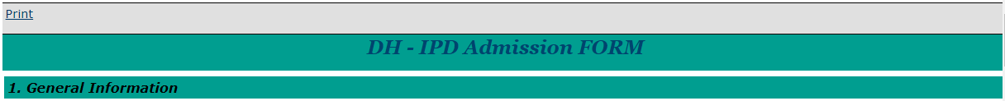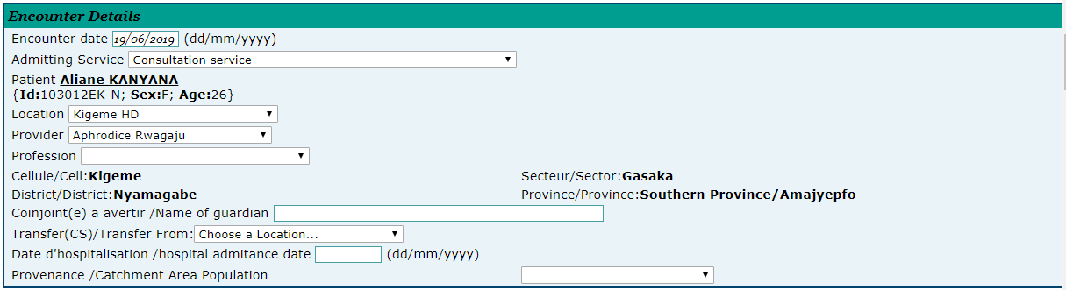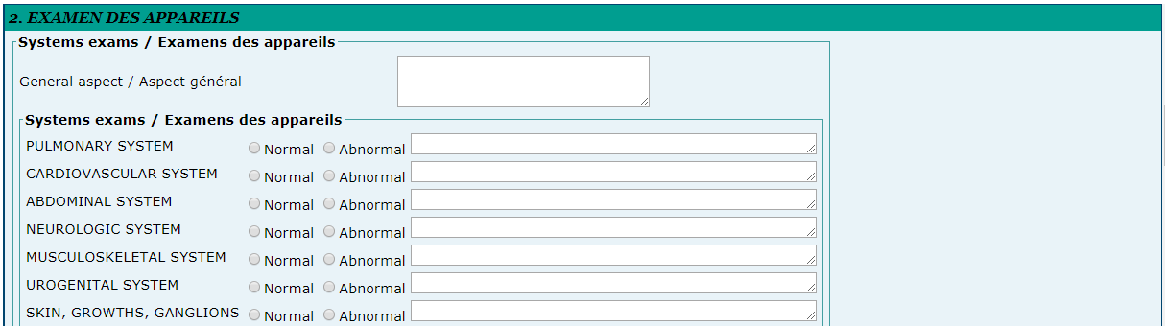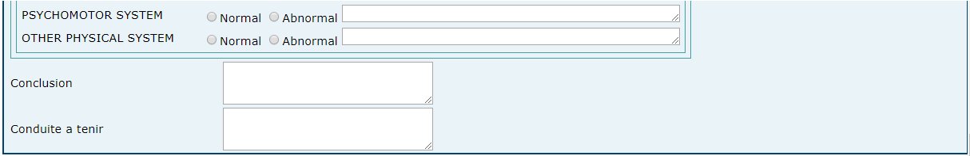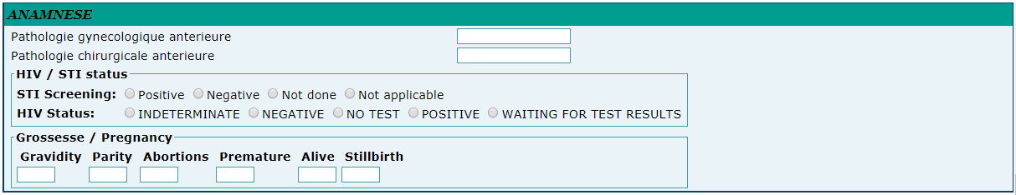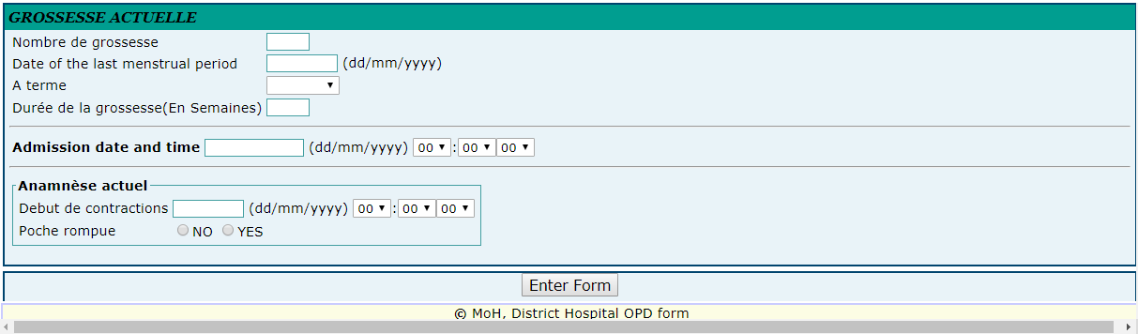

Ghjghj

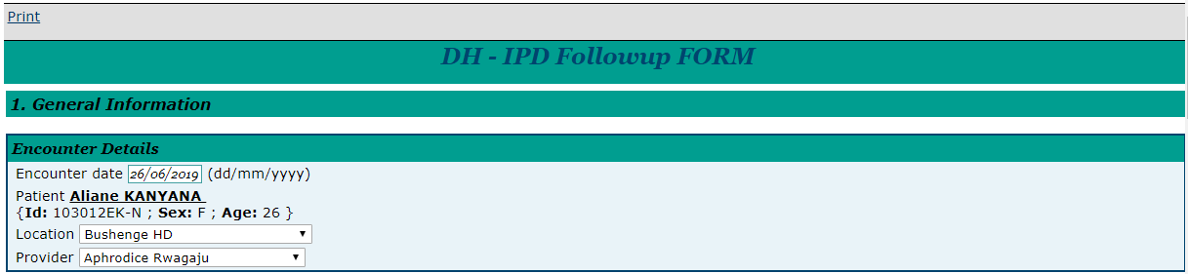



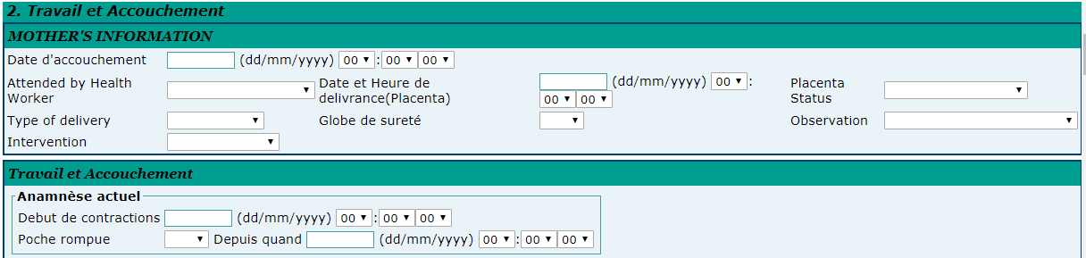

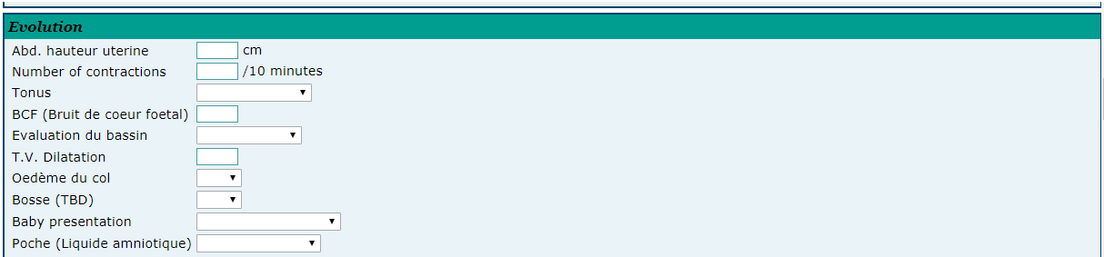

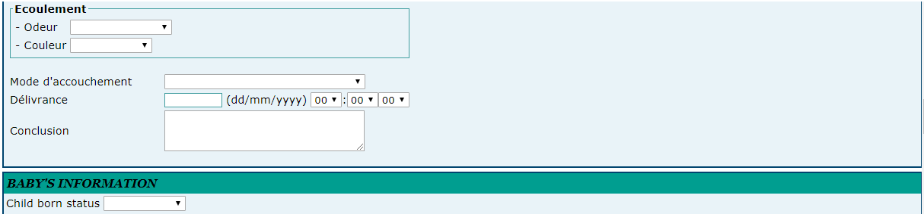

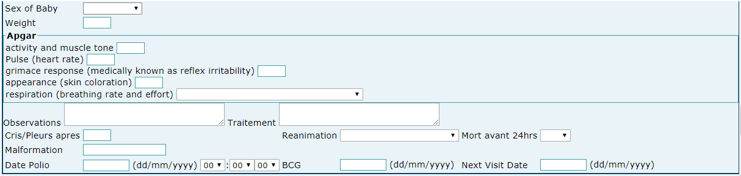

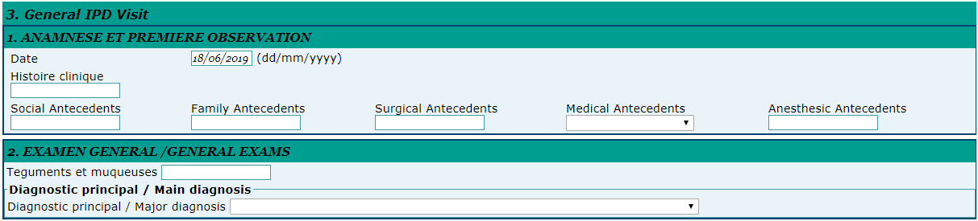

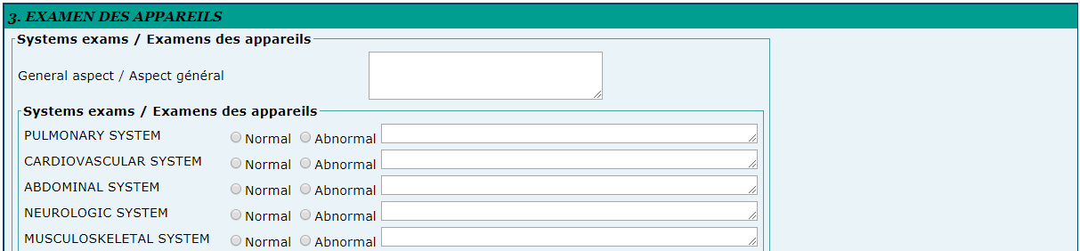

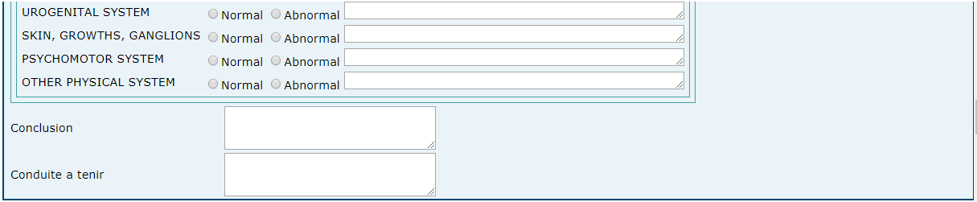

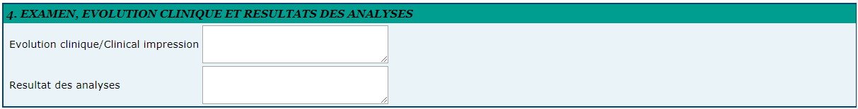

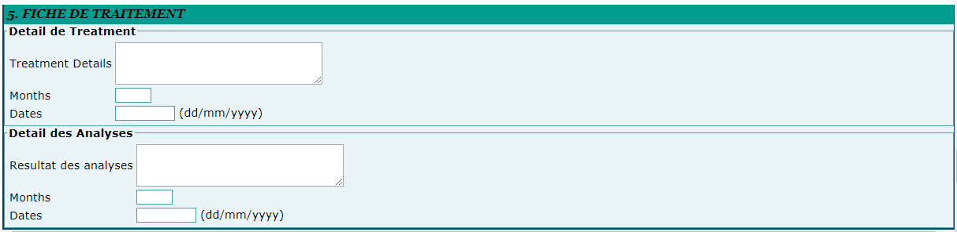



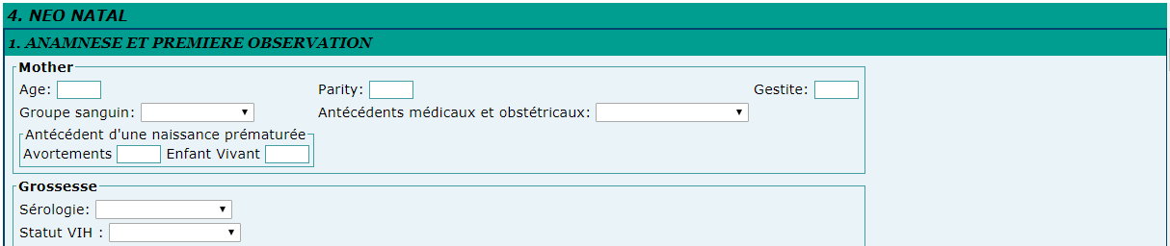

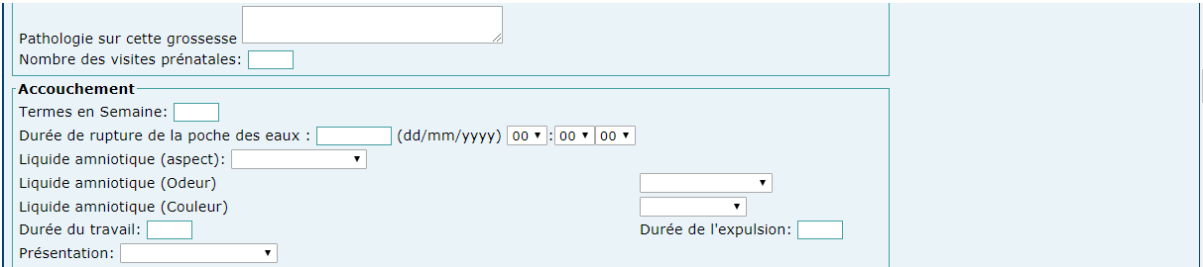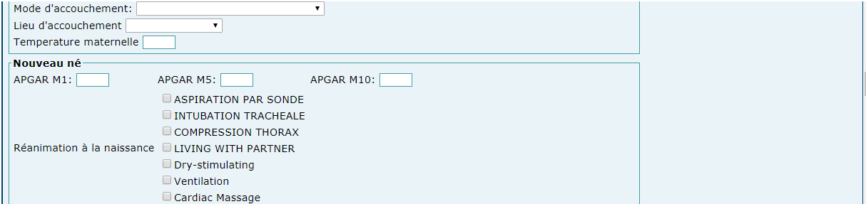

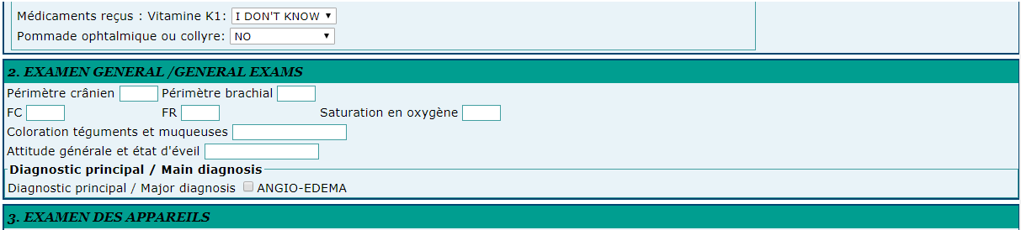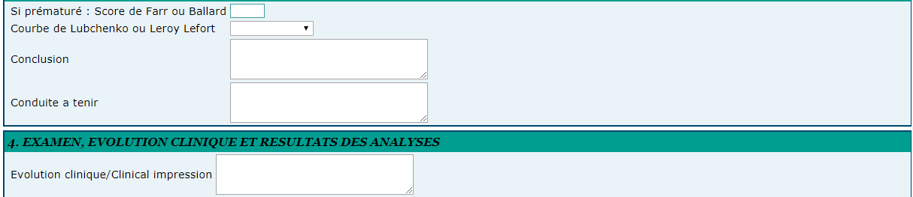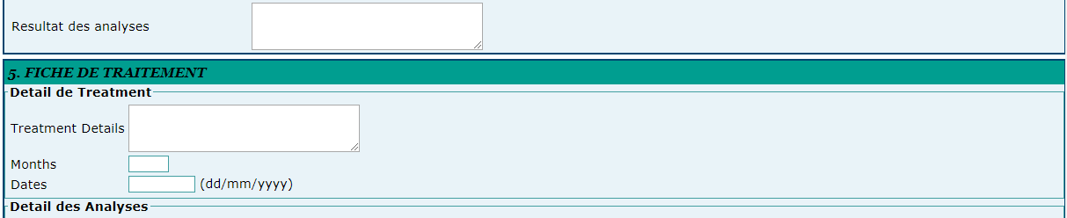



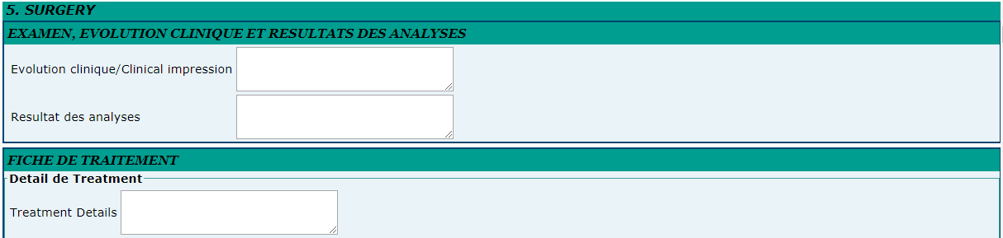

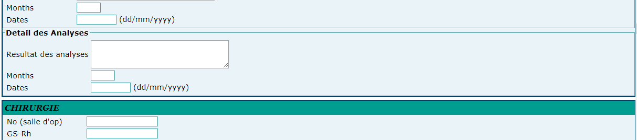

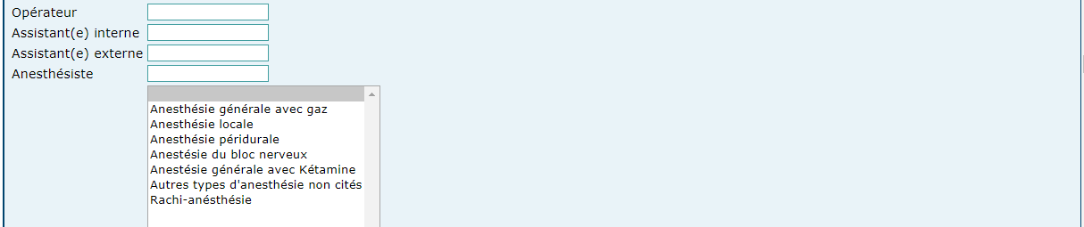







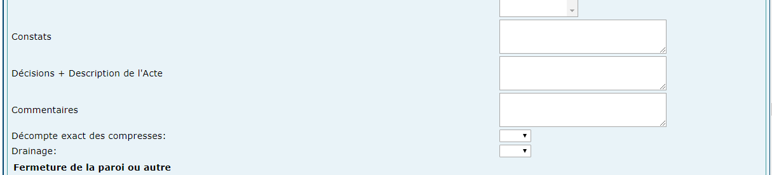

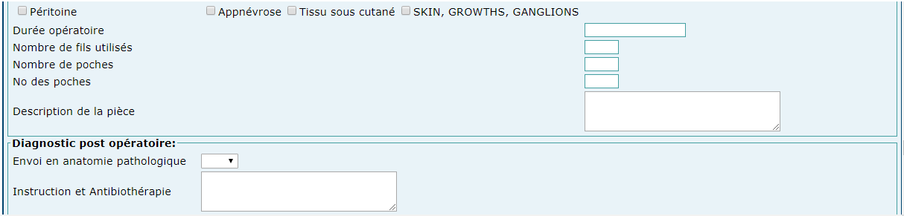

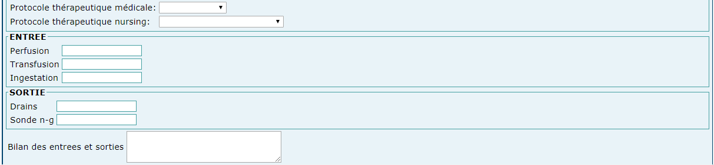

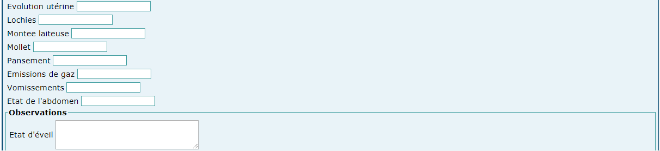

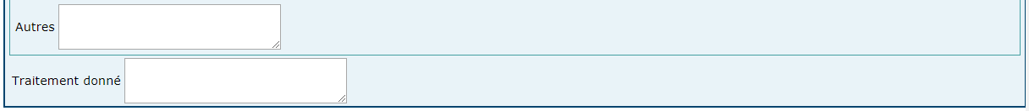



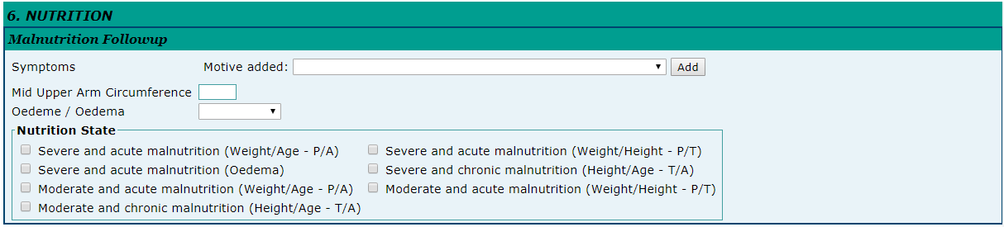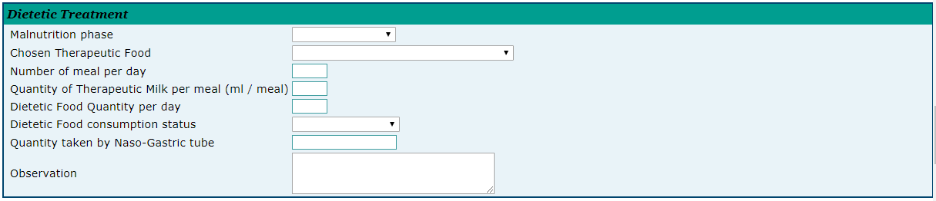

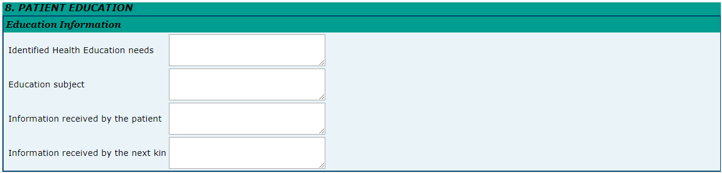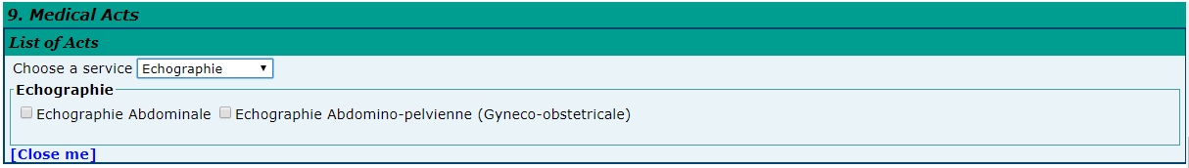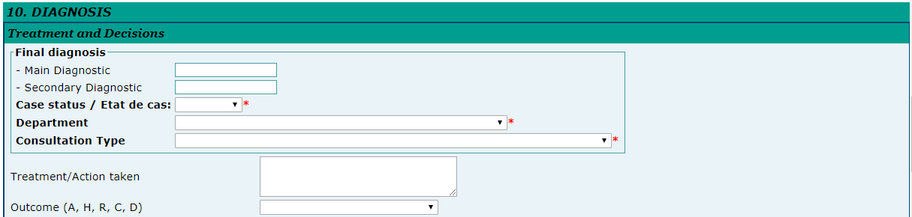

Dsadsad

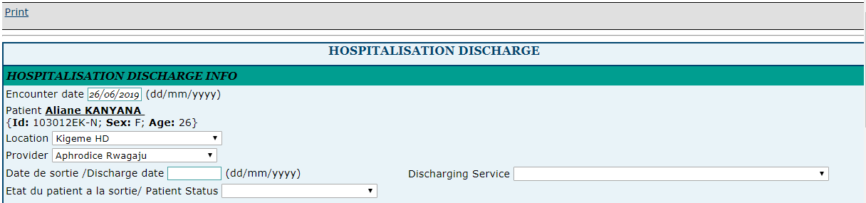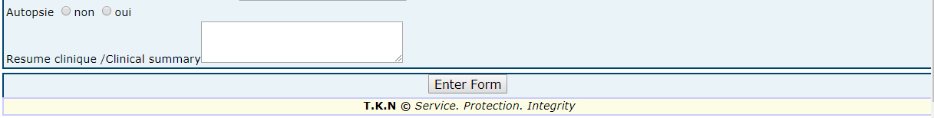

**3. Transfer all in one form**



**2.2.6.3.9 IPD FORMS**

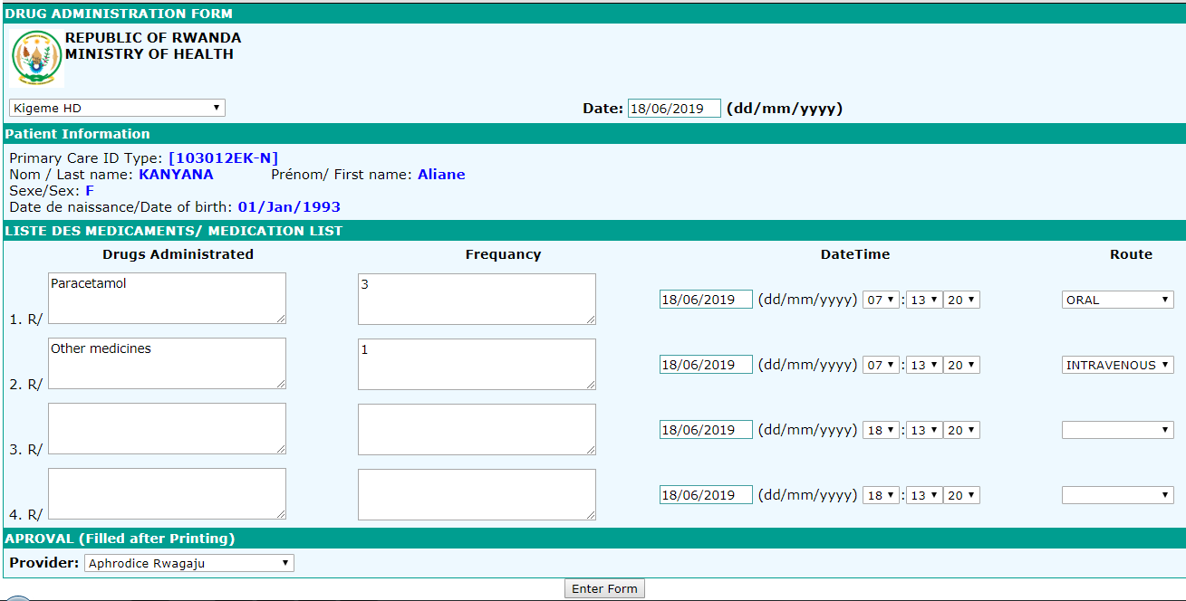

Viewing drug administration for the patient

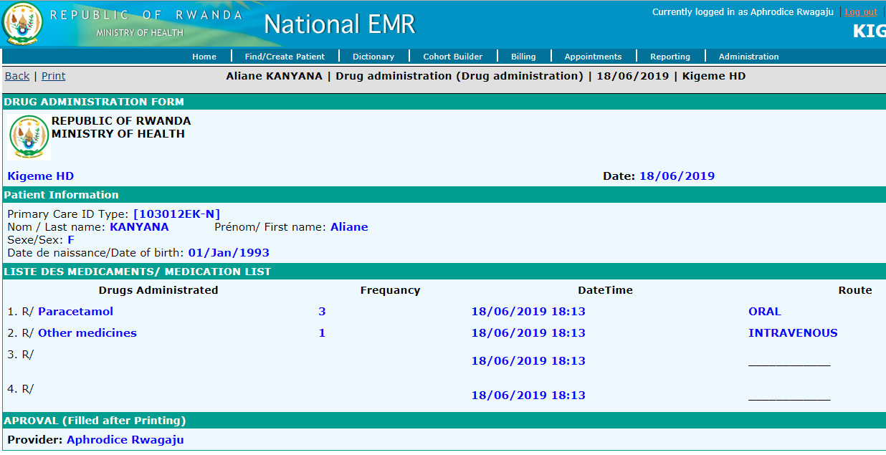

Dossier Infrimier

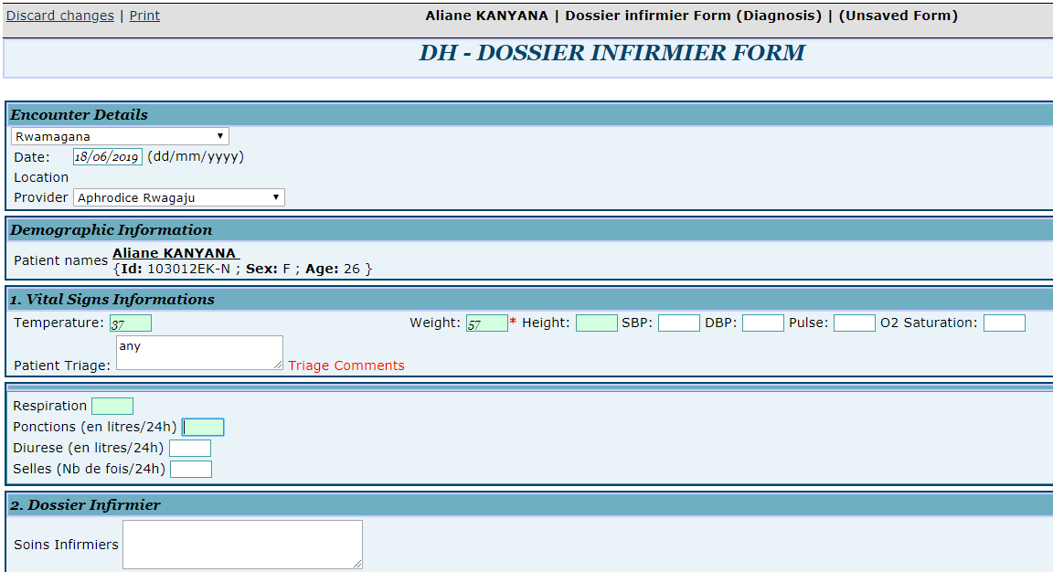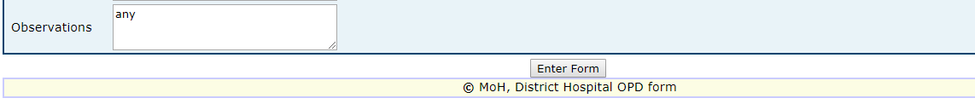

Ordonance medicale

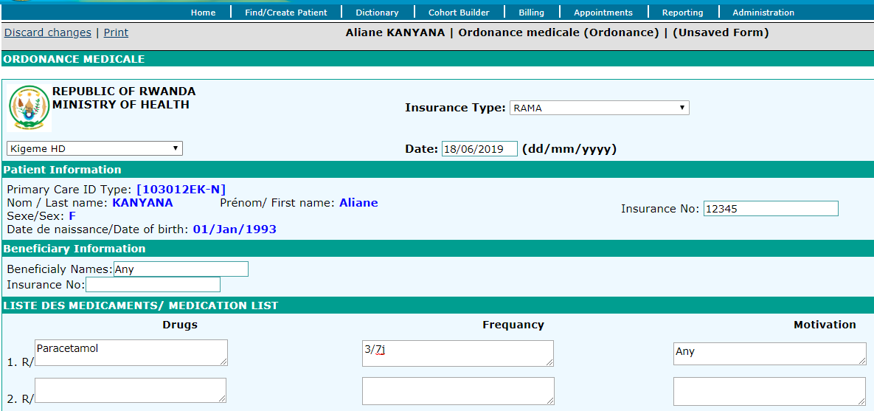 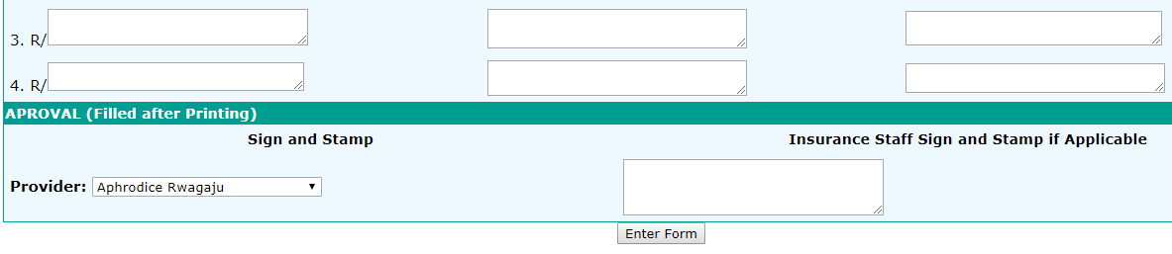

IIIIIIIIIIIIIIIIIIIIIIIIii BBBBB  
Ghghghhghghghgg

Hhhjghjj Stopped here

## 2.3 USING COHORT BUILDER

This is an OpenMRS module used to generate reports. It builds a cohort (a group of people with a shared or common statistical characteristics, eg: Age between 5 & 10, weight between 65 & 80 Kg) of patients based on the similarity of their characteristics.

**Steps**:

1. Log into EMR using your username and password
2. Click on “**Cohort Builder**” menu from main menu

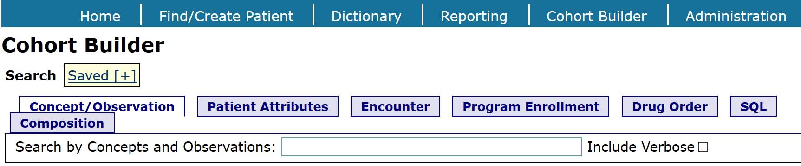

### 2.3.1 Concept / Observation

This tab is used to search for patients who have observations or concepts matching certain criteria. Type the name of the concept that you want to search for and choose that concept from the search results.

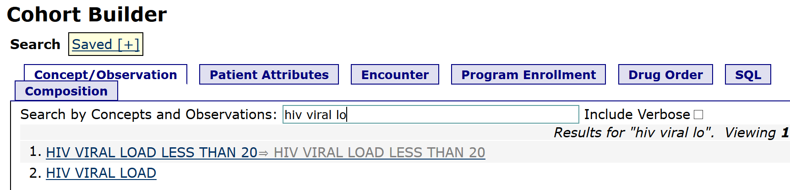

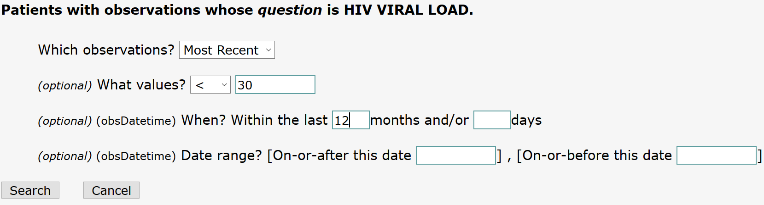

* + - 1. **Save search history in cohort**

Each **Patient Search** is added to your search history. This history is preserved until you choose to clear it or the web application is restarted. You may also save your search history to preserve it for future re-use.

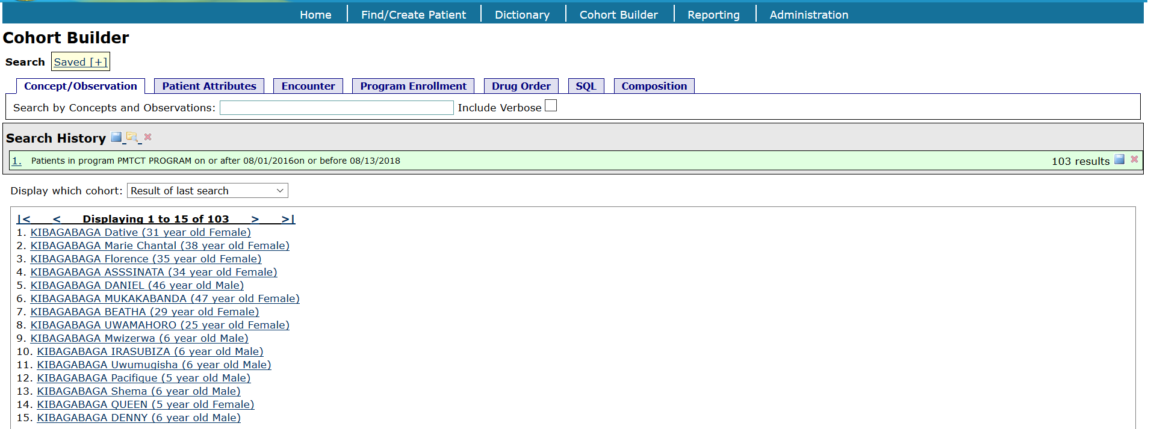

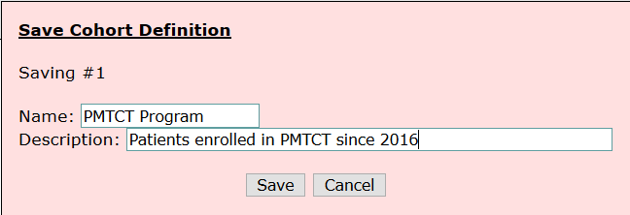

You can choose the values and dates for the HIV Viral Load

### 2.3.2 Patient Attributes

This tab is used to search based on simple demographics characteristics: gender, age, birthdate, marital status, etc.

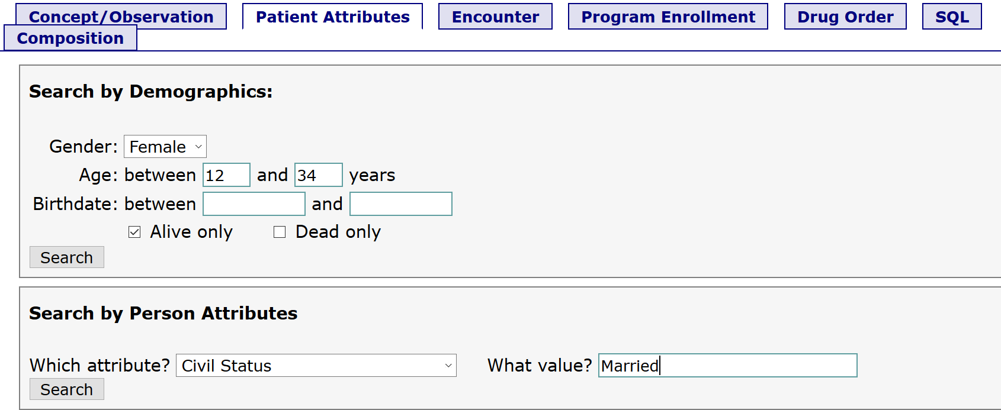

### 2.3.3 Encounter

This tab is used to search based on encounters patients have had, eg: Adult initial, ped return, ANC visit, etc.

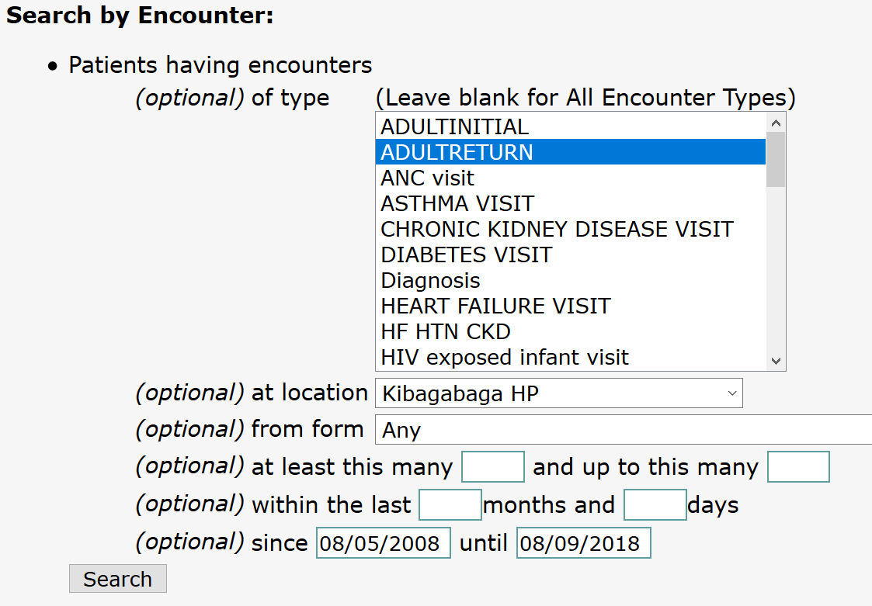

### 2.3.4 Program Enrollment

This tab is used to search for patients enrolled in a particular program or patient who have a particular status.

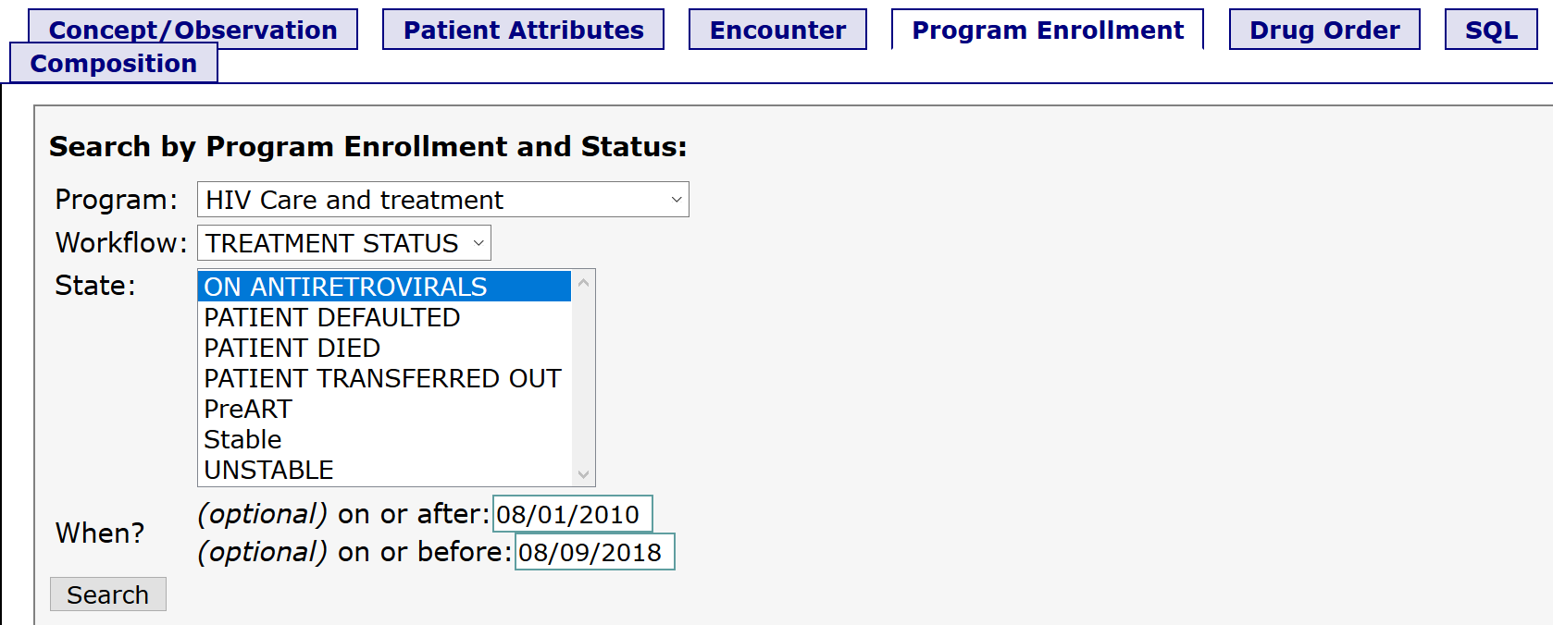

### 2.3.5 Drug Order

This tab is used to search patients taking specific drugs.

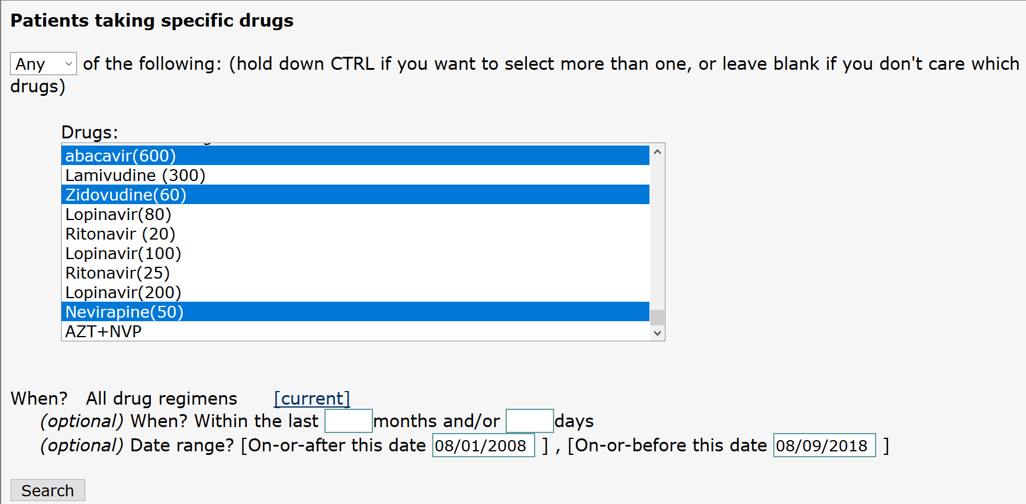

### 2.3.6 SQL

This is for advanced users who can be able to write SQL queries

### 2.3.7 Composition

After doing several searches, the composition tab allows to combine them using Boolean algebra. You can use **AND**, **OR**, **NOT** or **()** to build complex combinations of the other searches in your search history.

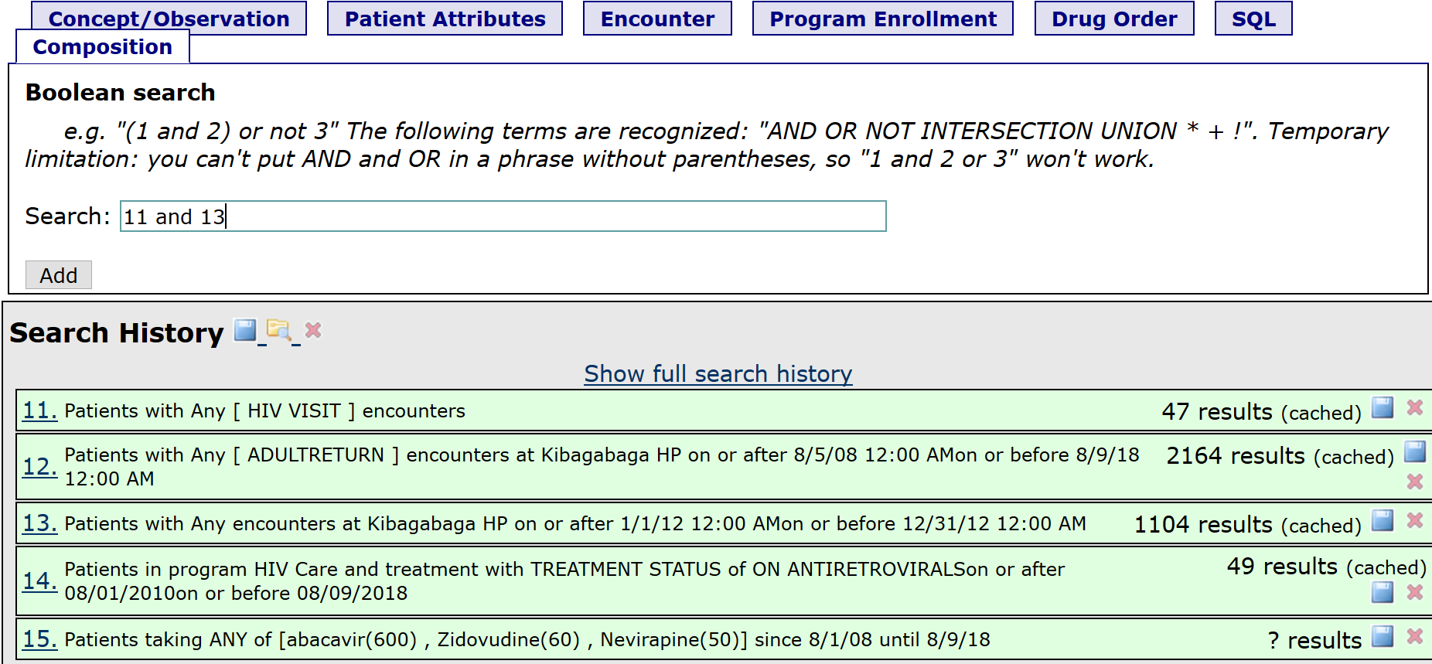

## 2.4 APPOINTMENT

### 2.4.1 Creating appointment

**Steps**:

1. Log into EMR using your username and password
2. Click on “**Home**” menu from main menu
3. Go to “**Appointment Management**” link of **useful links** section then click on “**Create appointment**” link to open the form

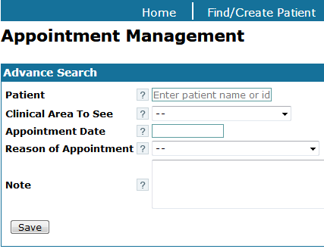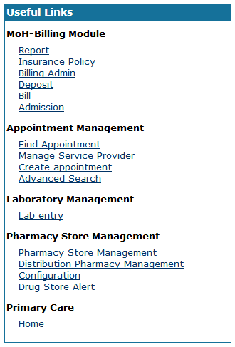

1. Fill the form and click on **[Save]** button to save the appointment

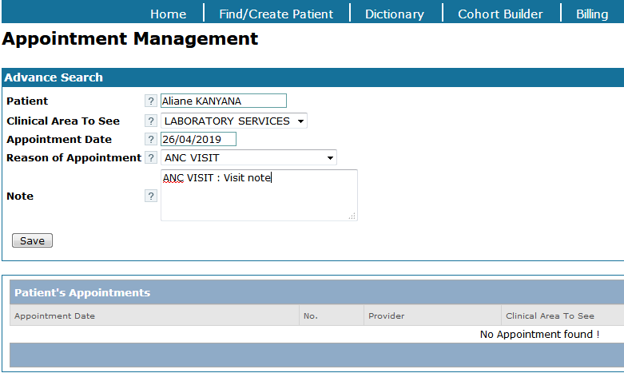

### 2.4.2. Finding appointment

**Steps**:

1. Log into EMR using your username and password
2. Click on “**Home**” menu from main menu
3. Go to “**Appointment Management**” link of **useful links** section then click on “**Find appointment**” link to open the form. The form bellow is open.

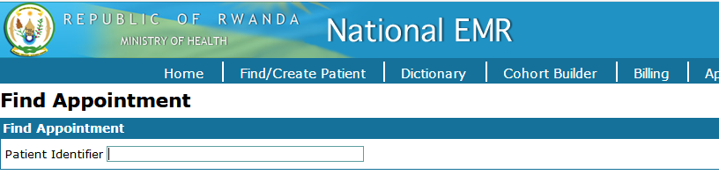

1. Enter the “**Patient identifier**”

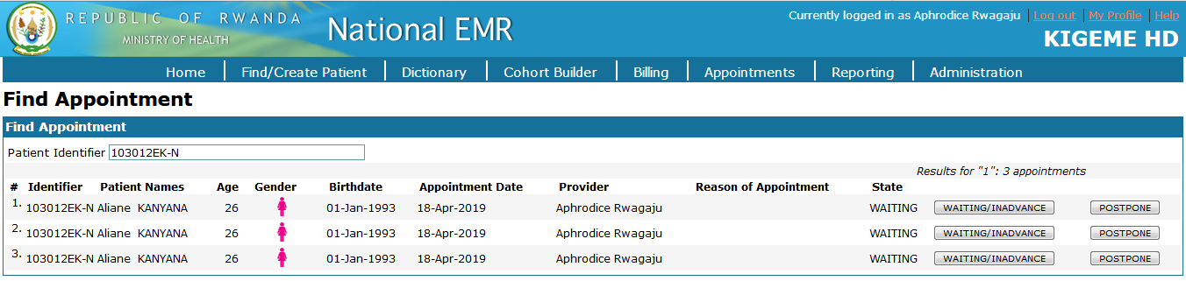

1. In case you need to change the status, click on **[Waiting/Inadvance]** button in the listed appointments

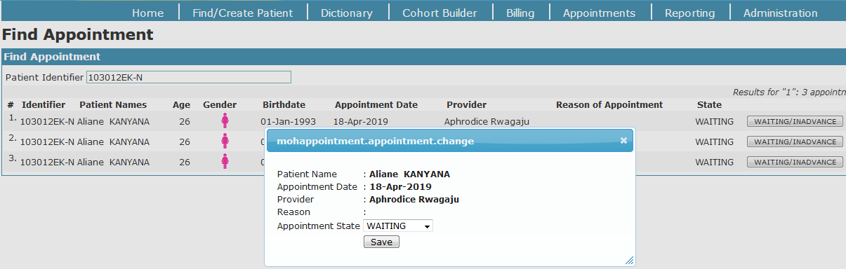

1. Change the status and save the changes
2. You can also postpone the appointment by clicking on **[postpone]** button

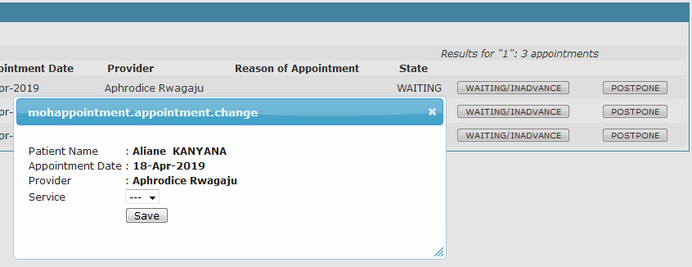

1. Select service provider and save changes

### 2.4.3. Manage service provider

#### 2.4.3.1 Adding service provider

**Steps**:

1. Log into EMR using your username and password
2. Click on “**Home**” menu from main menu
3. Go to “**Appointment management**” under **useful links** section and click on “**Manage service provider**” link

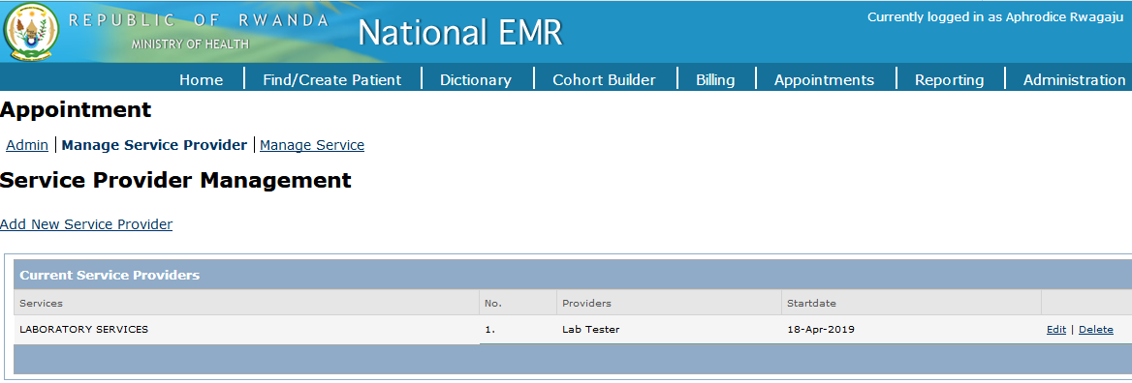

1. Click on “**Add new service provider**” link to add new provider

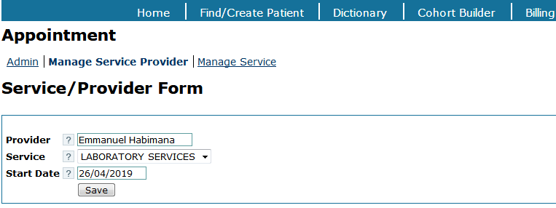

1. Click on **[Save]** button and you will be prompted to confirm or to cancel the record. Click on **[Ok]** button to confirm the record.

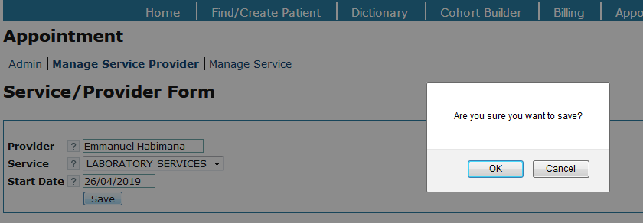

1. After saving the new provider, you will be directed to the list of service providers.

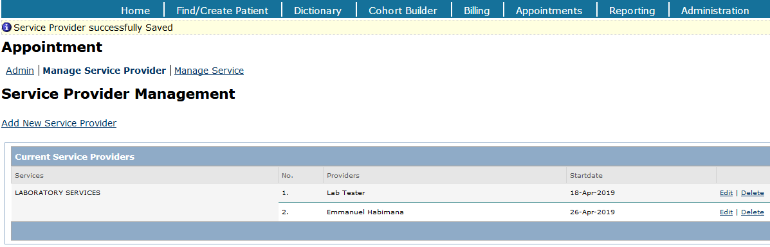

1. In case you need to edit or delete the service provider, use the “**Edit**” or “**Delete**” options available in service providers list. You can also export the list by using the **[Export]** button.

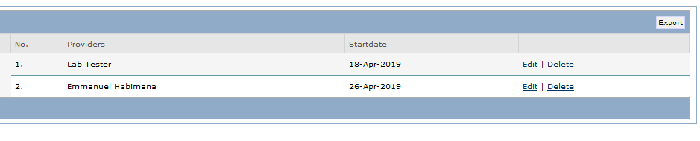

#### 2.4.3.2 Exporting service providers

**Steps**:

1. Click on **[Export]** button from the list of providers and fill the form

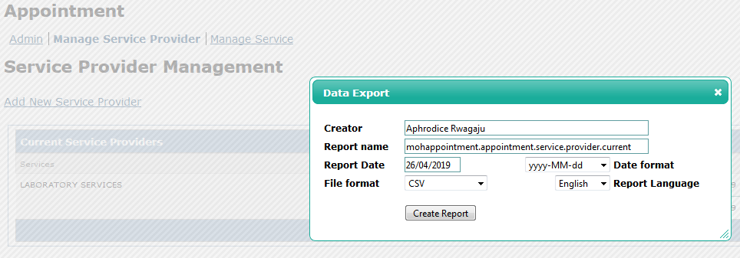

1. After filling the form, click on **[Create report]** button to download the list

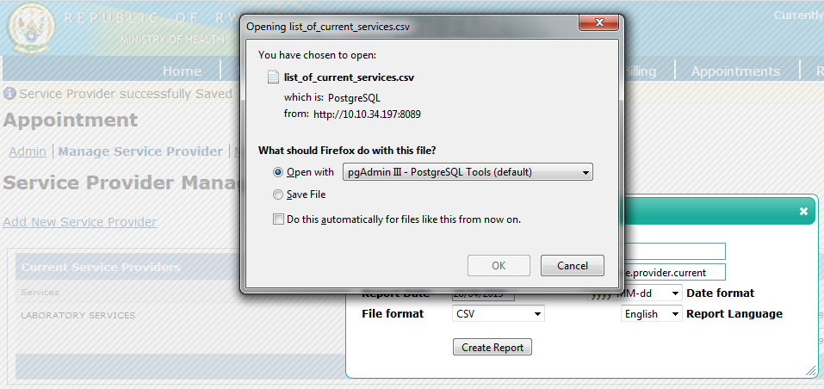

1. From the prompt window above, choose to open or save file of service providers list.

### 2.4.4 Advanced search

**Steps**:

1. Log into EMR using your username and password
2. Click on “**Home**” menu from main menu
3. Go to “**Appointment management**” under **useful links** section and click on “**Advanced search**” link.

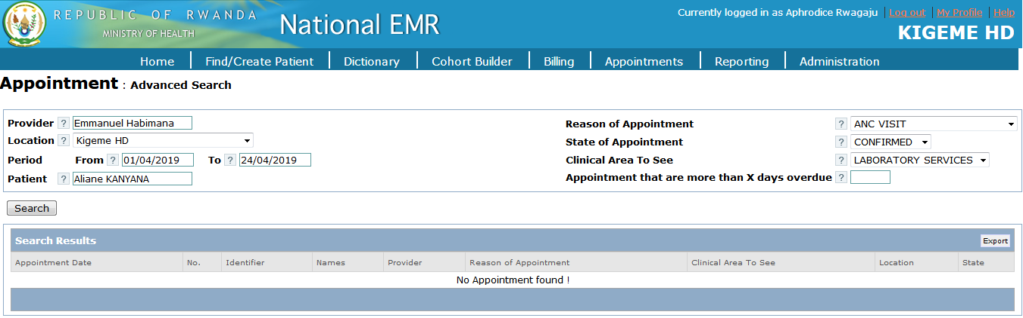

1. After filling the form with all search criteria, click on **[Search]** button to view the results.

## 2.5 LABORATORY ORDERS

It displays possible lab tests. Clinician selects one or combinations of tests to be taken by laboratory service during the patient visit.

### 2.5.1 Making laboratory order

**Steps**:

1. Log into EMR using your username and password
2. Click on “**Find/Create a patient**” menu from main menu
3. Find a patient from search field available on opened form
4. Click on “**Laboratory Order**” tab

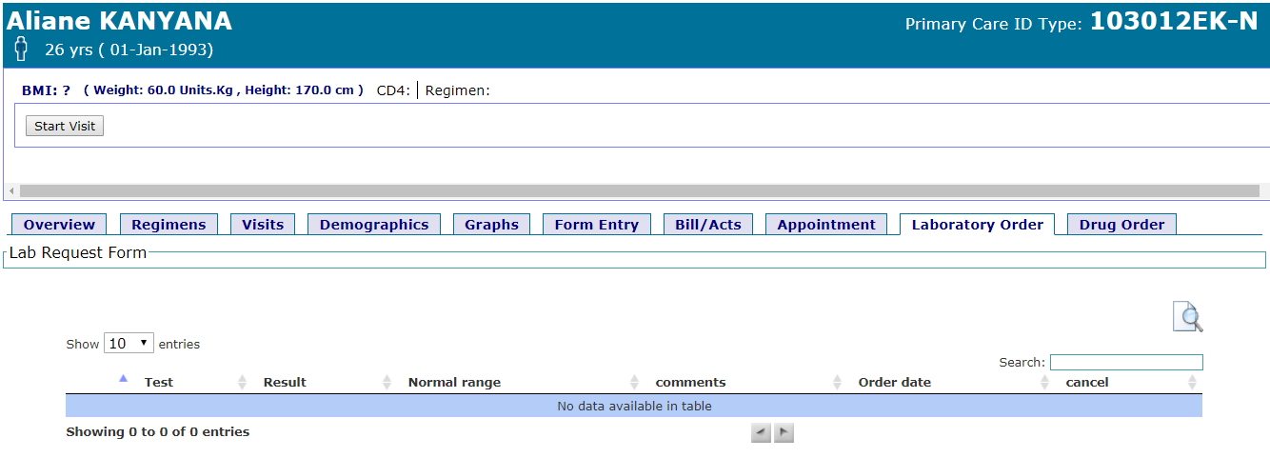

1. Click on “**Lab Request Section**” to open all possible tests
2. Select tests to be analyzed in laboratory

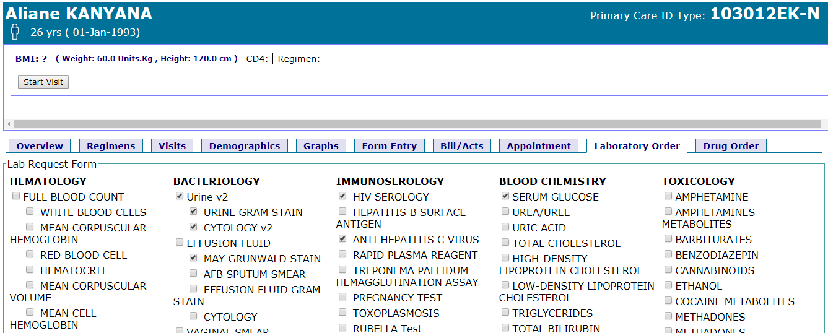

1. Scroll down the lab test form and click on **[Save Lab orders]** button to complete the process

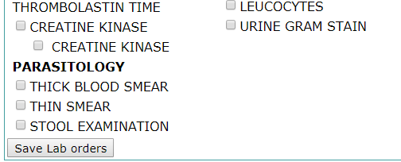

1. Click on “**Laboratory Order**” to view laboratory orders for selected patient

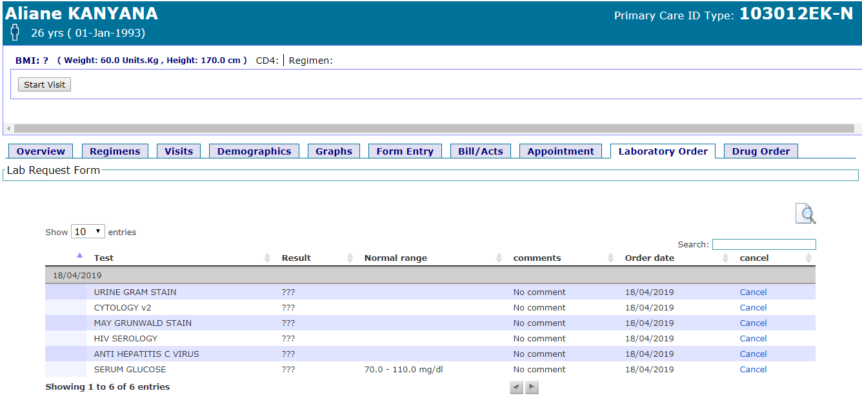

|  |  |
| --- | --- |
| Image result for information icon | **Note:**  The laboratory order list contains the following items:   1. Possible lab tests search 2. Lab orders date 3. Lab order items column 4. Lab order results column 5. Results normal range column 6. Comment column 7. Order date culumn 8. Canceling lab order option 9. Lab order search field 10. Print preview |

### 2.5.2 Laboratory results entry

#### 2.5.2.1 View lab order

**Steps**:

1. Log into EMR using your username and password
2. Go to “**Useful Links**” section on EMR home page
3. Click on “**Lab entry**” link under the laboratory management option

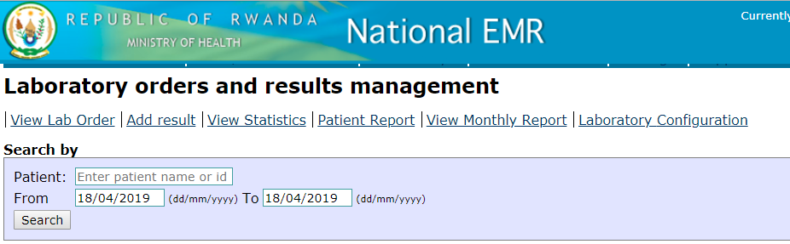

1. 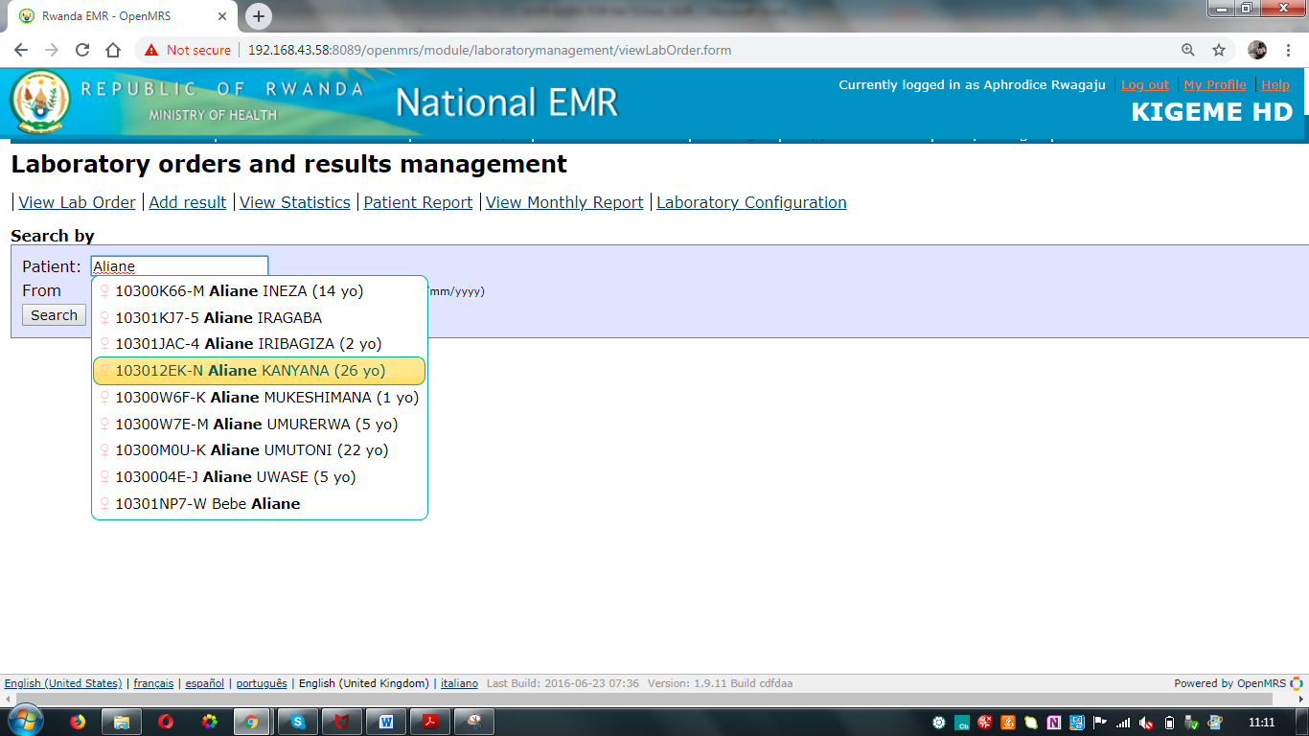Find a patient from search field available on opened form and click on **[Search]** button.

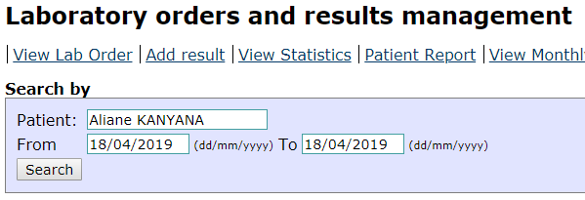

The laboratory order for the selected patient is open.

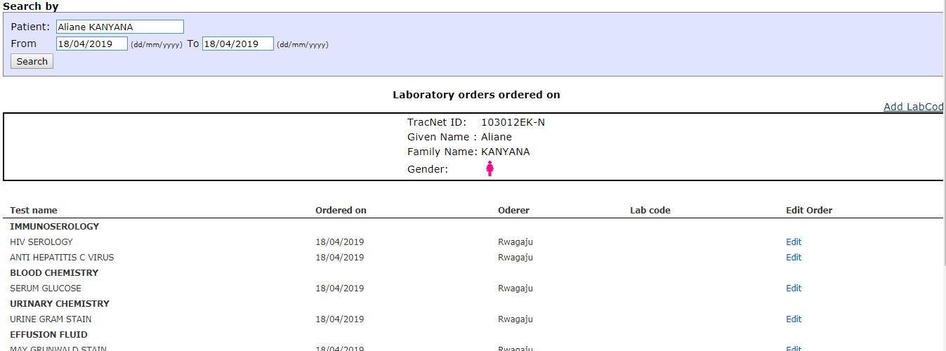

1. Click on “**Add LabCode**” link to assign the code to the laboratory order

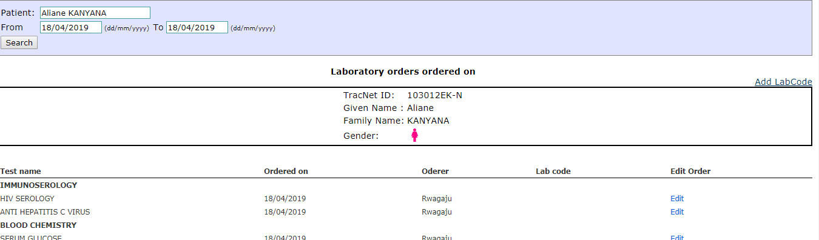

1. Enter the lab code for laboratory order and click on **[Add Lab Code]** button

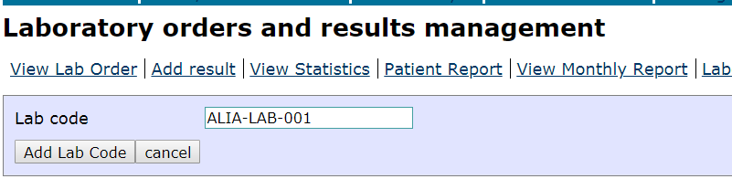

1. View the return page

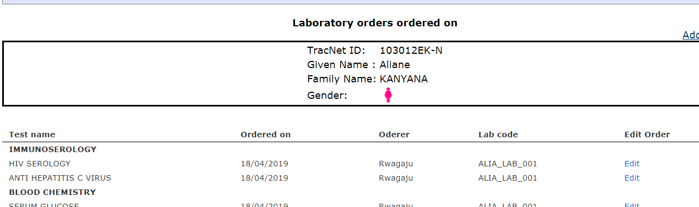

#### 2.5.2.2 Adding results to lab order

**Steps**:

1. Log into EMR using your username and password
2. Go to “**Useful Links**” section on EMR home page
3. Click on “**Lab entry**” link under the laboratory management option
4. Click on “**Add results**” tab
5. Enter laboratory order code and click on **[Search]** button

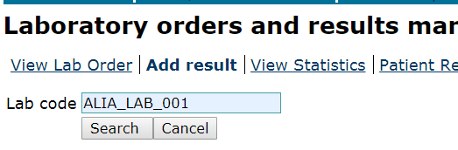

**Lab order code here!**

1. Fill the laboratory results form and click on **[Update]** button to save the changes

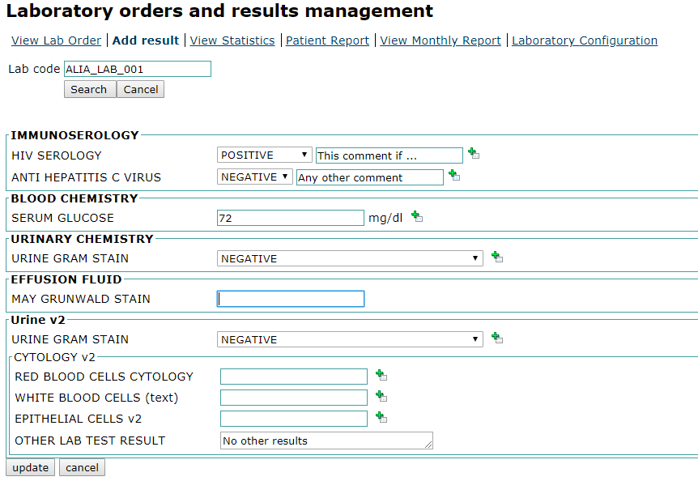

**Button to add comment**

**Comment**

#### 2.5.2.3 Patient report

The following are steps for viewing the laboratory order results for a patient:

**Steps**:

1. Log into EMR using your username and password
2. Go to “**Useful Links**” section on EMR home page
3. Click on “**Lab entry**” link under the laboratory management option
4. Click on “**Patient report**” tab
5. Enter laboratory order code or patient name and select visit date then click on **[Search]** button to view lab results the patient

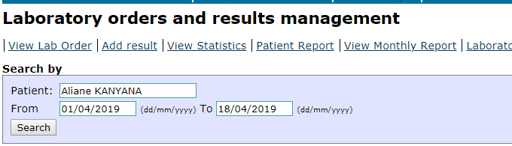



The following is the results page.

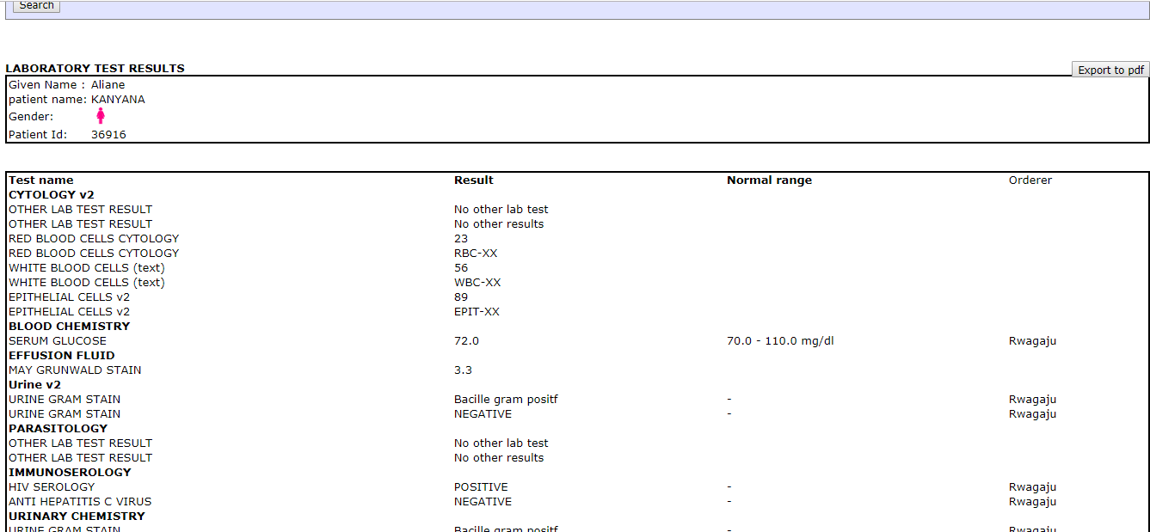

**Lab order test results**

1. Click on **[Export to PDF]** button in to red circle to open printable version for laboratory results

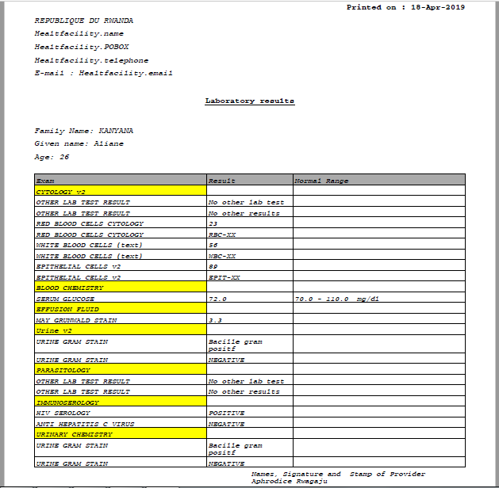

### 2.5.3 Viewing laboratory results monthly reports

There is a bug to be fixed for this function to work properly => to add steps and screenshots

### 2.5.4 Viewing laboratory results from patient dashboard

**Steps**:

1. Log into EMR using your username and password
2. Click on “**Find/Create a patient**” menu from main menu
3. Find a patient from search field available on opened form
4. Click on “**Laboratory Order**” tab and the page showing the results is returned

The laboratory order results page is open

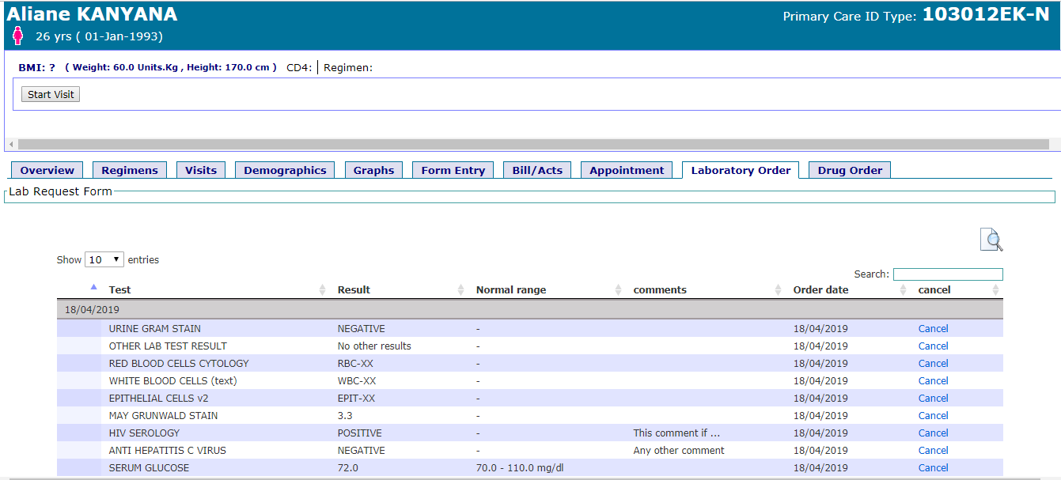

|  |  |
| --- | --- |
| Image result for information icon | **Note:**   * If results or some part of results are missing, it means no data entered yet. * Reporting window (i.e from date - to date) can be the same date (i.e one day) * For printing laboratory results, user should download the the PDF file and print it. * In normal case, results are accessible under patient dashboard |

## 2.6 PHARMACY

Pharmacy module deals with store management, distribution management, drugs management, pharmacy location management and reports.

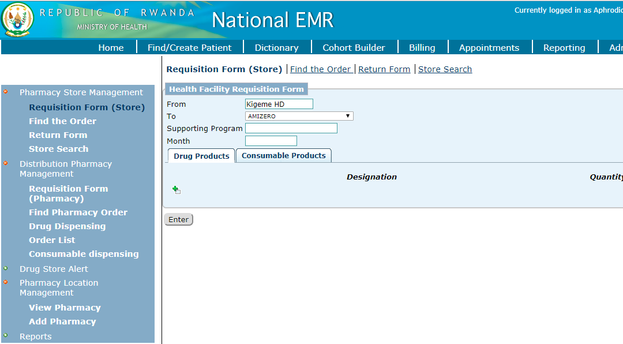

|  |  |
| --- | --- |
|  | **Item descriptions**   1. **Side navigation menu:** User uses this menu and submenu to navigate through possible functions of pharmacy module 2. **Enter button:** It is used to save item listed in 8 3. **Add new item button**: Once clicked, the form to record new requisition item is open 4. **Drug products tab**: Used to record drug products requisitions 5. **Consumable products tab**: Used to record consumable products requisitions 6. **Requisition basic information**: Used to record requisition basic information 7. **Horizontal navigation submenu:** User uses this area to navigate through possible functions of selected menu 8. **Record listing area:** Used to list items in requisition |

### 2.6.1 Pharmacy store management

#### 2.6.1.1 Health facility requisition

The health facility requisition form is used to place an order of drugs/medicines and consumable products by a health facility.

**Steps**:

1. Log into the EMR using your username and password
2. On home page, under the “**Pharmacy Store Management**” section, click on “**Pharmacy Store Management**” link
3. Select “**Drug Products”** tab and fill the form according to the requisition specifications

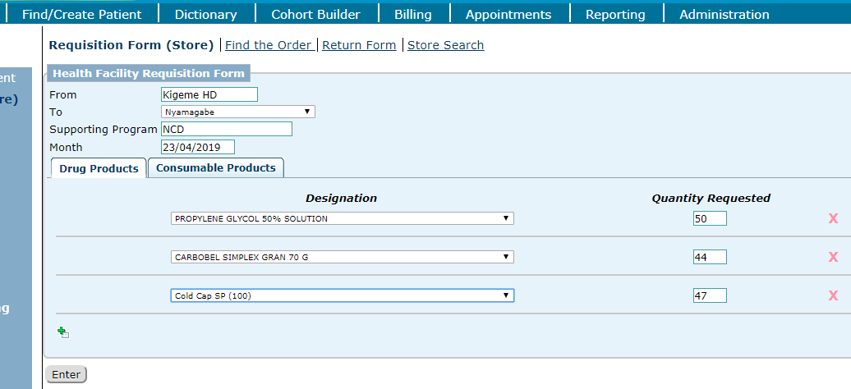

1. Select “**Consumable Products**” tab and fill the form according to the consumable products request

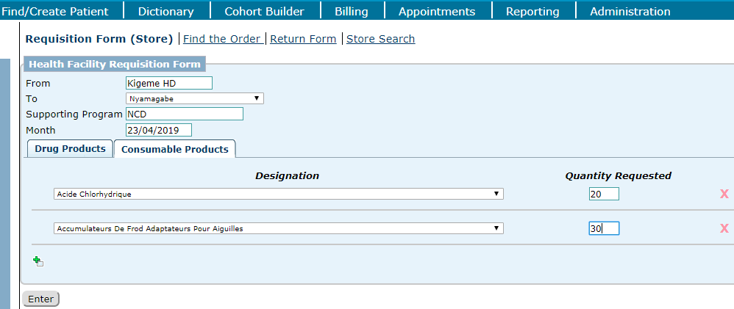

1. Click on **[Enter]** button to save the requisition

#### 2.6.1.2 Finding the order

**Steps**:

1. Log into the EMR using your username and password
2. On home page, under the “**Pharmacy Store Management**” section, click on “**Pharmacy Store Management**” link
3. Select “**Find the order**” tab and fill the form accordingly
4. Click on **[Find]** button to complete the process

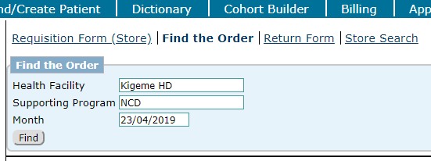

1. Click on the status to view the requisition report. For this case click on “**incomplete**” link.

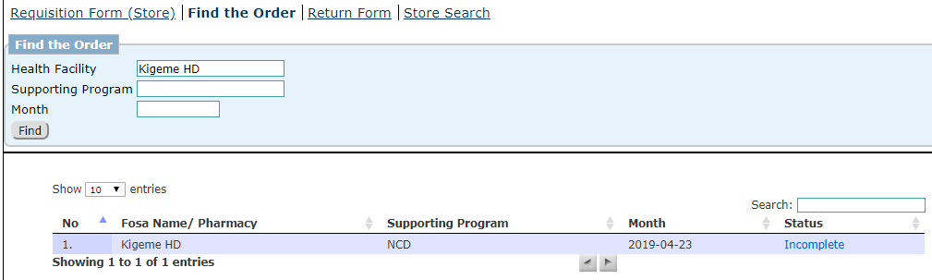

1. For changing the quantity requested, click on “**Edit**” icon and edit any record you want to modify

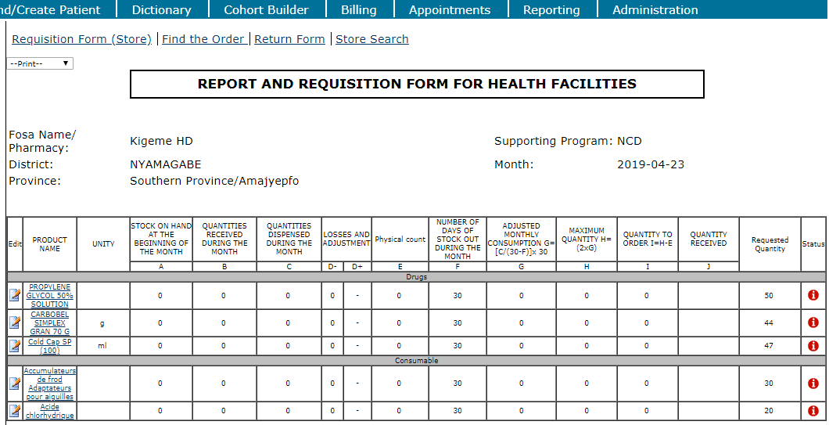

1. Enter your changes and click on **[Update]** button to save your changes

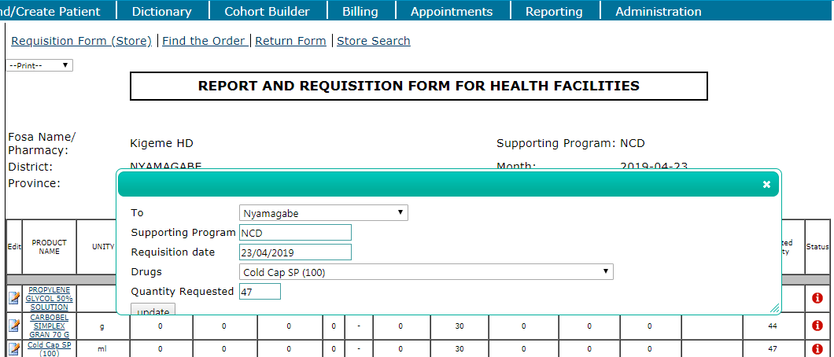

1. For approving the quantity requested, click on “**Red**” icon in status column

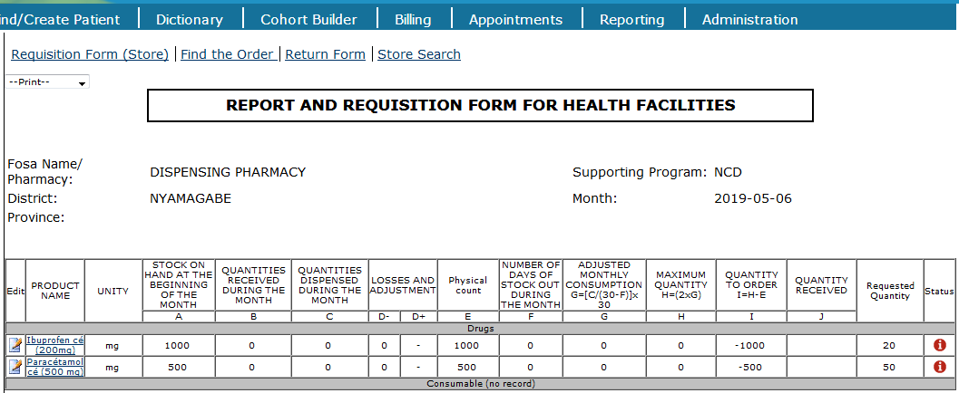

1. In the opened window, enter the quantity to be given to the pharmacy, select the lot number and expiry date and click on **[Update]** button to save the changes

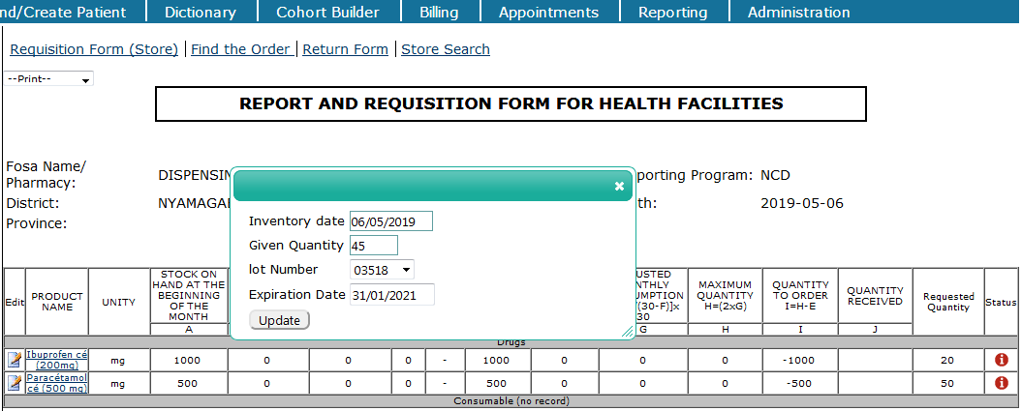

1. A “**√**” symbol will be marked on the accepted requisition

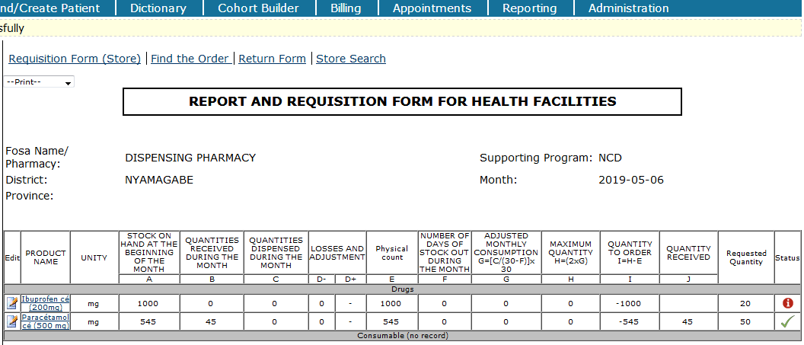

1. If all the requested drugs/consumables have been confirmed, the pharmacy order status will be marked as “**Completed**”

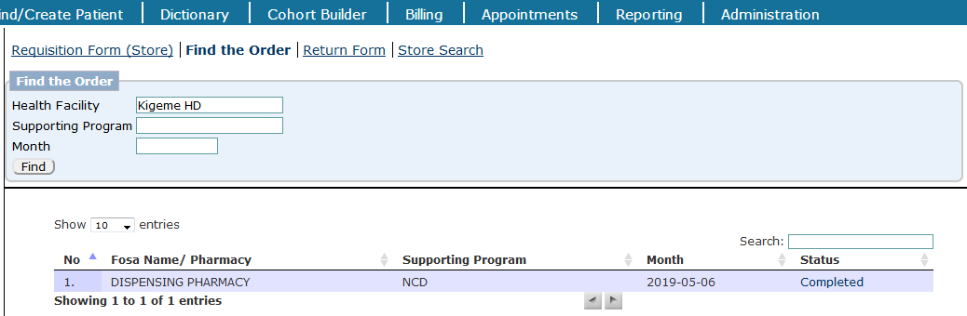

#### 2.6.1.3 Return form

In case a facility wishes to return the drugs or consumable products, the user fills bellow form:

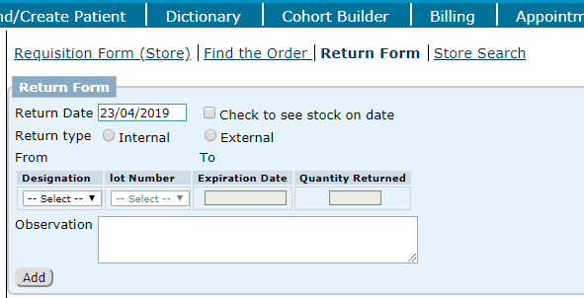

#### 2.6.1.4 Store search tab

Helps to view products in stock

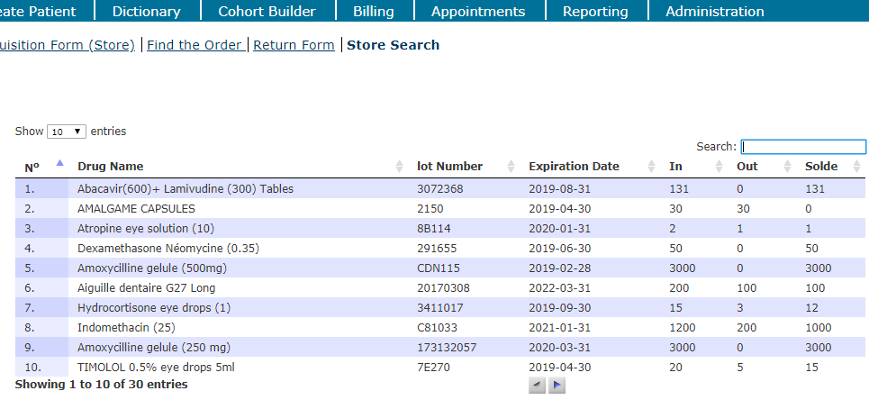

### 2.6.2 PHARMACY REQUISITION

#### Image result for information icon2.6.2.1 Requisition form

This process is done by nurses

The pharmacy requisition form is used to place an order of drugs/medicines and consumable products by a pharmacy.

**Steps**

1. Log into the EMR using your username and password
2. On home page, under the “**Pharmacy Store Management**” section, click on “**Distribution Pharmacy Management**” link
3. Select “**Pharmacy**” requesting drugs, enter supporting program and month
4. Click on “**Drug Product**” tab
5. Click on green plus sign to add new drug and fill the opened form. Repeat the process until all requested drugs are entered

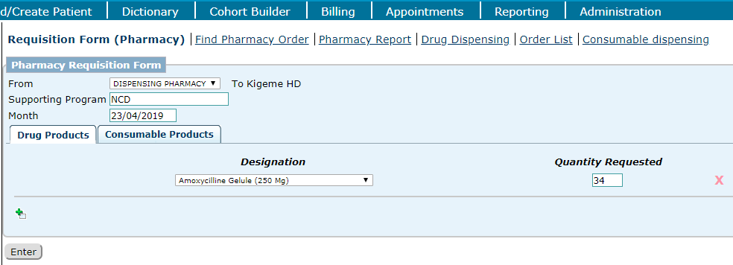

1. If consumable products are requested, click on “**Consumable Products**” and repeat the **step #5** to complete the process
2. Click **[Enter]** button to save changes

#### 2.6.2.2 Find pharmacy order

This process is done by store pharmacist

**Steps**

1. Log into the EMR using your username and password
2. On home page, under the “**Pharmacy Store Management**” section, click on “**Distribution Pharmacy Management**” link
3. Click on “**Find Pharmacy Order**” submenu
4. Select the pharmacy requesting the drugs, enter supporting program and month
5. Click on **[Find]** button

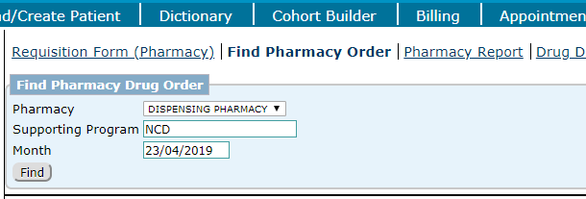

1. See the results displayed on bellow page

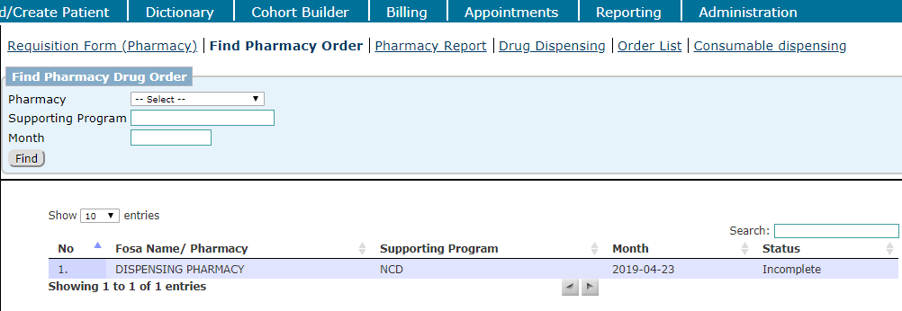

To complete steps of completed the order by store pharmacist

#### 2.6.2.3 Pharmacy report

**Steps**

1. Log into the EMR using your username and password
2. On home page, under the “**Pharmacy Store Management**” section, click on “**Distribution Pharmacy Management**” link
3. Click on “**Pharmacy Report**” submenu
4. Select the pharmacy in pharmacy options, enter reporting window (From date – To date)
5. Click on **[Find]** button and view the results on the same page

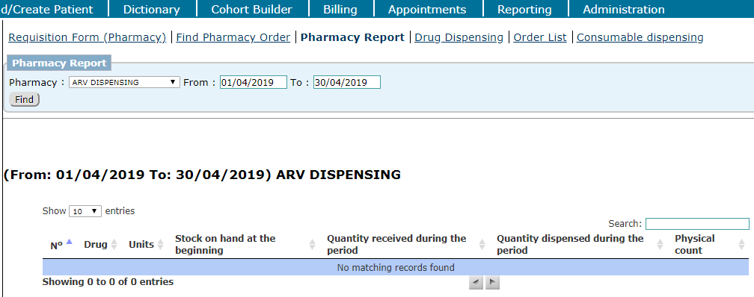

The above report returned zero items

#### 2.6.2.4 Drug order for patient

**Steps**:

1. Log into EMR using your username and password
2. Click on “**Find/Create a patient**” menu from main menu
3. Find a patient from search field available on opened form
4. Click on “**Drug order**” tab
5. Click on **[Create]** button

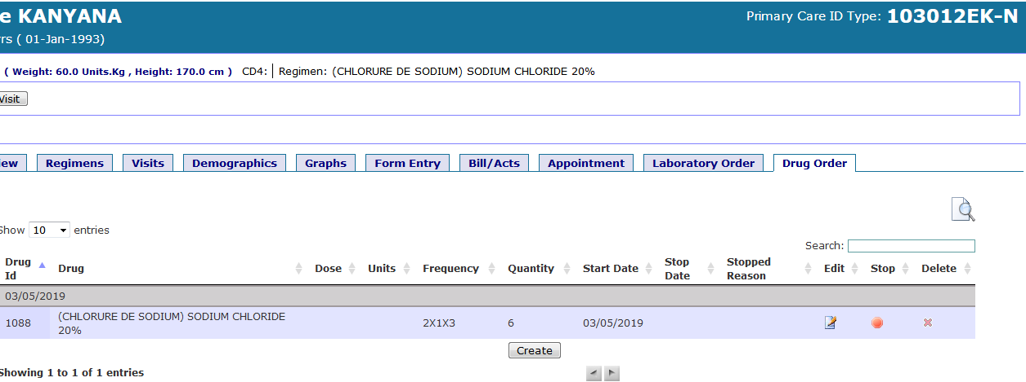

1. Enter medical prescription and click on [Submit] button to save the changes

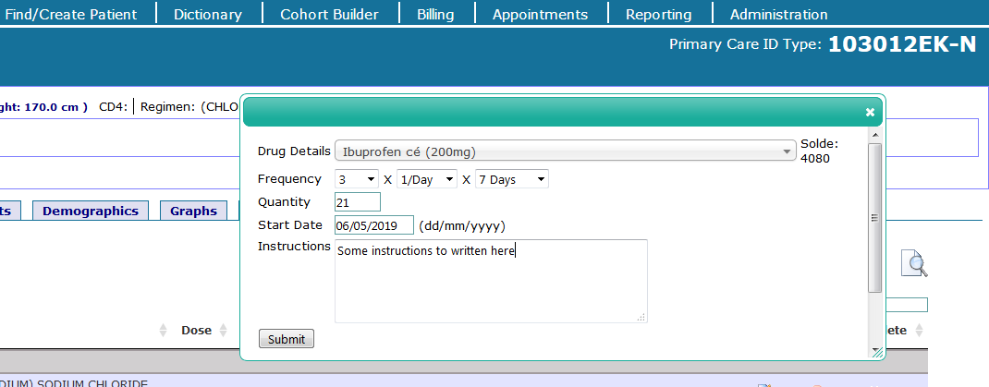

1. View the drug order for the patient

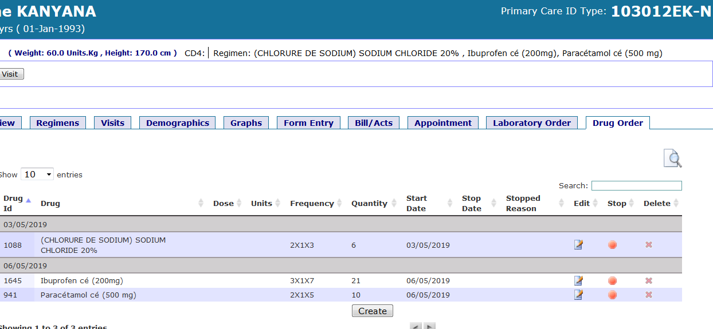

|  |  |
| --- | --- |
|  | **Item descriptions**   1. **Edit:** Click this icon to edit medical prescription 2. **Stop:** Click this icon to stop taking the described drugs 3. **Delete:** Click this icon to delete medical prescription |

#### 2.6.2.5 Drugs dispensing

**Steps**:

1. Log into the EMR using your username and password
2. On home page, under the “**Pharmacy Store Management**” section, click on “**Distribution Pharmacy Management**” link
3. Click on “**Drug Dispensing**” submenu
4. Enter patient name/ID
5. Select the **pharmacy** under pharmacy column. After the selection of pharmacy, all the patient drug orders will be populated on the form of the “**Drugs**” section
6. Enter **visit date**, **weight**, **next visit date** and select **Lot No**
7. Click on **[Save]** button to complete the process

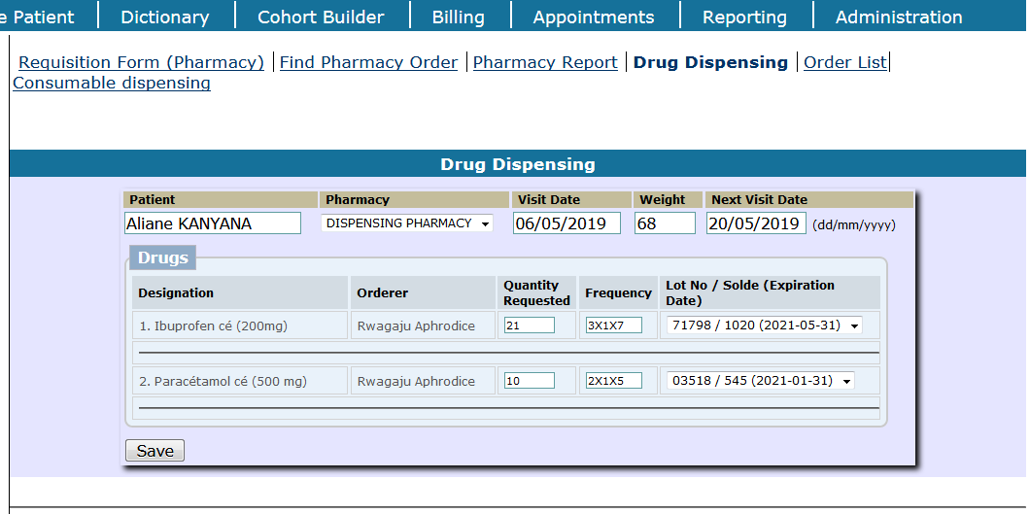

#### 2.6.2.6 Stopping the medical/drug prescription for the patient

**Steps**:

1. Log into EMR using your username and password
2. Click on “**Find/Create a patient**” menu from main menu
3. Find a patient from search field available on opened form
4. Click on “**Drug order**” tab and click on “**Stop**” icon in stop column

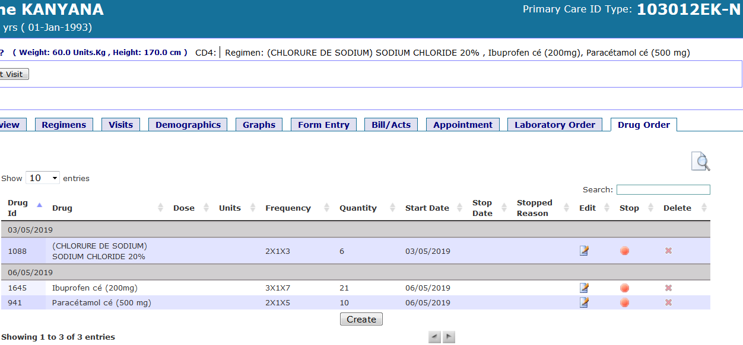

1. Select the **stop reason** and enter **stop date** then click on **[Update]** button to save changes

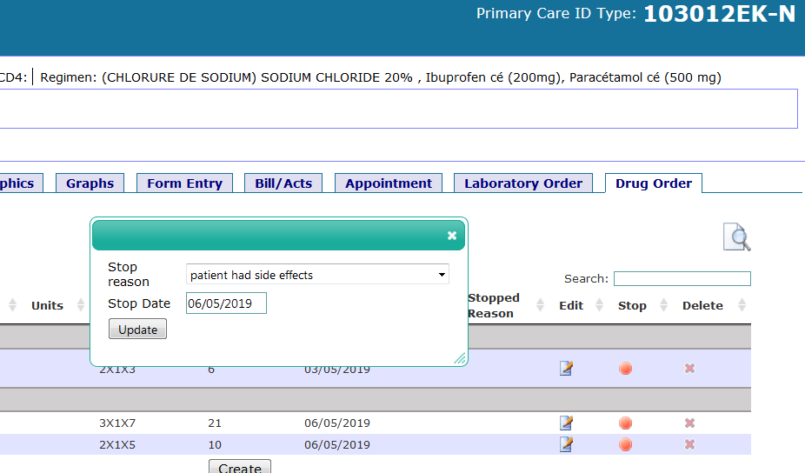

1. View the changes: The stop date and stop reason are shown in red cycle

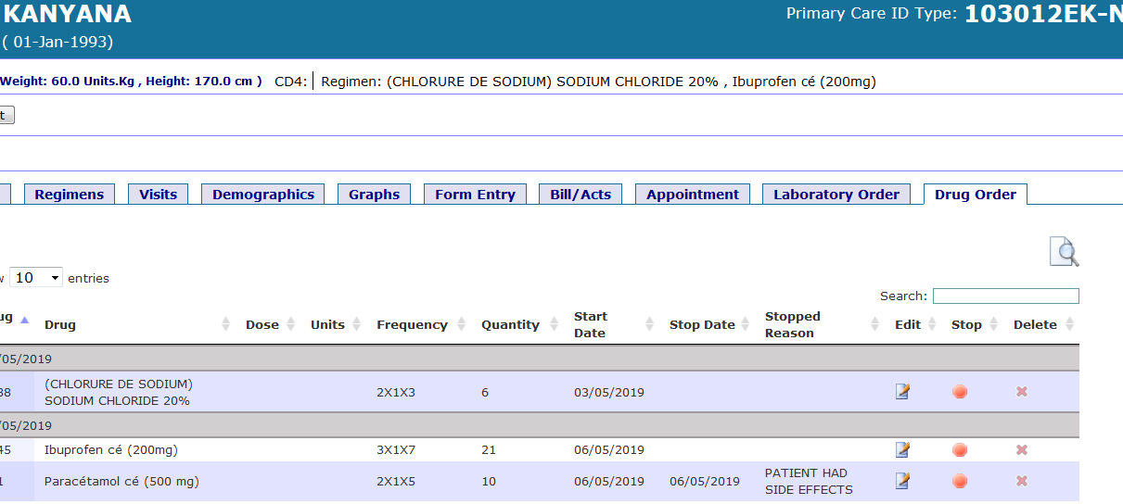

#### 2.6.2.7 Consumable product dispensing

**Steps**

1. Log into the EMR using your username and password
2. On home page, under the “**Pharmacy Store Management**” section, click on “**Distribution Pharmacy Management**” link
3. Click on “**Consumable Dispensing**” submenu
4. Enter **date, service, consumable, quantity** and the **patient name** or **patient ID**.
5. Click on **[Save]** button to complete the process

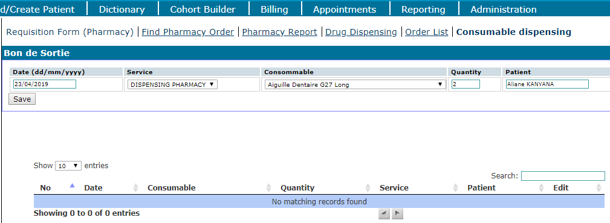

#### 2.6.2.8 Viewing dispensed consumable items

**Steps**:

1. Click on “**Consumable dispensing**” tab
2. Get the list of dispensed products

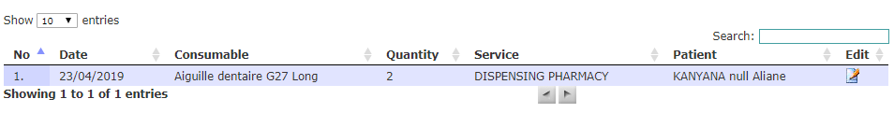

1. In case you need to edit, click on “**Edit**” icon in edit column
2. Fill the edit form and save changes

### 2.6.3 Drug store alerts & Expiration date alert

#### 2.6.3.1 Drug store alerts

Viewing “**Store run out**”

**Steps**:

1. Click on “**Drug store alert**”
2. Click on “**Drug store alerts & Expiration date alert**”
3. Click on “**Store run out**” tab and get the results page

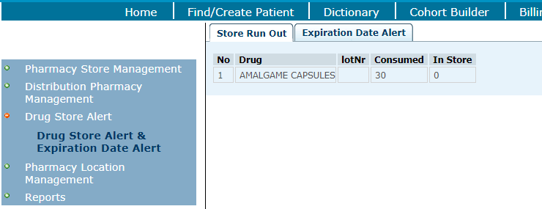

#### 2.6.3.2 Viewing expiration date alert

**Steps**:

1. Click on “**Drug store alert**”
2. Click on “**Drug store alerts & Expiration date alert**” link
3. Click on “**Expiration date alert**” tab and get the results page

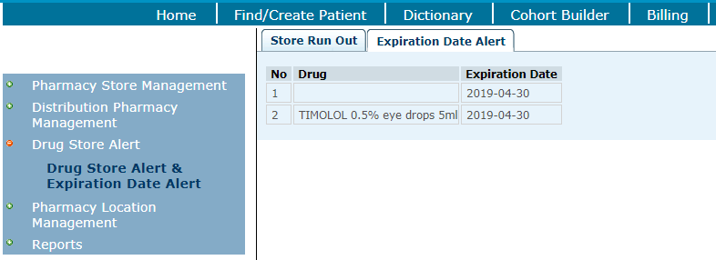

### 2.6.4 Pharmacy location management

#### 2.6.4.1 Adding pharmacy locations

**Steps**:

1. Log into the EMR using your username and password
2. On home page, under the “**Pharmacy Store Management**” section, click on “**Distribution Pharmacy Management**” link
3. Click on “**Pharmacy location management**” left menu
4. Click on “**Add pharmacy**” link and fill the form

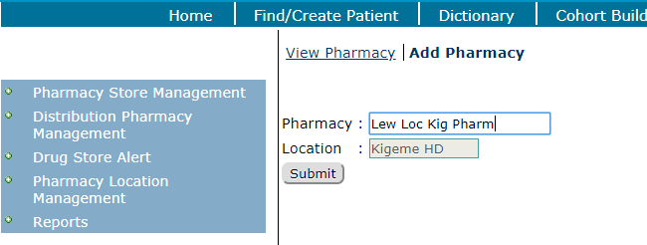

#### 2.6.4.2 View locations

**Steps**:

1. Log into the EMR using your username and password
2. On home page, under the “**Pharmacy Store Management**” section, click on “**Distribution Pharmacy Management**” link
3. Click on “**Pharmacy location management**” left menu
4. Click on “**View pharmacy**” link and see the list

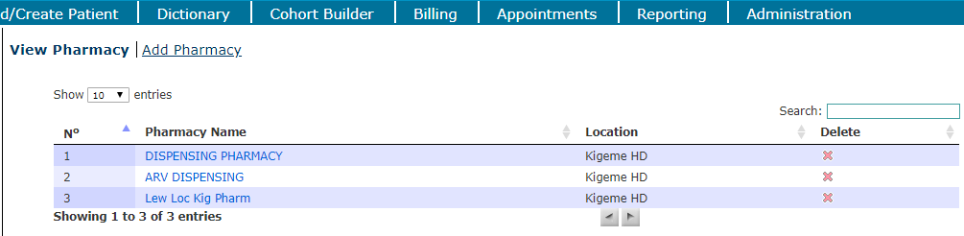

### 2.6.5 Pharmacy report

**Steps**:

1. Log into the EMR using your username and password
2. On home page, under the “**Pharmacy Store Management**” section, click on “**Distribution Pharmacy Management**” link
3. Click on “**Reports**” left menu
4. Click on “**Pharmacy report**” link under “**reports**” menu
5. Select pharmacy name and the reporting window (From date – To date)

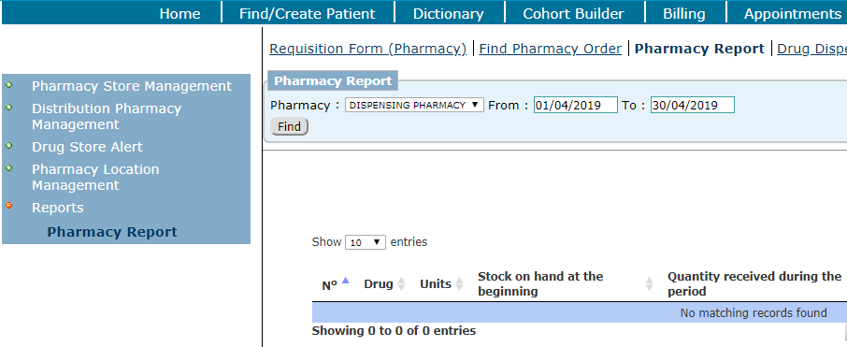

1. Click on the **[Find]** button to view the report

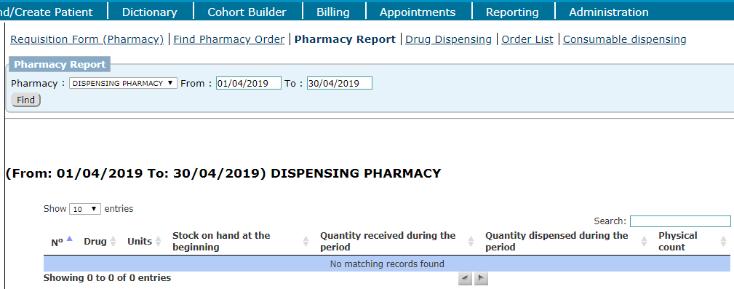

## 2.7 BILLING

Billing module is used to manage billing records. Its main menus are: **Manage Insurance Policy**, **Admission**, **Bill**, **Manage reports** and **Billing Admin**.

### 2.7.1 Manage Insurance Policy

**Steps**:

1. Log into EMR using your username and password
2. On home page, click on “**Insurance policy**” link in MOH billing module section

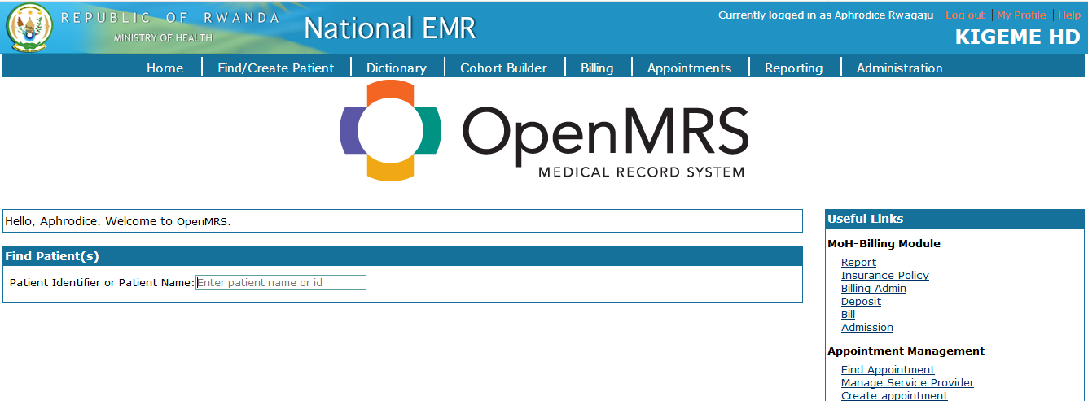

1. Search for a patient to create insurance policy. If the patient already has an insurance card number, search the patient using the card number.

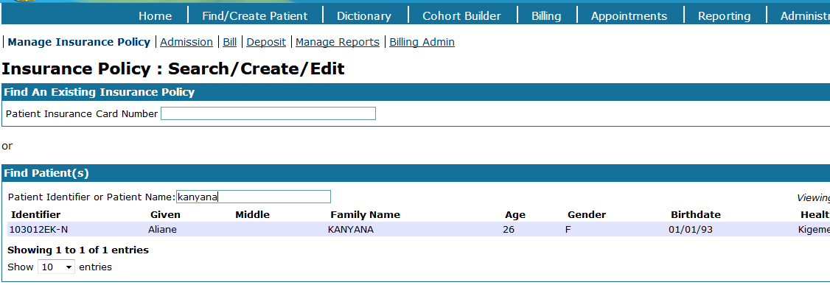

1. Select the patient then fill the form of insurance policy and click on **[Save insurance policy]** button

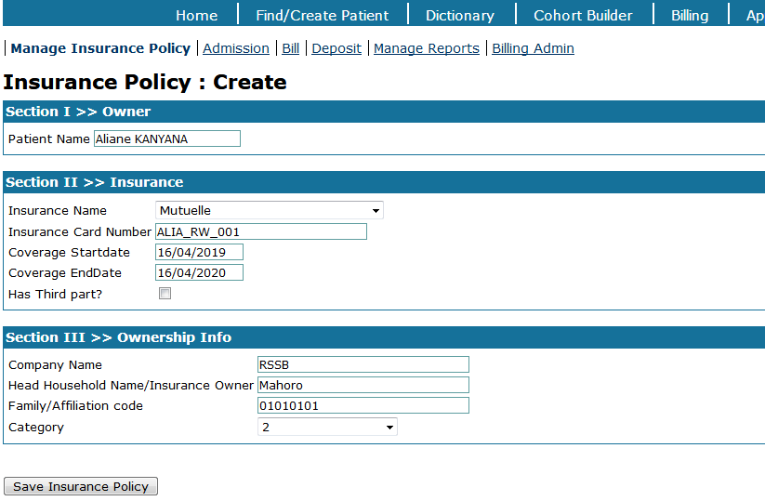

### 2.7.2 Admission

**Steps**:

1. Log into EMR using your username and password
2. On home page, click on “**Admission**” link in MOH billing module section

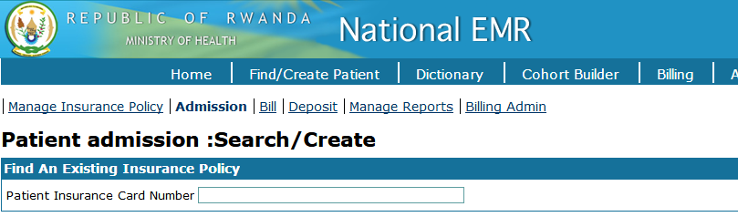

1. Search the patient using the insurance card number

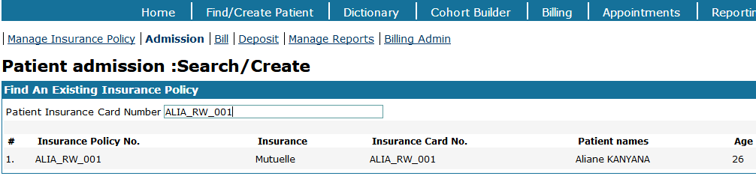

1. Select the patient then fill the admission date and select the disease type. Save the information by clicking on **[Save admission]** button

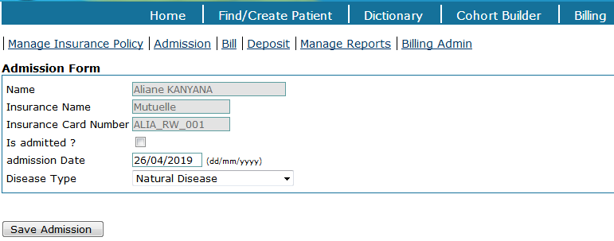

1. View the page after saving the admission

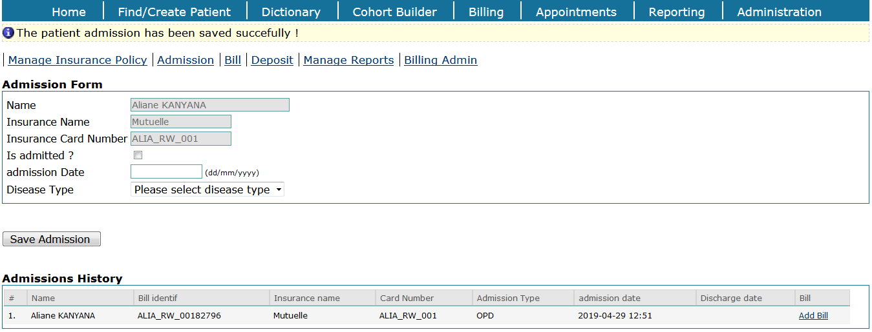

### 2.7.3 Billing a patient

**Steps**:

1. Log into EMR using your username and password
2. On home page, click on “**Bill**” link in MOH billing module section
3. Enter the patient insurance card number and select the patient

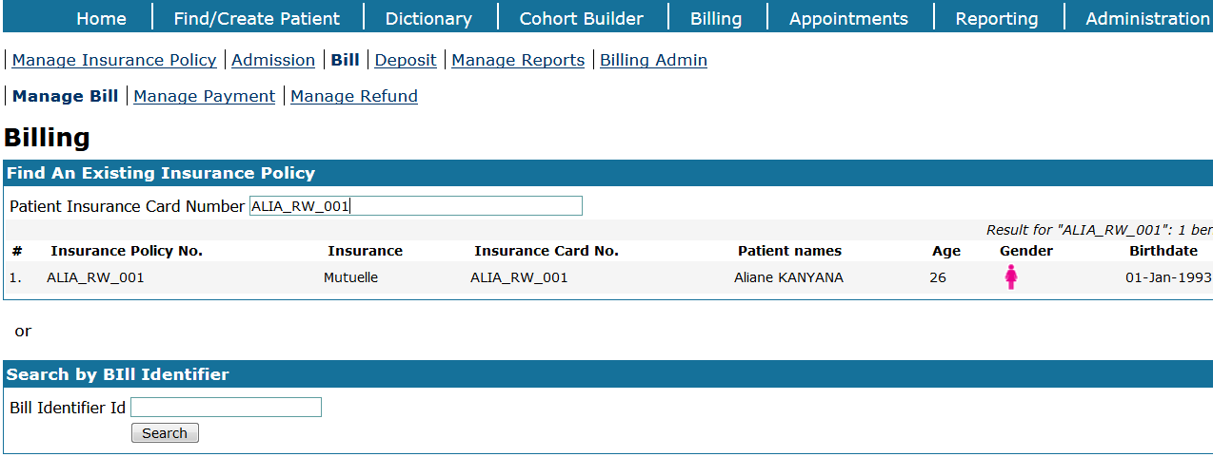

1. Click on “**Add**” link in **global bill list** section

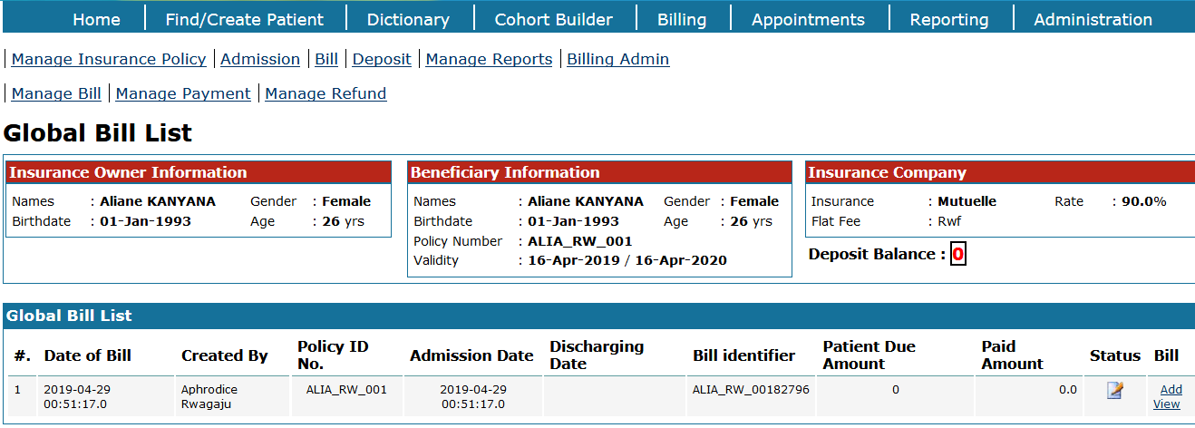

1. Select services by department and click on **[Search services]** button

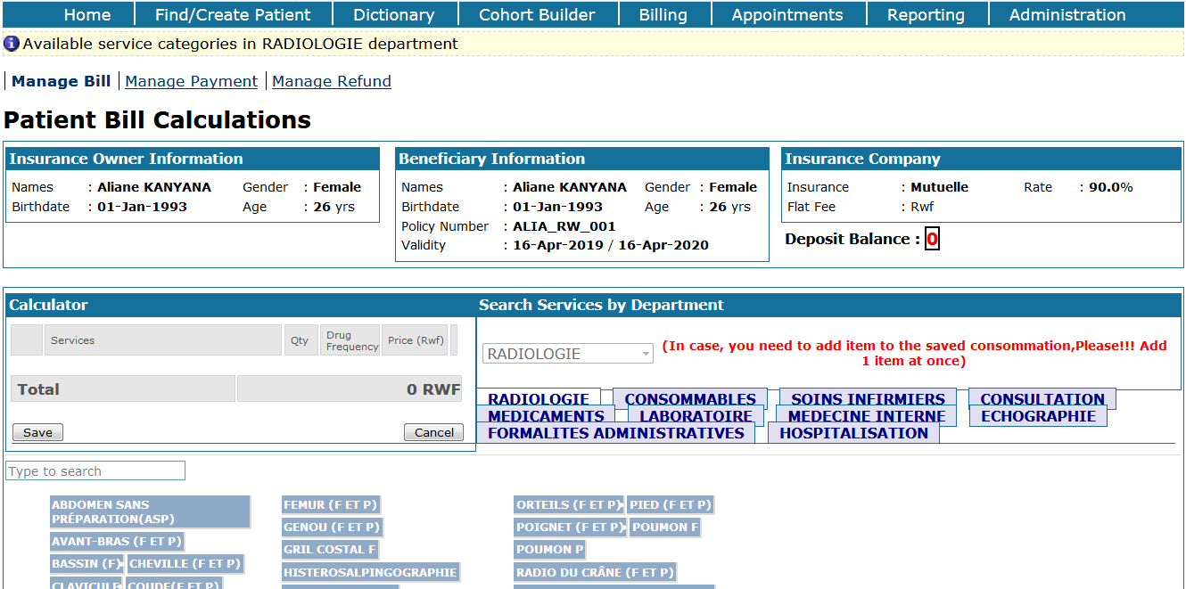

1. After selecting services by department, add billed items to the calculator by clicking on desirable item and save the bill

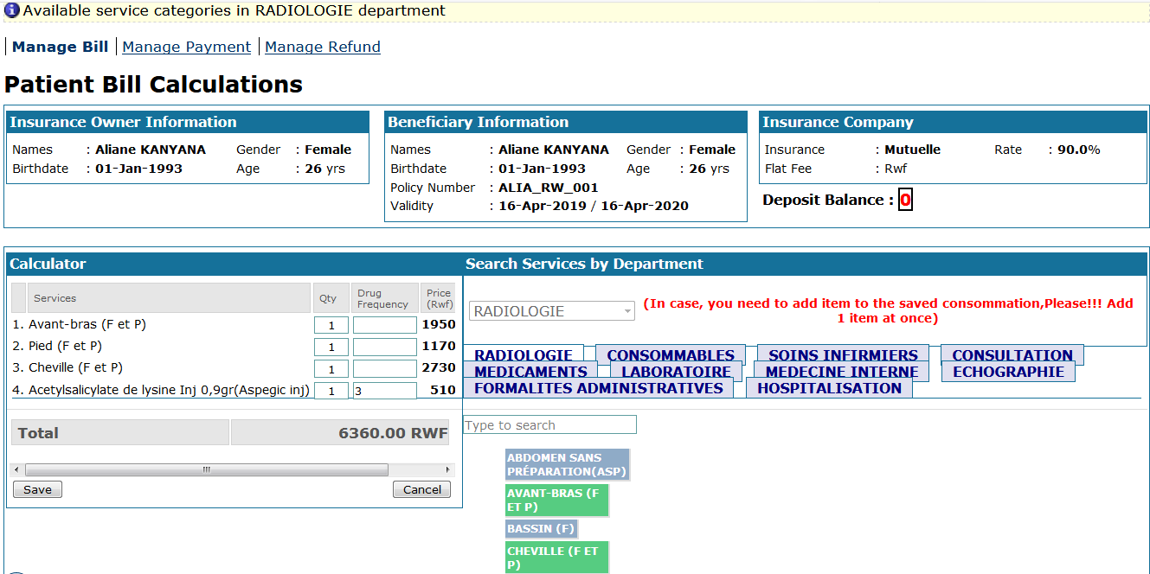

1. The patient bill payment is generated as follows:

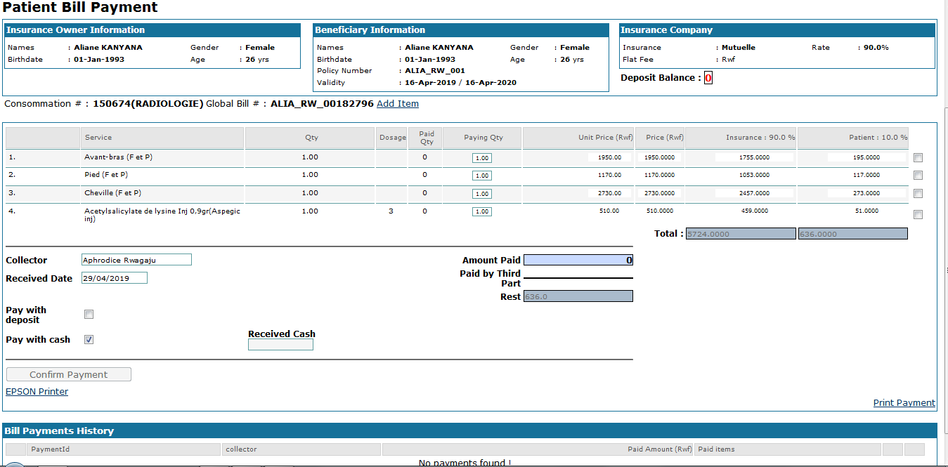

### 2.7.4 Paying a bill

**Steps**:

1. Log into EMR using your username and password
2. On home page, click on “**Bill**” link in MOH billing module section
3. Enter the patient insurance card number

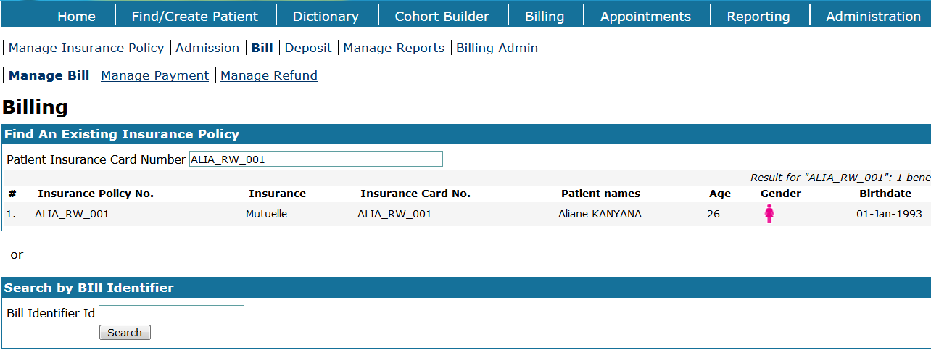

1. Select the patient, view and copy the **bill identifier**

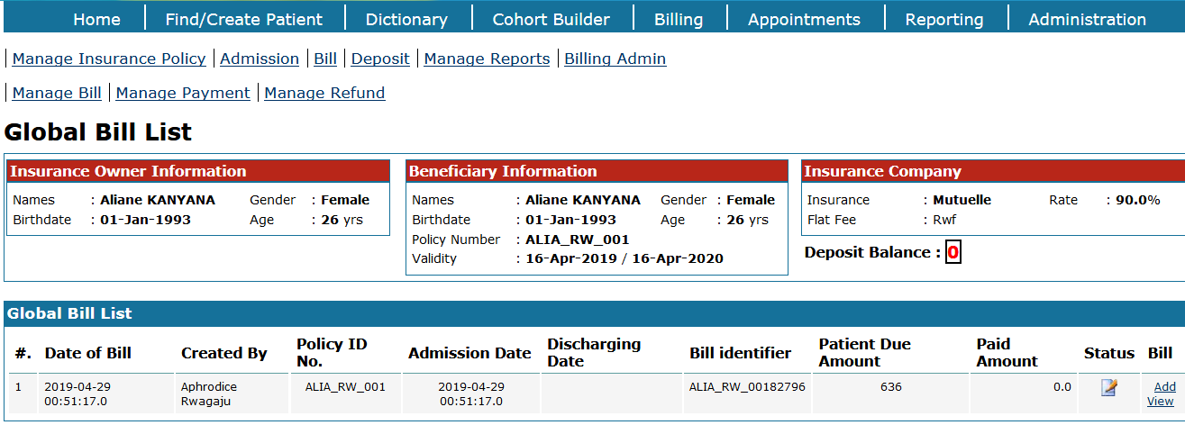

1. Click on “**Manage payment**” link then paste the **bill identifier** and click on **[Search]** button

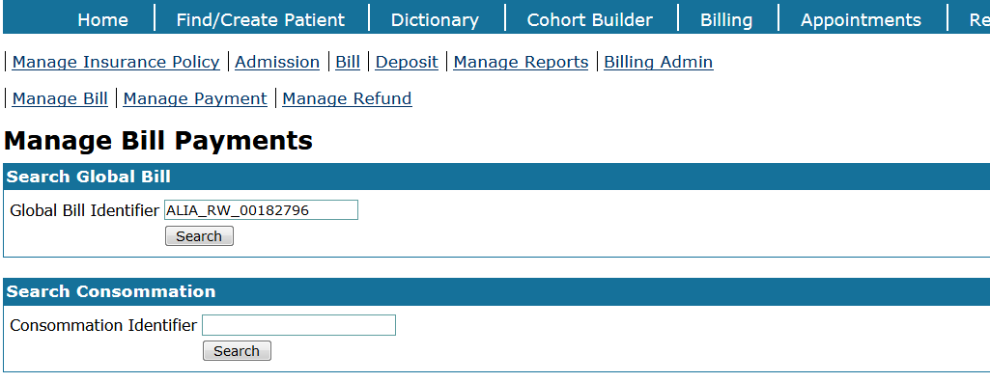

1. View the **total due amount** for the bill and click on “**View link**” from “**Payment**” column

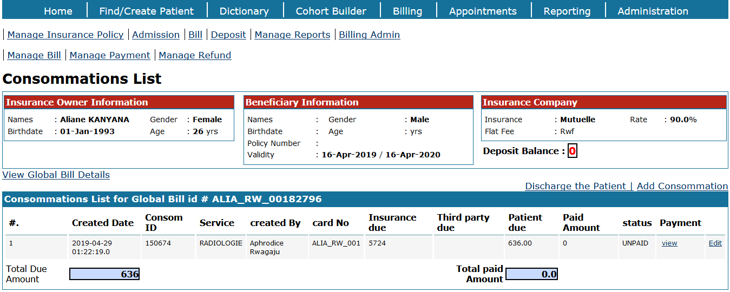

1. Select billed items to pay for and enter the received cash amount. Click on **[Confirm payment]** button

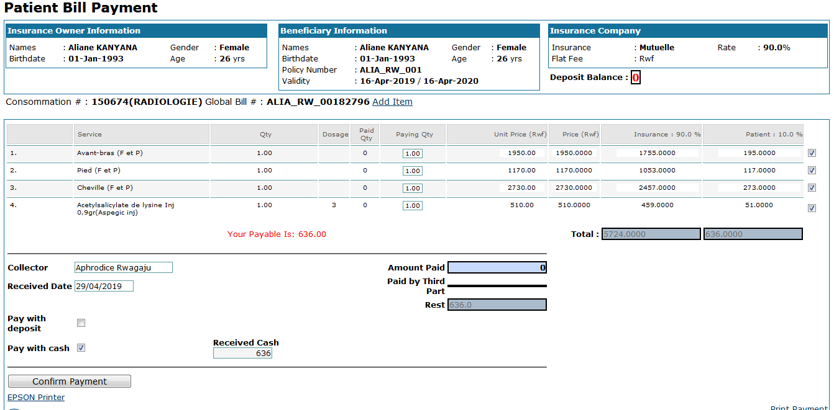

1. The rest amount to be paid is zero (0)

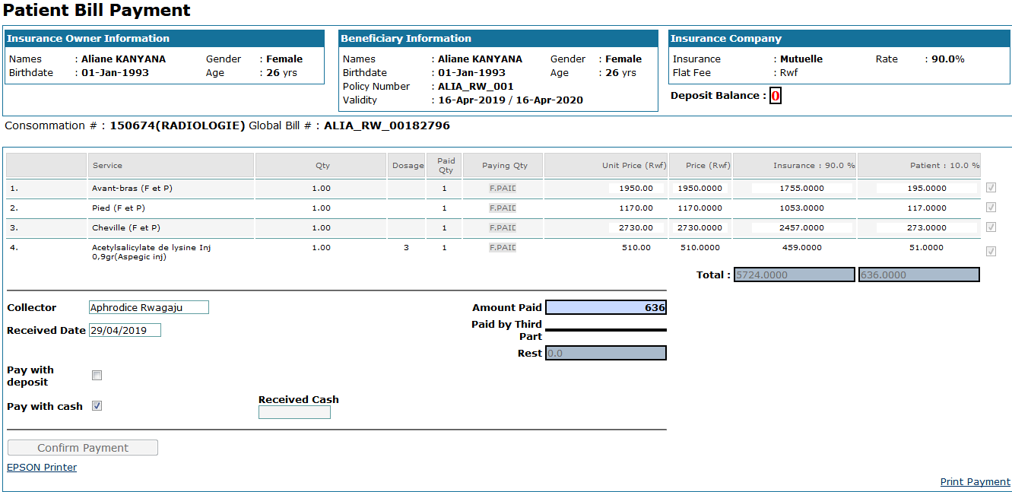

1. The user can print the payment slip for the patient using either normal printer or small Epson printer. Based on printer you are using, click on “**Print**” or “**Epson**” to print the payment slip.

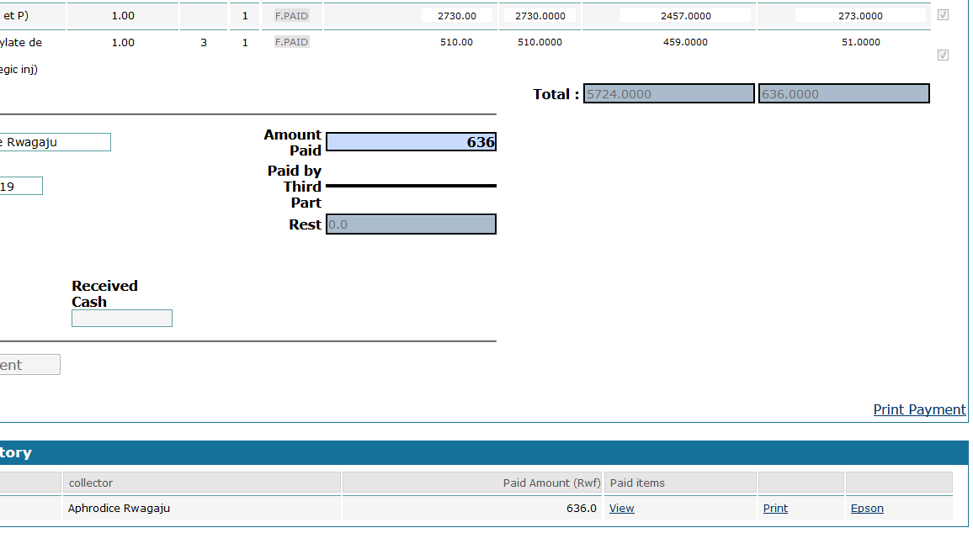

### 2.7.5 Discharging the patient

**Steps**:

1. Log into EMR using your username and password
2. On home page, click on “**Bill**” link in MOH billing module section
3. Enter the patient insurance card number
4. Select the patient and click on “**View**” link from “**Bill**” column

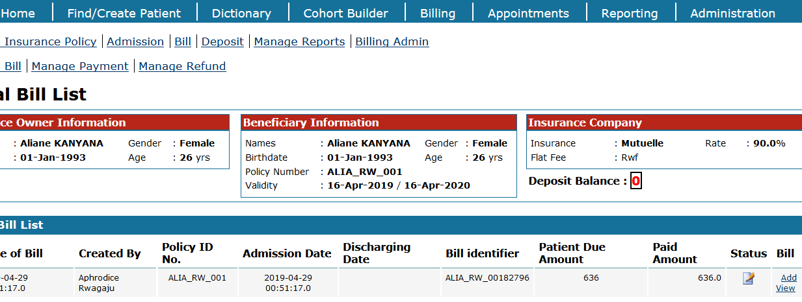

1. Click on “**Discharge the patient**” link

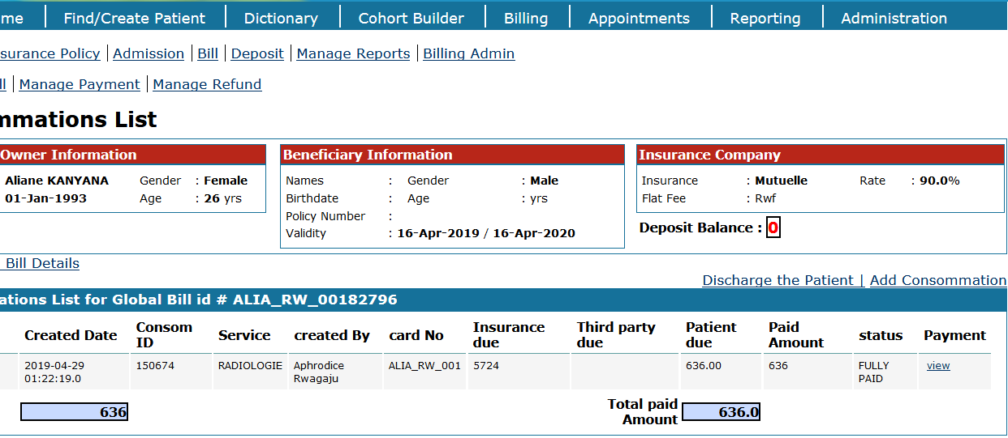

1. Enter admission date, closing date and the closing reason then click on **[Save]** button to confirm the discharge of the patient

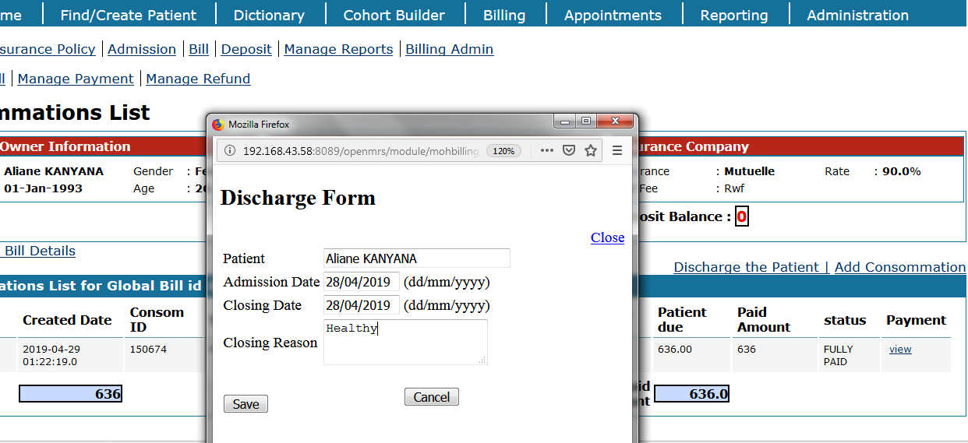

### 2.7.6 Deposit

**Steps**:

1. Log into EMR using your username and password
2. On home page, click on “**Deposit**” link in MOH billing module section
3. Enter the patient name or patient ID and click on “**Search**” button

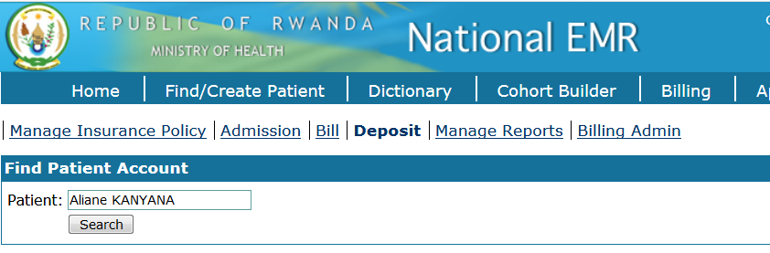

1. Enter the **amount** deposited and the deposit **date** then click on **[Submit]** button

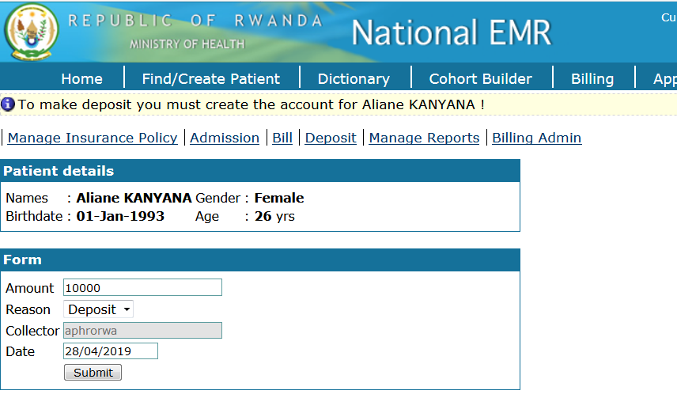

1. The deposit amount is displayed. The patient can use this amount to pay bill or be refunded the amount not used during the discharge process

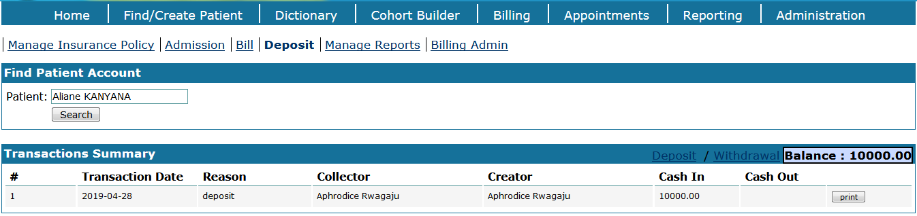

### 2.7.7 Withdrawal of unused amount

**Steps**:

1. Log into EMR using your username and password
2. On home page, click on “**Deposit**” link in MOH billing module section
3. Enter the patient name or patient ID and click on **[Search]** button
4. Click on “**Withdrawal**” link

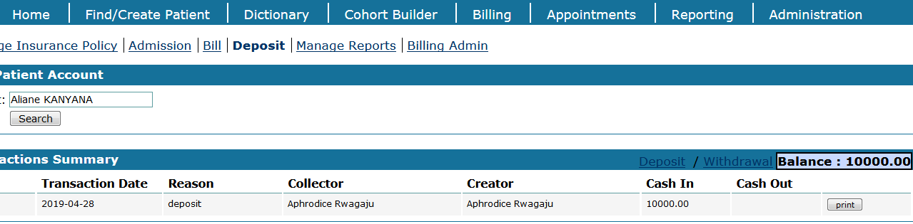

1. Enter the amount to withdraw, reason, date and click on **[Submit]** button to confirm the transaction

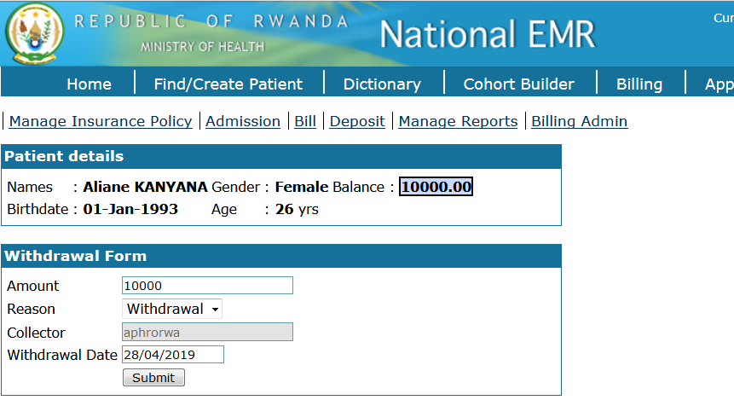

1. The amount remaining is zero (0) if the total balance amount is withdrawn

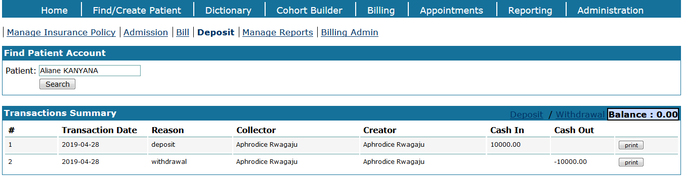

### 2.7.8 Refunding / reimbursement

**Steps**:

1. Log into EMR using your username and password
2. On home page, click on “**Billing**” menu from main menus
3. Click on “**Bill**” link
4. Click on “**Manage Refund**” link
5. Enter the payment identifier and click on **[Search Payment]** button

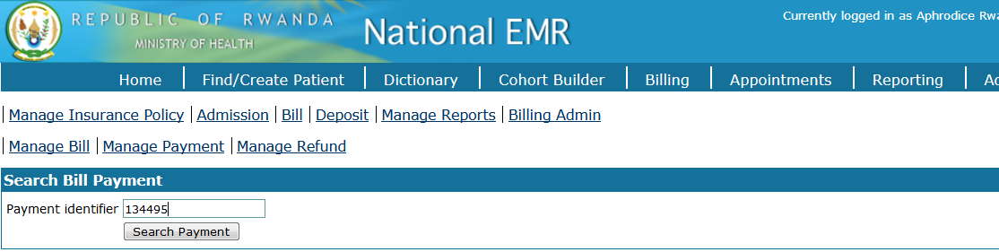

1. View the search results and click on “**Refund**” link to perform the refund process

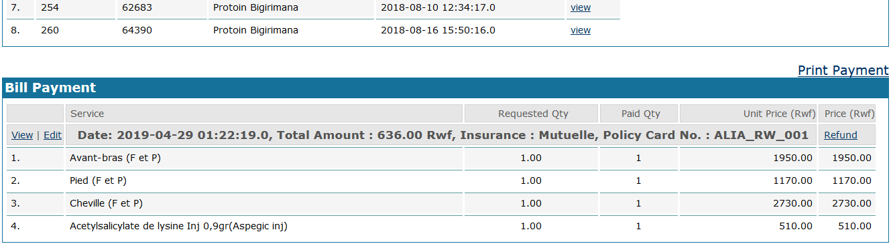

1. Select billable items to be canceled, enter the reason of refund and view the due amount to be refunded

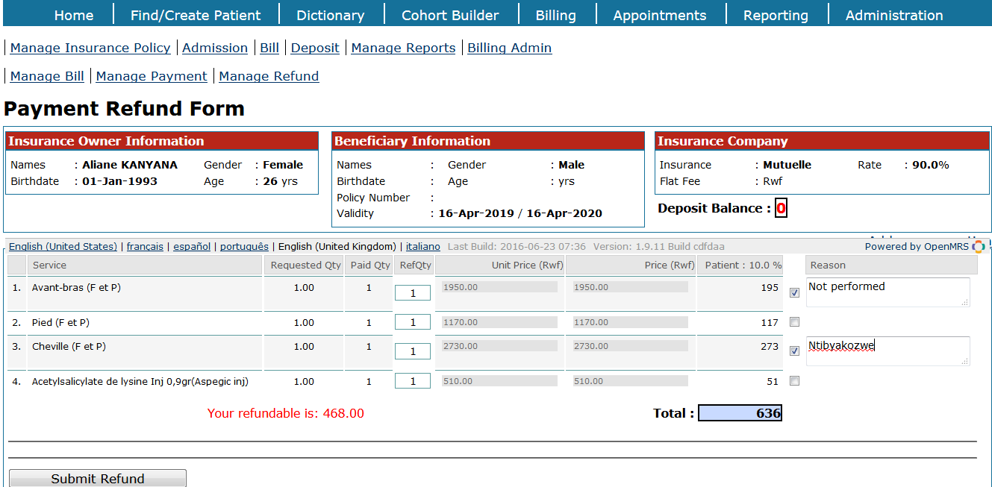

1. You will receive the notification message to wait for the approval of chief cashier

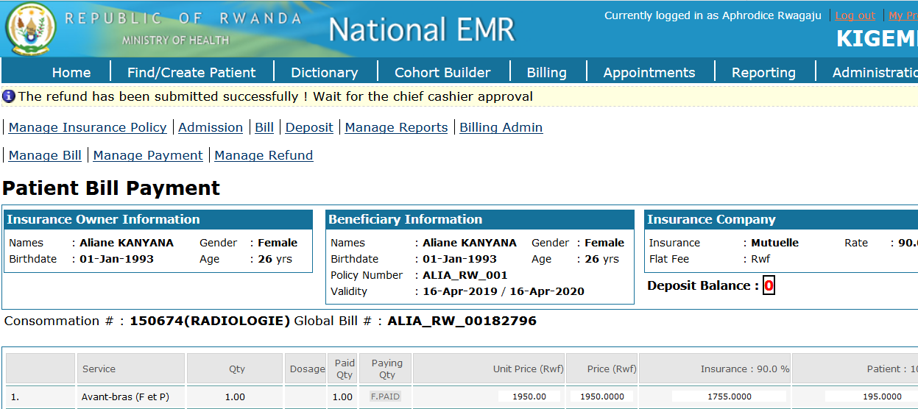

1. Identify the refund request and click on “**View**” link to approve the refund

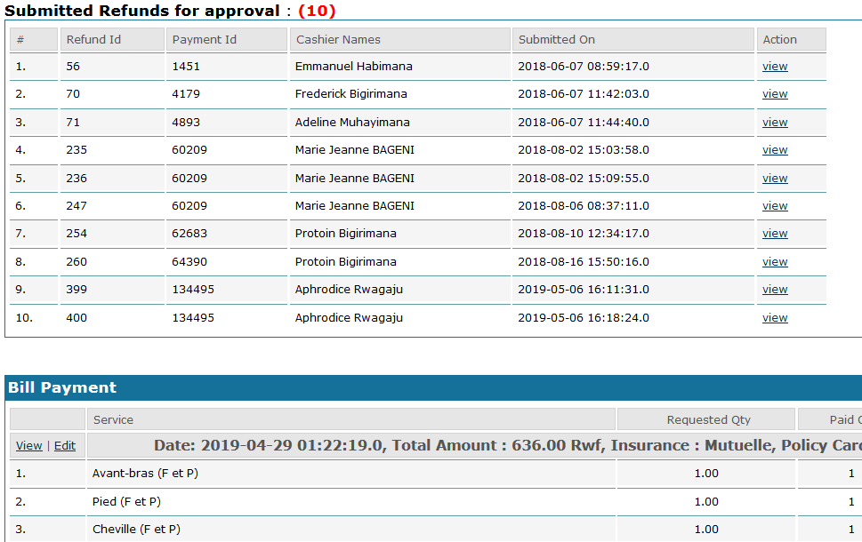

1. Approve the refund and click on [Save] button

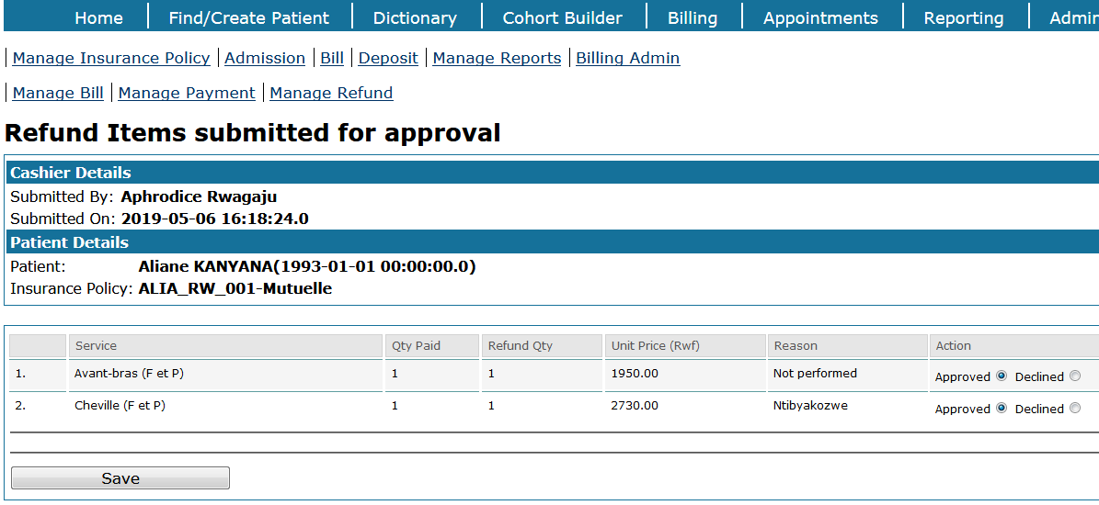

1. You will the notification that the **refund has been verified by the chief cashier**

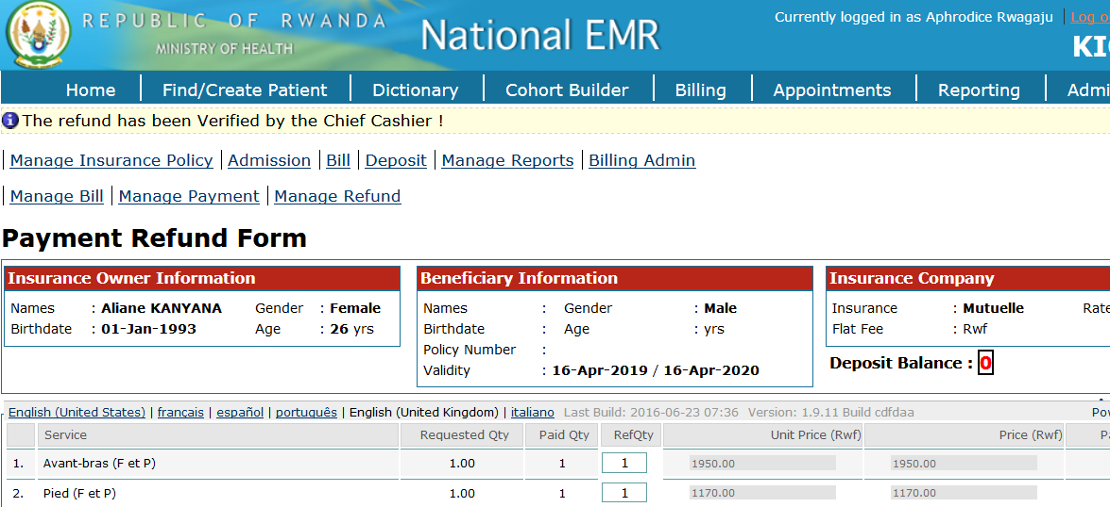

1. Go to **billing** link from main menu, click on **bill** link, click on **manage refund** link then enter payment ID and search. Check for your confirmed refund request

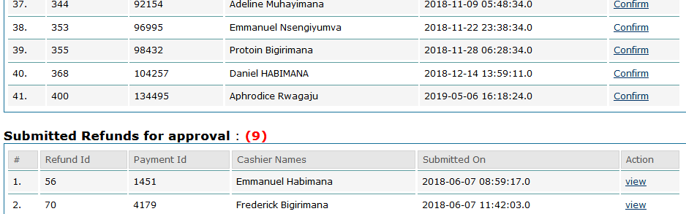

1. Enter the refund date and click on **[Save]** button to save the changes

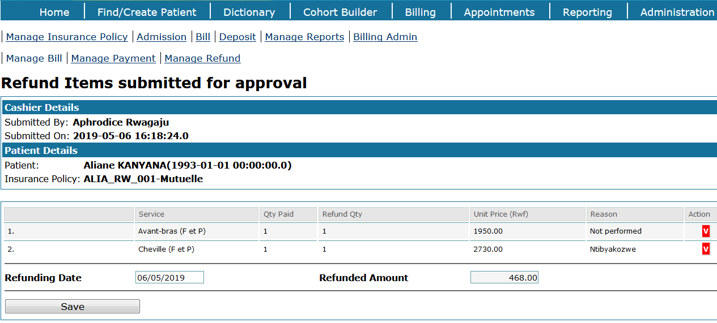

1. Refund has been confirmed

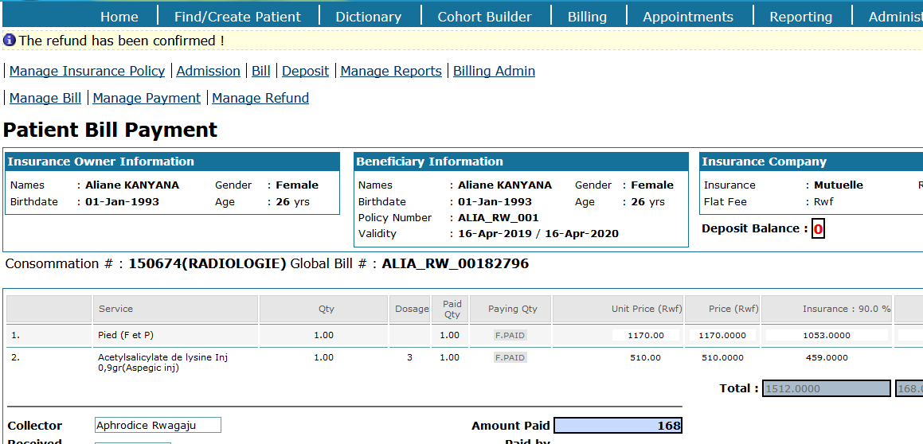

1. You can use the same page to print the receipt for the patient

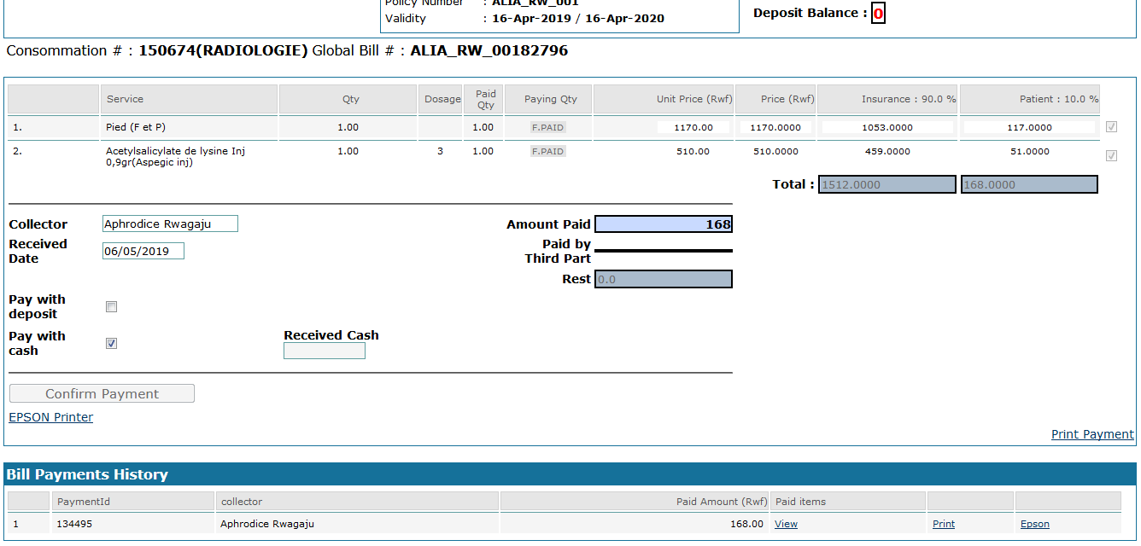

### 2.7.9 Billing report

|  |  |
| --- | --- |
|  | **Different report options of the billing module:**   1. **Find bills** 2. **Cashier report** 3. **Deposits** 4. **Service report** 5. **Refund report** 6. **Insurance report** 7. **Third party report** |

All reports have almost the same parameters. Cashier report can be generated as an example as follows:

**Steps**:

1. Log into EMR using your username and password
2. On home page, click on “**Report**” link in MOH billing module section

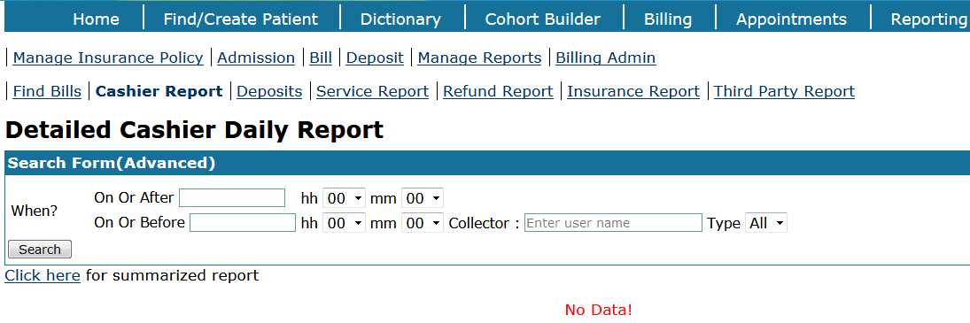

1. Fill the form with reporting window (from date – to date). Here the report of April 2019 is selected. Two options to generate report are available: **[Search]** button and “**Click here** …” link. Click on “**Click here for summarized report**” link to generate summarized report

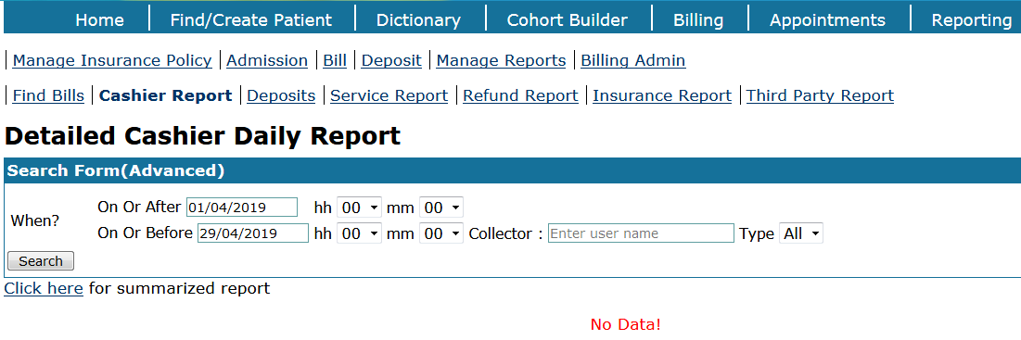

1. View the generated report

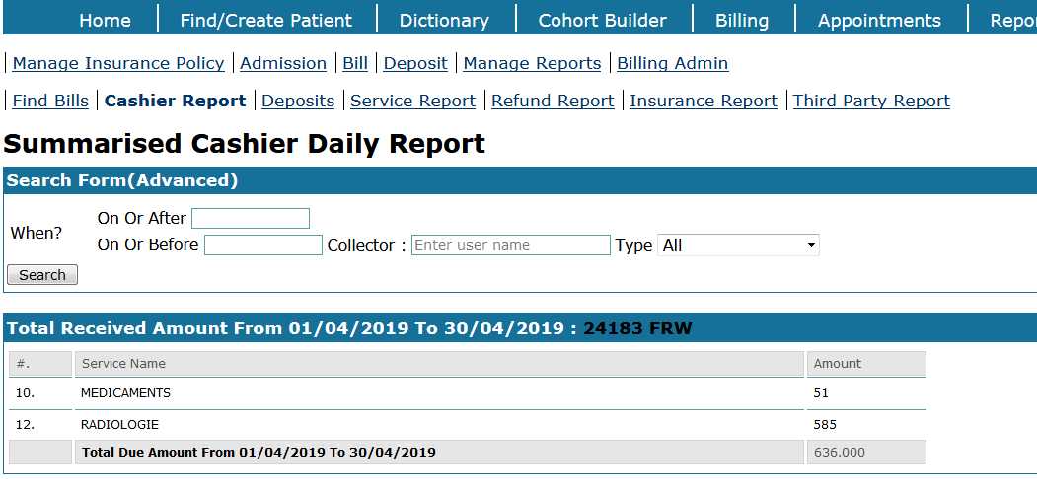

1. If needed, you can generate the report in PDF format. Click on **[PDF]** button to generate the report in PDF format

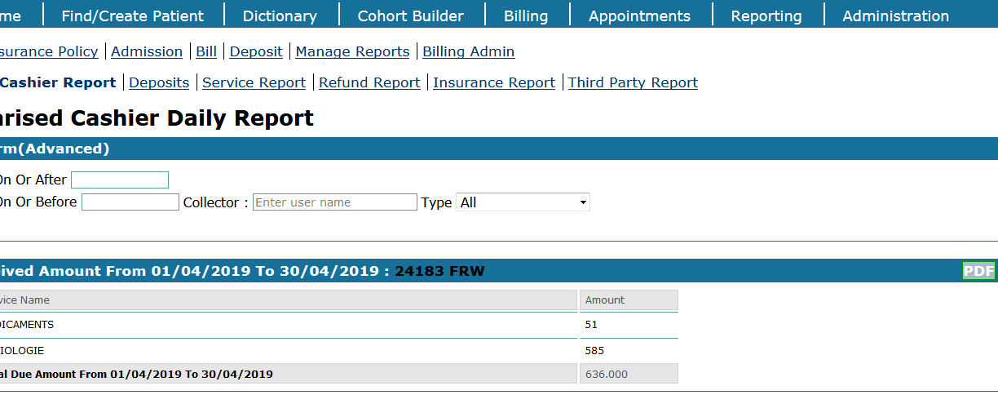

## 2.8 REPORTING

The reporting Module was designed to provide a feature-rich and user-friendly web interface for managing reports within OpenMRS.

**Steps:**

1. Click **“**[**Add/Remove Definitions**](https://192.168.1.115/openmrs_19/module/rwandareports/rwandareports.form)**”** on the Admin Page

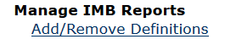

1. Find **“MOH Reports”** and Click on **(Re) Register**



1. **Click on Reporting to start the reports**



1. Click on **‘**[**MOH-HMIS Indicator report’**](https://192.168.1.115/openmrs_19/module/reporting/run/runReport.form?reportId=853bf52a-bd4b-4774-b371-c391708e0e5d) and **[Request report]** button

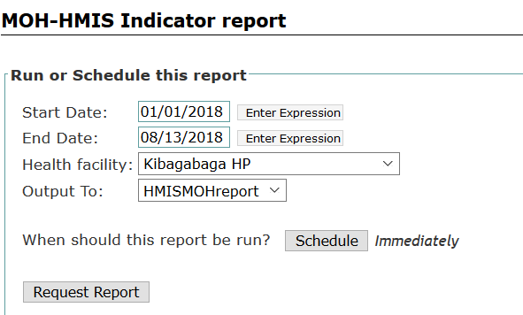

1. View Reports

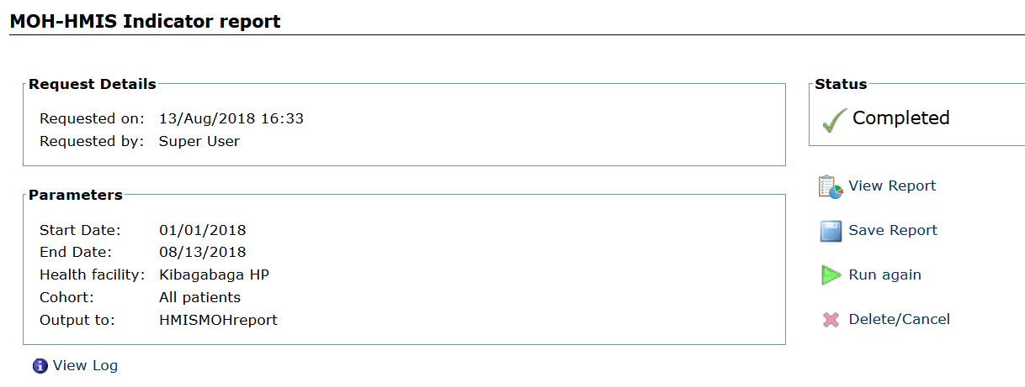

### Manage data exports

This is a method of turning the key-value pairs of observations and patient data into a one-row-per-patient csv file.

**Steps**

1. Click Manage Data Exports on the Admin page

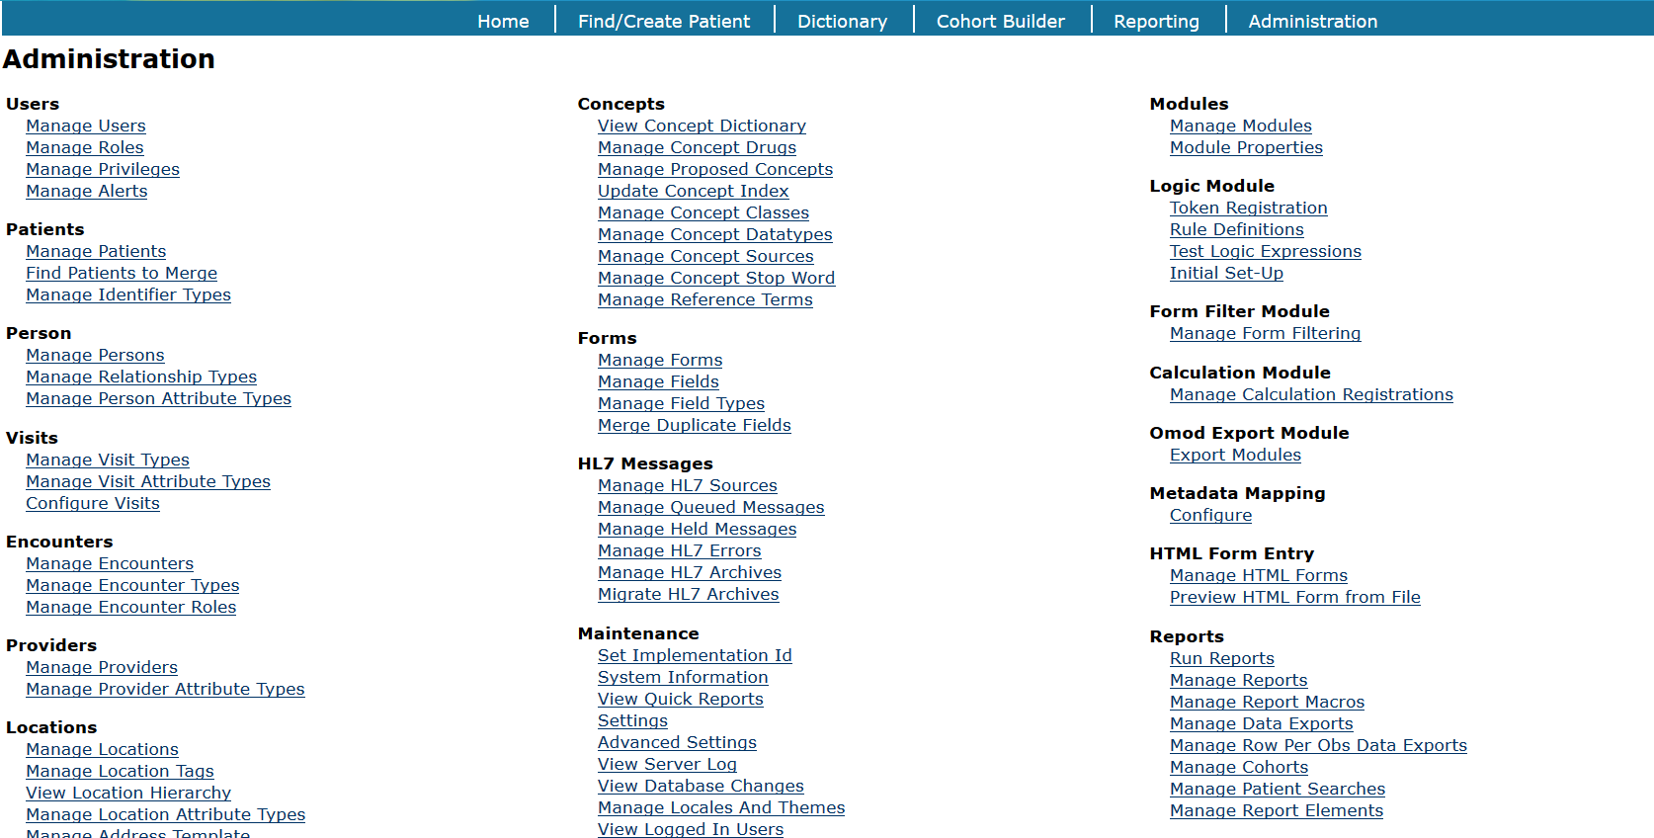

1. Click Add New Data Export

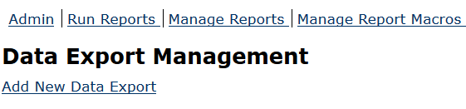

1. Fill in a name and description

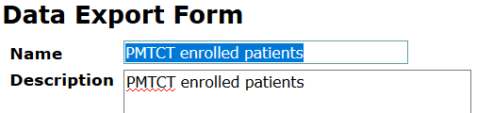

1. Click to the **“Define Columns”** tab & Click **“Add another column”**
2. Use the dropdown box on the **“Simple Column”** tab to choose OpenMRS Identifier Number

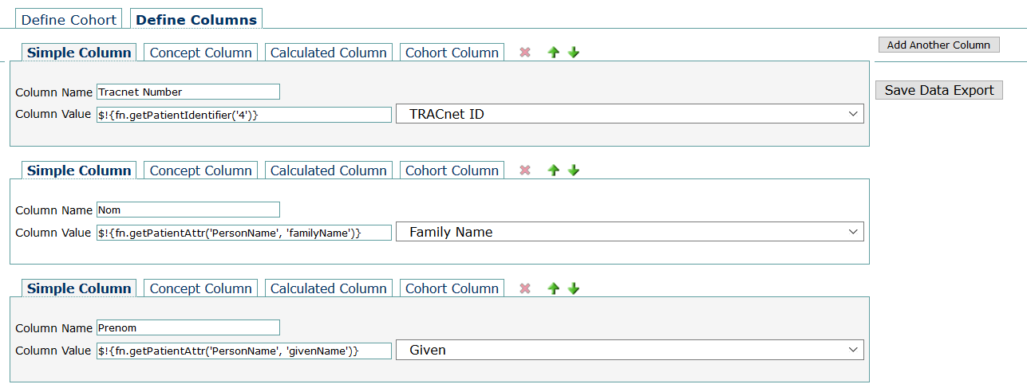

1. Click **[Save Data Export]**

The data export will be cached for your locale until you regenerate it again.  If there are other users on the system in your locale they will be able to see and download the cached export.

